**JANUARY 2022**

|  |
| --- |
| Dear Managing Broker:  I look very much forward to working with and serving you this year – the 111th year of our association.  Our theme for the year is “Together Stronger.” Truly, we can accomplish much more, and take greater pride in our achievements, if we work together.  The REALTOR® organization has been a model for professional cooperation since its founding. Let’s agree to more than just working together this year, but actively looking for opportunities to share tasks in our own circles – listen and speak, lead and follow, teach and learn. Together, this will be our best year yet!  **Eric Etzel**, 2022 SAR President |

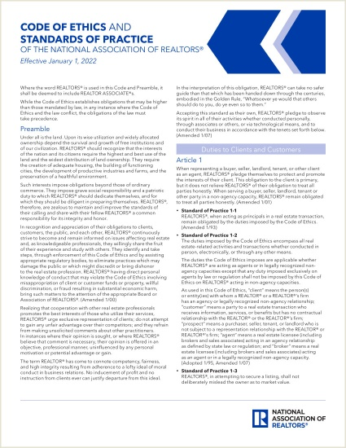

**2022 Code of Ethics and Standards of Practice**

**of the National Association of REALTORS®**

NAR's Code of Ethics, adopted in 1913, was one of the first codifications of ethical duties adopted by any business group.

The Code ensures that consumers are served by requiring REALTORS® to cooperate with each other in furthering clients' best interests.

The Preamble to our Code of Ethics was written by a Washington REALTOR® - it’s a good read.

Here is our Code of Ethics, newly updated for 2022:

[**https://cdn.nar.realtor/sites/default/files/documents/2022-COE-Standards-of-Practice-2021-12-15.pdf**](https://cdn.nar.realtor/sites/default/files/documents/2022-COE-Standards-of-Practice-2021-12-15.pdf)

|  |  |  |  |  |  |  |  |
| --- | --- | --- | --- | --- | --- | --- | --- |
| |  | | --- | | **A Moderating Market**  **Area Realtors say homebuyers will find more properties to choose from and less volatile prices during 2022** | | *Homebuyers stymied in the past by Spokane’s ever-climbing real estate prices and bidding war after bidding war may have reason for optimism in the new year.*  *Although they can expect increasing home prices, high demand and low inventory, area Realtors say, the housing market won’t be as frenzied as 2021.*  *﻿“Sale prices will continue to increase, but not at the rate it did in 2021. I believe the reason it will increase is lack of supply and demand will remain strong,” said Rob Higgins, executive officer for the Spokane Association of Realtors.* | | |  | | --- | |  | |  |  |  |  | | --- | --- | | |  | | --- | |  | | |

Here’s the link to the story:

[**https://www.spokesman.com/stories/2021/dec/28/us-home-prices-surge-184-in-october/**](https://www.spokesman.com/stories/2021/dec/28/us-home-prices-surge-184-in-october/)

|  |  |  |  |
| --- | --- | --- | --- |
|  | | |  | | --- | |  | |
|  | |  |  | | --- | --- | | |  | | --- | |  | | | |

|  |
| --- |
|  |

|  |  |  |  |  |  |  |
| --- | --- | --- | --- | --- | --- | --- |
| |  | | --- | |  | | **Real Estate Market Forum**  **Tuesday, February 15th**  **8 a.m. to 2 p.m.**  **at the Coeur d'Alene Resort**  **Registration open now!** |  |  |  | | --- | --- | | |  | | --- | |  | | | |  | | --- | | Come join us at the 35th Annual Real Estate Market Forum, covering trends in real estate, construction, and the local economy in the Spokane-Kootenai-Bonner area.  An outstanding group of speakers has been assembled by the Market Forum Planning Subcommittee.  The price for the 2022 Market Forum is $70.  That price will be available until the Wednesday before the event. At noon that day, the price goes up to $75, which will be the walk-up price, if space remains.  ﻿The 2018 event at the Resort sold out at 600, and we had 713 at the 2020 event in Spokane.  If you choose to not use electronic registration, checks (payable to SKRERC) can be sent to the Spokane Association of REALTORS, 1924 N. Ash, Spokane, WA 99205, attention Tami Peterson.  Registration questions can be directed to her at **509-326-9222**. | |

Here’s the link to register online:

[**https://www.eventbrite.com/e/2022-real-estate-market-forum-registration-237894778687**](https://www.eventbrite.com/e/2022-real-estate-market-forum-registration-237894778687)

|  |  |  |  |  |  |
| --- | --- | --- | --- | --- | --- |
| |  | | --- | |  | | **Growth with a Purpose 2022**  **Thursday, February 17th**  **8:30 a.m. - 5 p.m.**  **Ruby River Hotel**  **700 North Division Street** | | |  | | --- | | **Spokane REALTORS®**  **Young Professionals Network** | | Build Your Brand  Build Your Business  Build Your Wealth  Join Us for an all day IN PERSON business conference with **Chelsea Peitz**, **Ruthy Taylor**, **Ray Ellen** and many more!  You must purchase your tickets through the link in Eventbrite.  Tickets will increase to $75 on February 10th | |

Here’s the link to register online:

[**https://www.eventbrite.com/e/growth-with-a-purpose-spokane-realtor-ypn-event-tickets-227313509827**](https://www.eventbrite.com/e/growth-with-a-purpose-spokane-realtor-ypn-event-tickets-227313509827)

**DECEMBER MARKET STATISTICS**

675 residential closed sales on less than one acre, including condominiums, were reported for December 2021. Compared to December 2020 sales were down 52 sales or 7.2%, 675 v. 727. The average closed sales price for December was $417,357 up 23.5% from last December closed sales price of $337,961. The median closed sales price for December was $390,000 up 23.8% from December last year, $390,000 v. $315,000.

The year-end residential closed sales are up less than one percent from 2020, 8,238 v. 8,191. The 2021 average closed sales price was $400,612 up 24.7% from the average closed sales price for 2020 of $321,311. The 2021 median closed sales price was $370,000 up 23.3% from 2020 median closed sales price of $300,000.

Inventory continues to be at record lows. As of this report, our inventory of single-family homes/condos on the market totaled 224, down from one year ago when inventory was 236 properties. New construction closed sales reported to the Association for 2021 totaled 999 down 93 properties or 8.5% from 2020.

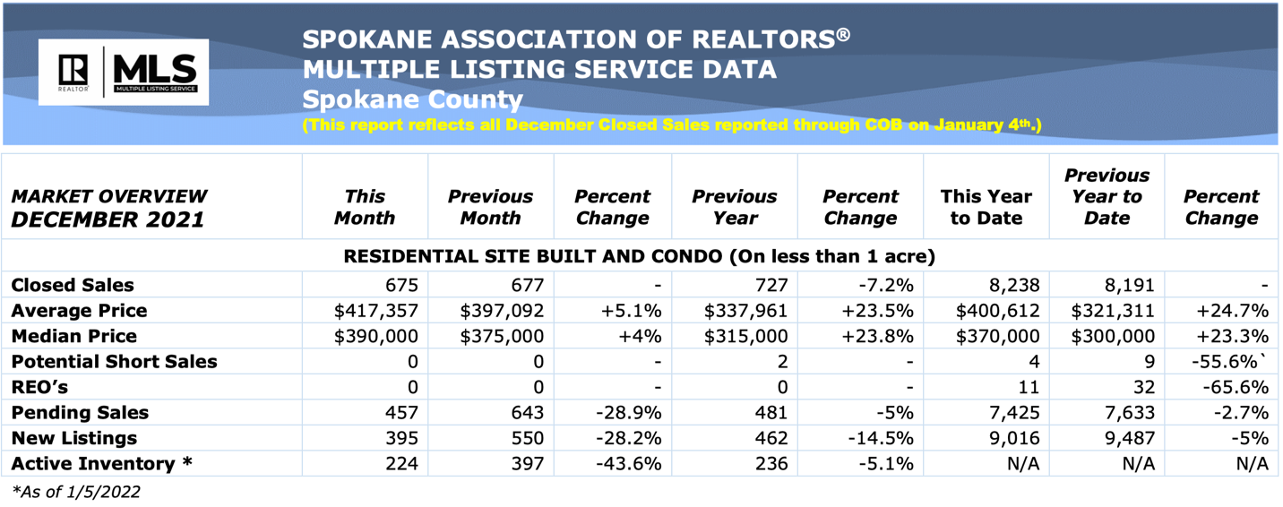

The above is an excerpt of the Spokane Association of REALTORS’® **December 2021** Residential Market Activity Report. Access to the full report each month is a benefit of your association membership. See the full report online here (after you log in to the member portal): [**https://www.spokanerealtor.com/mls/market-activity-mls-statistics**](https://www.spokanerealtor.com/mls/market-activity-mls-statistics)

**DECEMBER KEY BOX STATISTICS**



