SEPTEMBER 2019

Mark your calendar for Friday, October 4th!
Professional Search Training classes by REALTOR.com will be at the SAR.
Watch the Weekly Notices for additional details.

MARKET “BUSTLING WITH ACTIVITY”

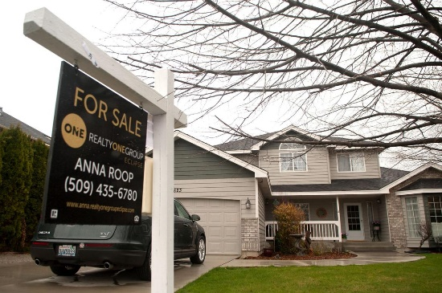
The Spokane County real estate market was bustling with activity in August, but not enough to drive up home sales, as persistently high demand and low inventory continued to be the norm.

Home sales declined 5% last month compared to August 2018, according to data from the Spokane Association of Realtors.

More than 869 single-family homes and condominiums on less than 1 acre sold last month, down from 915 homes in August 2018, according to the Realtors association.

"Every month this year we've had sales down compared to the same month last year," said said Rob Higgins, executive officer for the Spokane Association of Realtors.

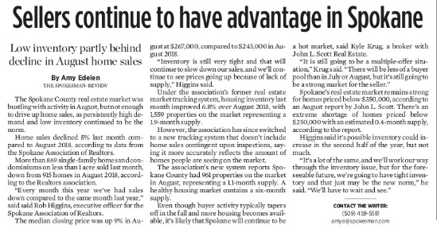
Read the full article in The Spokesman-Review (pictured) online here:

https://www.spokesman.com/stories/2019/sep/09/spokane-home-sales-decline-5-in-august-spurred-by-/

SEPTEMBER IS REALTOR® SAFETY MONTH

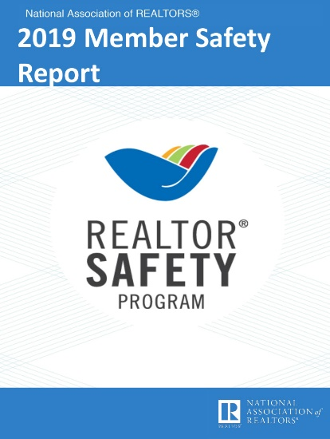
NAR is just out with its 2019 Member Safety Report.

It reports 33% of REALTORS® have experienced a situation that made them fear for their personal safety or safety of their personal information.

Common situations that caused fear: open houses, vacant homes/model homes, meeting clients alone, properties that were unsecured or inhabited, buyers who refused to meet in public places, properties in remote areas.

Download the complete report (pictured above) online here:

https://www.nar.realtor/member-safety-report

LEGAL HOTLINE: BUYER’S AGENCY AGREEMENT

Washington REALTORS® Legal Hotline lawyer Annie Fitzsimmons is back with a new video to talk about the forms revisions that took place in July 2019.

In this video, Annie covers revisions to Form 22A, the Financing Addendum.

Watch Annie's new four-minute video online here:

Form 22A Financing Addendum 2019 Revisions

CRS CLASS IN SPOKANE

October 17-18

Building an Exceptional Customer Service Referral Business
Class: 8:30 a.m. to 5:00 p.m.
Location: SAR / 1924 North Ash Street

16.0 clock hours

Download the class flyer (pictured) from among the supporting documents to this newsletter.

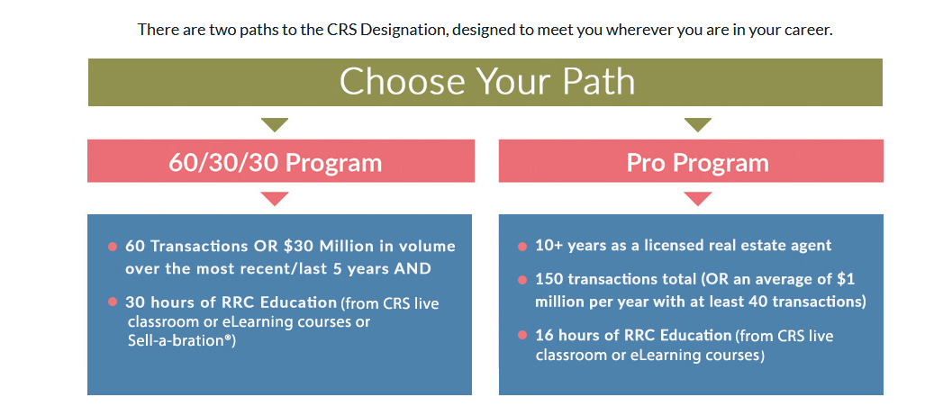

ASSESSOR’S LETTER TO REALTORS®

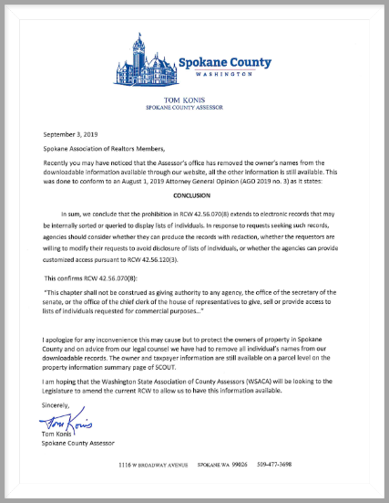
Your Association has received a letter from Spokane County Assessor, Tom Konis, addressing an evolving legal opinion that affects his office and, ultimately, all REALTORS® in Washington state.

An August 1, 2019, Washington State Attorney General Opinion says an existing law which prohibits the release of owner names in property records for commercial purposes must extend to electronic data.

In response, the Spokane County Assessor's office has removed owner names from downloadable property information available through its website.

Read the Assessor's letter to Spokane REALTORS® explaining its position on this issue (pictured) among the supporting documents to this newsletter.

AUGUST MARKET STATISTICS

869 closed sales of single-family homes on less than one acre, including condominiums were reported for August 2019. Compared to August 2018 closed sales were down 5%, 869 v. 915. The average sales price for August 2019 was $288,256, up 11.4% from the average selling price for August 2018, which was $258,826. Median sales price for August 2019 compared to August 2018 was up 9%, $267,000 v. $245,000.
Year to date closed sales through August 2019 are down 11.3%, 5,005 closed sales compared to 5,643 through August 2018. The year to date average closed sales price is up 11.1%, $281,625 compared to $253,472. The year to date median closed sales price is up 11.6%, $260,000 compared to $233,000.
Inventory continues at very low levels. A major status change was implemented for the August report. We no longer have the CTGI (Contingent-Inspection) status as those properties are now reported as PNDI (Pending-Inspection). This reduced our active inventory to 961 properties, for a 1.1 month supply. Under the old system our inventory, which included CTGI, as of this report would total 1,559 properties, up 6.8% from 1,460 properties last year. New construction sales reported to the Association through August total 558 compared to 588 reported last year, down 5%.
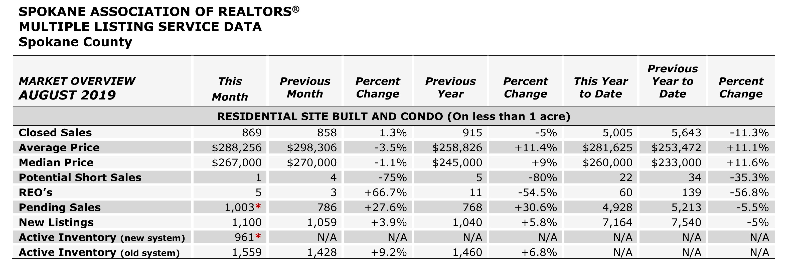

The above is an excerpt of the Spokane Association of REALTORS’® August 2019 Residential Market Activity Report. Access to the full report each month is a benefit of your association membership. See the full report online here (after you log in to the member portal): https://www.spokanerealtor.com/mls/market-activity-mls-statistics

AUGUST LOCKBOX STATISTICS

