NOVEMBER 2019

EDUCATION EXCELLENCE AND ANNUAL MEMBERSHIP MEETING

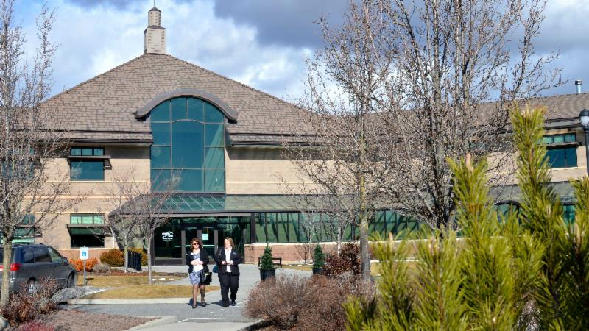
Thursday, November 21st
at CenterPlace in Spokane Valley

Early-bird registration accepted
through November 14th!

Join your friends and colleagues for the SAR's final Education Excellence and Annual Membership meeting of 2019.

This event is bundled with four main events:

Top Shelf Business Practices
in the morning

Quarterly Business Meeting with
Buffet Lunch at 11:30a.m.

Social Media Marketing for REALTORS®
in the afternoon

Attend the day and go home with 6.5 clock hours! Attendance for clock hours will be proctored - extended absence from class(es) will disqualify you from credit.

The event flyer is offered among the supporting documents to this newsletter.

Reminder to Vote! SAR Voting Closes Next Week!

VOTING CLOSES NEXT WEEK!
Remind your brokers that voting is open for you to make your selections for 2020 SAR officers and directors.
Deadline to fill out your ballot is Wednesday, November 20th, at 4:30 p.m.
ALL VOTING is DONE ELECTRONICALLY and IS EASY!
If you haven't voted already, you may do so right from the MLS Dashboard - look for the VOTE icon on the MLS Dashboard:
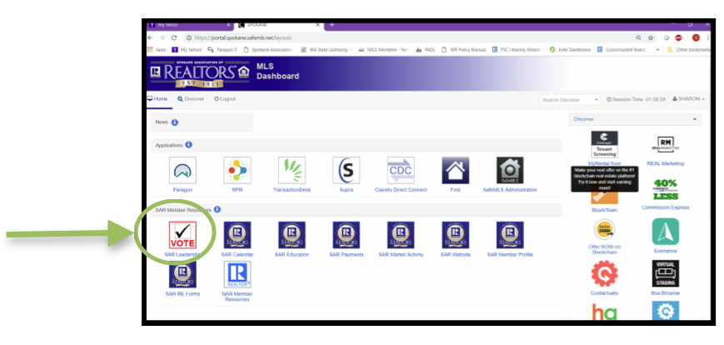
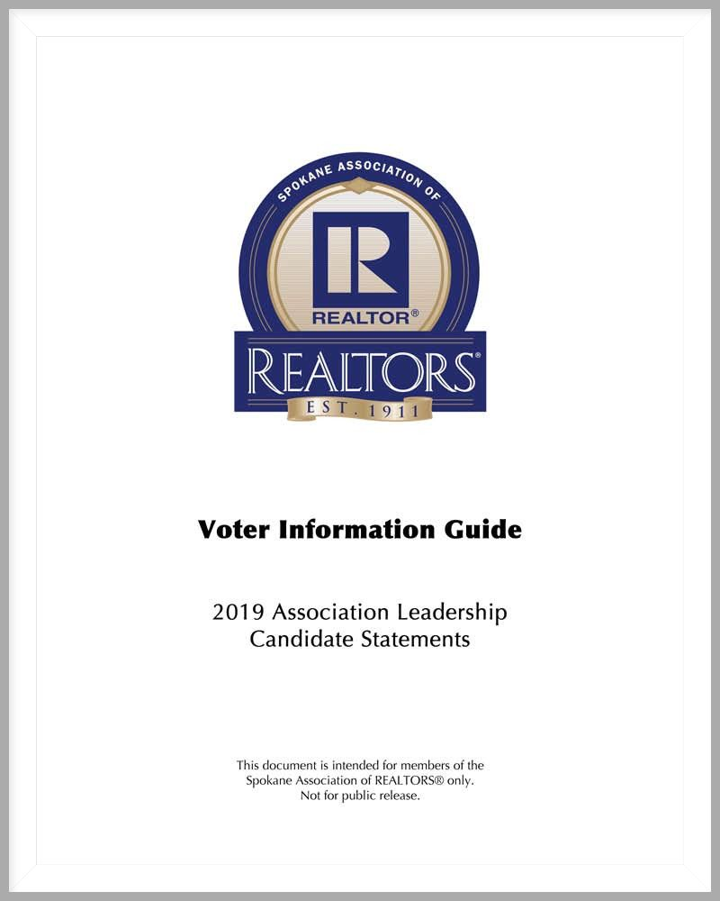
Check your Weekly Notices for the final Slate of Candidates or download the Official Voter Information Guide. Download your copy here to help you make your ballot decisions:
https://www.spokanerealtor.com/other/2019%20SAR%20VOTER%20GUIDE.pdf

The members of your 2020 SAR leadership team will be announced at the association's Annual Membership Meeting on Thursday, November 21st at CenterPlace Regional Event Center.

THAT’S WHO WE R® – ADVOCACY MESSAGE

Your Spokane Association of REALTORS® has created a new advocacy message to help consumers better understand who we are and what we do.

This message was paid for with an advocacy grant from the National Association of REALTORS®.

Be among the first to see the message online here.

This is also posted to the SAR Facebook page - you can share it from there.

Watch for this message in your favorite local television newscasts in coming days.

Watch the new 30-second message online here.

That's Who We R®

Add this video to your website with this code:

<iframe width="976" height="549" src="https://www.youtube.com/embed/GcflZg5hb7Q" frameborder="0" allow="accelerometer; autoplay; encrypted-media; gyroscope; picture-in-picture" allowfullscreen></iframe>

ASSESSOR LETTER: CURRENT USE

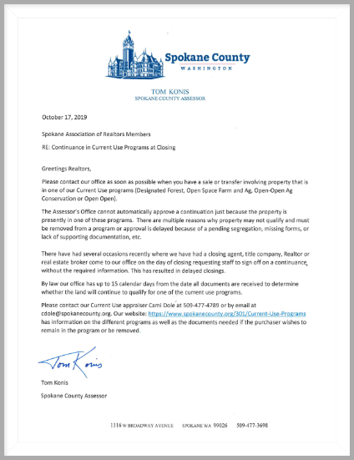
Are you working with clients who wish to continue existing land use programs after closing - like forest, open space or farmland designations?

Your SAR has received a letter (pictured above) from Spokane County Assessor Tom Konis with advice on how to help you move a client's "continuance of program" request through the approval process as quickly as possible.

This letter (pictured) is offered among the supporting documents to this newsletter.

SMART METERS: A SIMPLE GUIDE

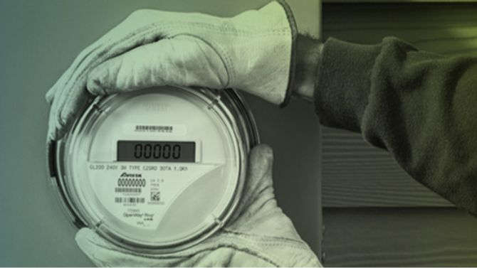
Your SAR is in touch with Avista Corp. to answer member questions about smart meters.

Avista is in the process of upgrading all of its electric meters to smart meters and installing smart modules on all of its gas meters in the State of Washington. The new smart meters are part of an integrated system designed to make us smarter together.

Sellers are not responsible for the cost to upgrade Avista's meters, nor is it a requirement to upgrade Avista's meter as part of a sale.

It's important to note that Avista's transfer of service process (from one responsible party to another) is not related to or activated by the real estate closing process. To avoid long periods without power, the accountable party needs to contact Avista to accept responsibility or the service will be shut off.

Avista stop service process:
- The date you enter as your stop service date should be the last day you are responsible as the electricity may be shut off on the date service is taken out of your name.
- Service may be disconnected as early as 8 am on that date.
- If you need the electricity to stay on through a certain date, we should set your stop date for the day after.
For more information, visit this excellent resource page on the subject: myavista.com/smartmeters

WR LEGAL HOTLINE: MAILBOX RULE
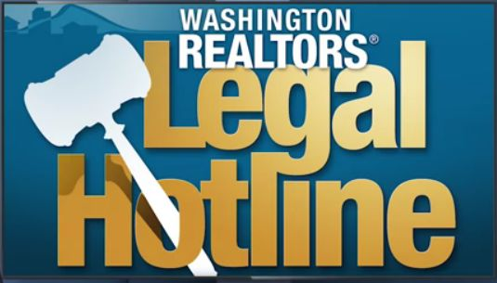
Washington REALTORS® Legal Hotline lawyer Annie Fitzsimmons receives questions about earnest money through the WR Legal Hotline all the time.

So, in this video, she focuses on the delivery of earnest money, a clear explanation of Form 21-Paragraph B (the paragraph that controls when earnest money is due) and the "Mailbox Rule."

Watch the 14-minute video online here:

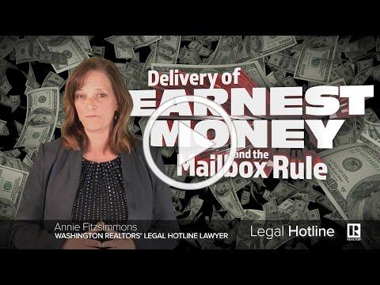
Delivery of Earnest Money and the Mailbox Rule

GRIDMAPS BACK IN STOCK!

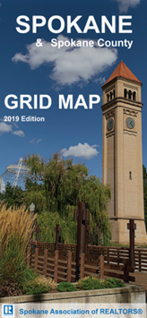
Spokane County grid maps are back in stock and available now at your SAR!

Call or email ahead for bulk orders.

Email: front@spokanerealtor.com

or call 509-326-9222.

OCTOBER MARKET STATISTICS

The numbers are strong for October. Residential closed sales on less than one acre including condominiums totaled 846 for October. This number is up 22.8% from October 2018 when 689 closed sales were reported. October’s average closed sales price was $287,985, an increase of 8.9% over the October 2018 average closed sales price of $264,453. The median closed sales price was $265,000 up 10.4% from last year’s median for October of $240,000.
Year to date closed sales are down 6% through October. 6,652 closed sales reported compared to 7,076 through October last year. The year to date average closed sales price is $283,416 up 11.1% from last year’s average closed sales price of $255,183. The year to date median closed sales price is $260,000 compared to last years of $234,975 an increase of 10.7%.
Inventory is down slightly from last month but up slightly from this time last year. We continue with a 1.2 months supply as of this report. New construction closed sales reported to the Association for October show a healthy increase, 113 closed sales reported this month compared to 79 for October 2018.

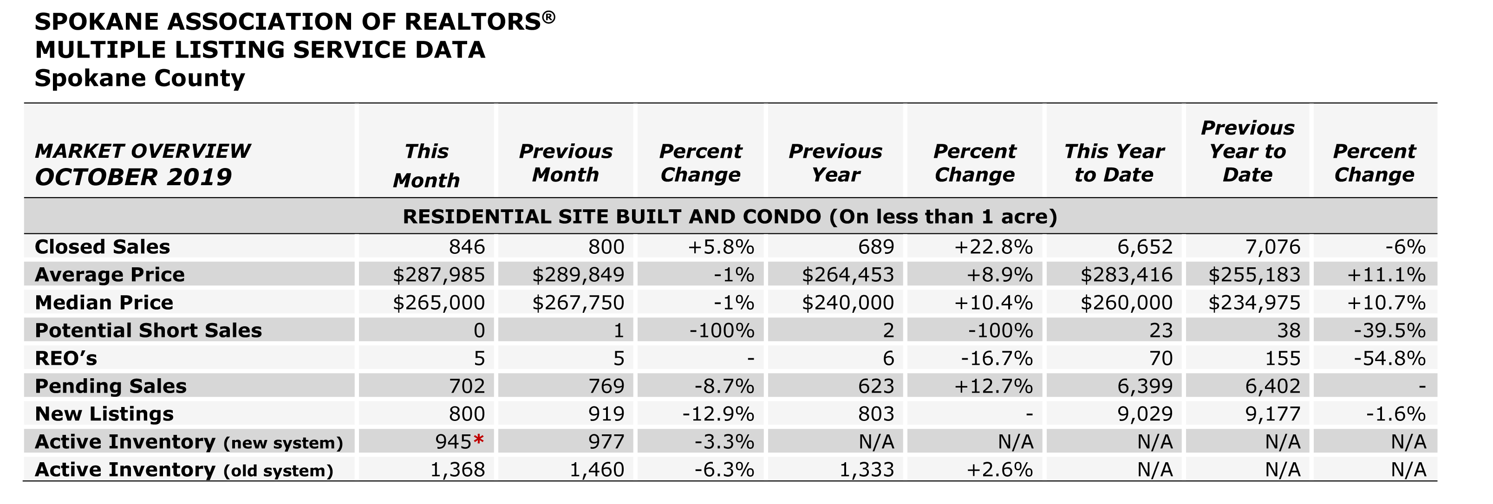

The above is an excerpt of the Spokane Association of REALTORS’® October 2019 Residential Market Activity Report. Access to the full report each month is a benefit of your association membership. See the full report online here (after you log in to the member portal): https://www.spokanerealtor.com/mls/market-activity-mls-statistics

OCTOBER LOCKBOX STATISTICS

