**OCTOBER 2020**

**HOME SALES SHOW NO SIGNS OF SLOWING**

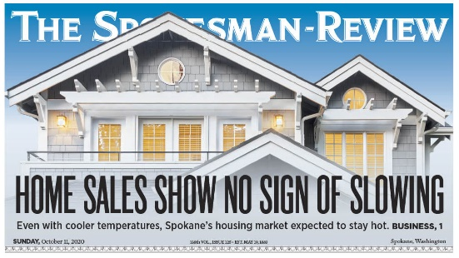*Despite fall's arrival - the time of year when housing markets across the country usually see a cooling in activity that matches the weather - Realtors say the Spokane-area market shows little signs of slowing down.*

*"It's a pretty competitive scenario for buyers right now," said Tom Clark, president of the Spokane Association of Realtors, adding although there was an uptick in listings during the last couple of weeks of September, it was common to see multiple offers and homes selling above asking price.*



Read the entire article in Sunday's edition of ***The Spokesman-Review*** [**online here**](https://www.spokesman.com/stories/2020/oct/11/spokanes-housing-market-to-remain-competitive-this/).

**PHASE 2 PROTOCOLS UPDATED**

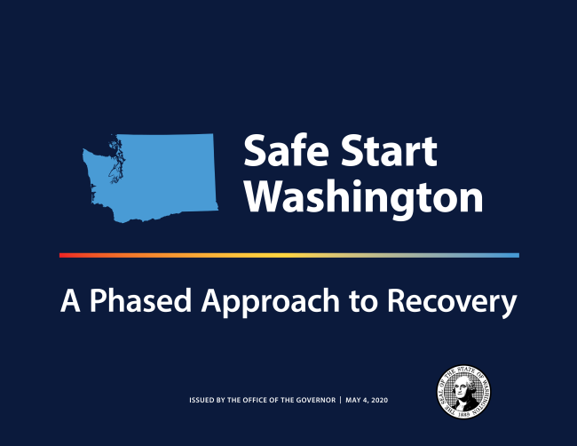

**Up to Five Persons Now Permitted In Addition to Broker!**

There has been a change to the protocols for Phase 2 counties (Spokane County is a Phase 2 county).

**In-person activities including showings, inspections, appraisals, and final walk-throughs may now include up to five (5) persons (in addition to the broker).** The prior Phase 2 restrictions limited the number of persons on site to three (3) persons (including the broker).

Open houses are now permitted in Phase 2 counties – see next page for details.

The other protocols for in-person activities must continue to be followed in all counties, including:

* In-person activities must be by appointment only;
* Face coverings are required to be worn at all times by real estate brokers, their clients, and industry partners (e.g. appraisers, inspectors, photographers, stagers, etc.). Brokers may not provide services to any client who does not wear a face covering.
* The persons on site must strictly follow social distancing guidelines by remaining at least six feet apart at all times; and
* The protocols for Phase 1 and 1.5 counties and Phase 3 counties have not changed. Please note that no more than two (2) persons, including the broker, are permitted on site in Phase 1 and 1.5 counties.

Phase 1 and 1.5 counties include: Benton, Franklin, Yakima, Chelan, and Douglas.

Phase 2 counties include: Adams, Clallam, Clark, Cowlitz, Grant, Jefferson, King, Kitsap, Klickitat, Okanogan, Pierce, San Juan, Skagit, Snohomish, **Spokane**, Walla Walla, and Whatcom.

Phase 3 counties include:

 Asotin, Columbia, Ferry, Garfield, Grays Harbor, Island, Kittitas, Lewis, Lincoln, Mason, Pacific, Pend Oreille, Skamania, Stevens, Thurston, Wahkiakum, and Whitman.

The Safe Start Washington plan was issued by the governor on May 31st.

You can read more about it [**online here**](https://medium.com/wagovernor/inslee-issues-safe-start-proclamation-for-county-approach-to-re-opening-d479030c23e6).

**GOVERNOR OPENS DOOR TO OPEN HOUSES**



Washington Governor **Jay Inslee**, last week, announced that limited open houses are now permitted in Phase 1.5, Phase 2, and Phase 3 counties (Spokane County is currently in Phase 2).

In order to hold an open house, the firm and broker must take measures to ensure that occupancy is restricted to the gathering size permitted by the current county phase and all other required protocols are followed (face coverings, social distancing, sanitation, etc.)

For Phase 1.5 and Phase 2 counties - no more than five (5) people, in addition to the broker, may be in the property at any one time.  For Phase 3 counties - no more than ten (10) people, in addition to the broker, may be in the property at any one time.

Brokers must strictly adhere to the occupancy restrictions for open houses. Firms should develop processes that brokers follow to ensure compliance, including the following:

* Post signs at the property (e.g. on the open house signs, at the front door, inside the property etc.) alerting the public to the occupancy restriction and reminding the public to wear face coverings and social distance.
* Brokers need to carefully monitor the number of persons on site at any one time and not admit more than the allowed number of persons into the property.
* Brokers need to constantly monitor the front door and potentially lock the door from time to time to prohibit additional persons from entering.
* Firms may consider assigning two brokers to an open house - one to stand outside and monitor the number of persons admitted to the property, and the other to be inside the property.
* Brokers must enforce the face covering requirement.
* Persons waiting to enter the property must social distance and wear face coverings.
* Clean and disinfect all surfaces, before and after the open house, and have sanitizer placed around the property.
* Because contact tracing in the event of an outbreak is important, brokers should maintain contact information for all attending an open house.
* Please keep in mind that the firm and broker hosting an open house are at risk of criminal and civil liability for failure to fully comply with the required protocols.

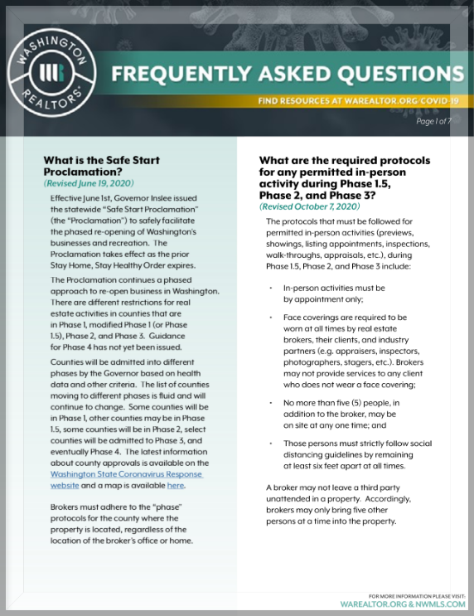

Download the latest Washington REALTORS® FAQ (updated October 7th - pictured) online here:

[**https://www.warealtor.org/docs/default-source/coronavirus/wr-nwmls-faqs-100720.pdf?sfvrsn=2**](https://www.warealtor.org/docs/default-source/coronavirus/wr-nwmls-faqs-100720.pdf?sfvrsn=2)

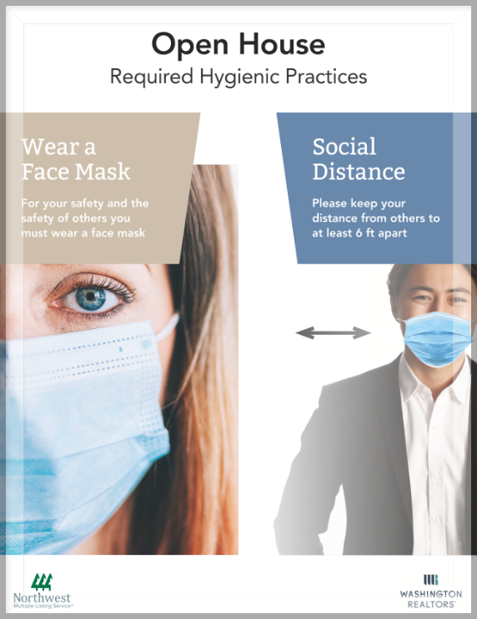

Washington REALTORS® and Northwest MLS have created an assortment of signs and a sign-up sheet that brokers can use for open houses.

* Sign alerting the public to the occupancy restriction for Phase 1.5 and 2 and Phase 3 counties (Spokane County is currently at Phase 2).
* Sign reminding the public to wear face coverings and social distance (pictured above).
* A sign-in sheet including contact information for all attending an open house.

Download the packet online here:

[**https://www.warealtor.org/docs/default-source/coronavirus/covid-requirements-open-house-signs.pdf?sfvrsn=4**](https://www.warealtor.org/docs/default-source/coronavirus/covid-requirements-open-house-signs.pdf?sfvrsn=4)

**WINDOW TO THE LAW: OPEN HOUSES**

In-person showings can be a potentially risky activity, as the coronavirus is still actively spreading in many parts of the country.

By following a few key guidelines, real estate professionals can serve the best interests of their clients in selling or buying a home, while also protecting the health and well-being of all concerned.

The five-minute video is online here:

|  |
| --- |
| [Window to the Law: Showing Guidance During a Pandemic](https://youtu.be/tai9WcZFu4g) |
| **Window to the Law:**  **Showing Guidance During a Pandemic** |

**GUIDE TO SUCCESS**

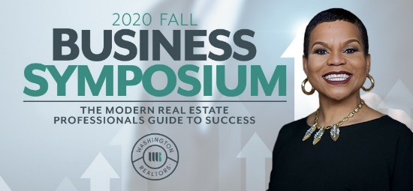The Washington REALTORS® Fall Business Symposium will convene virtually on **Tuesday, October 27th and Thursday, October 29th, at 9 a.m. both days.**

Join us for two days of virtual premier continuing education.

This year, we've invited the dynamic instructor, **Marki Lemons-Ryhal** (pictured), to teach her popular class: ***The Modern Real Estate Professionals Guide to Success.***

Creating valuable content is important to your real estate business growth...especially during our current situation with everything being virtual/digital.

In 2020, 80% of all content viewed online will be videos.

They say a picture is worth a thousand words.

If a picture is worth a thousand words, then one minute of video content is worth 1.8 million words.

Learn to turn one video into photos, a podcast, blog posts, tweets, Facebook status updates, and much, much more for only $5 per video.

You will be amazed at how easy the process is.

**Find out more and** [**register online here**](https://www.warealtor.org/education/symposiums/fall-business-symposium)**.**

**NAR: Find Your R**

**November 2-18**

The 2020 National Association of REALTORS® Conference and Expo will be virtual, this year, but still packed with as much chewy goodness as it always is.

If you've ever been curious to check this out, 2020 is the perfect year to sample it - there'll be no travel or lodging expenses, and you can drop in as your schedule permits while you continue to run your business.

Find Your R at the 2020 REALTORS® Conference & Expo!

[**Check out the program and register online here.**](http://marketing.nar.realtor/q/17FXPJ1qx1YFXhwNgc4iGJ/wv)

**SAR ANNUAL MEETING**

****November will bring a couple of excellent continuing education opportunities with our Washington REALTORS® Legal Hotline attorney Annie Fitzsimmons, and the SAR Annual Meeting – all virtual this year due to continuing precautions against the Corona Virus Disease.

Our Quarterly Zoom classes with Annie Fitzsimmons are scheduled for:

**Tuesday, November 17th – 1 - 4:30 p.m.**

* To Disclose or Not to Disclose

In every transaction, brokers, buyers and sellers have disclosure obligations. These obligations arise from statutory law and from case law. How do you know what to disclose and what not to disclose? This class attempts to answer this question by studying actual court decisions and analyzing what made the court rule the way it did. The different between liability and no liability may be surprising to you! Don't miss this very informative class with Annie Fitzsimmons.

**Wednesday, November 18th – 9 - 12:30 p.m.**

* Death, Divorce and Disgruntled Clients

Would you like to spend a few hours discussing super-fun, upbeat, exciting topics? If so, then you don't want to miss this class! We will discuss the always exhilarating trifecta of: death, divorce and disgruntled clients! Okay... so maybe the topics don't sound super-fun but won't it be fun to know how to handle the title issues when your client needs to sell grandma's house, now that grandma has passed? Wouldn't you like to know what to say to the buyer who tells you that he/she is ready to purchase and the divorce will be final in a month or two? How fun would it be to know what to say to that buyer (or buyer's agent) who calls you after closing to tell you that the refrigerator is missing and you owe them a new fridge? In this class, we discuss all of these topics and arm you with the knowledge to handle these situations professionally, with a confident smile, putting your client (and you) at ease.

**Wednesday, November 18th – 1 p.m.**

* General Membership Zoom meeting
  + Continue to watch the Weekly notices for the details

**2020 SAR FOOD DRIVE**



The 2020 SAR ***Fun, Friendly, Food Fight*** is over and the numbers are in!

Even though we felt the headwinds of not being able to collect food or money at the stores, we still will make a terrific contribution to 2nd Harvest:

**Total Amount collected:  $14,679**

**Which will provide 73,395 meals**

(Every $1 collected = 5 meals)

**Cheers to Food Drive Committee Chair Judy Flemmer and her committee for doing such a top-shelf job with this year’s food drive – despite all of this year’s challenges!**

The winning office - the one that brought in the most money - will be announced at the association's Virtual Annual Membership Meeting/Class on **Wednesday, November 18th**.

**SAR MEMBER SURVEY**

**THANK YOU!**

**Thank you to all who participated in our recent Mini Survey!**

There were a total of 838 respondents - 665 from email and 173 from the web link - for a participation rate of 37%.

Our survey vendor, Agency McKenna, reports this is more than twice the participation rate they see on similar surveys at REALTOR® associations across the country. The more data collected for a survey, the more accurate its results will be.

Since the world has changed a lot this year, this survey - commissioned by your SAR Membership Committee - sought to capture member feedback on how your association is doing in serving you and your real estate business, and how we can adapt and change our service to you in this new world.

We'll share a summary of results here in the Weekly Notices after the report is shared with the Board of Directors at its October meeting, last week.

If you completed the survey, your name will be entered into a drawing to win free SAR local dues for 2021 OR one of two (2) Visa® gift cards valued at $100 each OR one of four (4) Visa® gift cards valued at $50 each.

**CYBER SECURITY: WHAT YOU NEED TO KNOW**



NAR Associate Counsel, **Deanne Rymarowicz**, discusses the importance of cyber security and what members can do to continue working smart while staying safe and preventing attacks.

See Deanne's new four-minute video online here:

|  |
| --- |
| **[Cybersecurity: What You Need to Know](https://youtu.be/31kJNqQSuQw)** |
| **Cybersecurity: What You Need to Know** |

**RIGHT TOOLS, RIGHT NOW**

In light of the challenges presented by [**COVID-19**](https://www.nar.realtor/coronavirus), and its impact on the real estate industry, NAR is taking steps to support members through these uncertain times.

The Right Tools, Right Now initiative, which was activated once before in 2009, makes new and existing NAR products and services available for **FREE or at significant discounts** – right now – and is available to REALTORS® and REALTOR® Associations.

Visit the NAR **Right Tools, Right Now** website online here:

[**https://www.nar.realtor/right-tools-right-now**](https://www.nar.realtor/right-tools-right-now)

**SEPTEMBER MARKET STATISTICS**

778 closed sales of single-family homes on less than one acre, including condominiums were reported for September 2020. Compared to September 2019 closed sales were down 2.6%, 778 v. 799. The average closed sales price for September 2020 was $332,867, up 15% over the average closed sales price from September 2019, which was $289,395. The median closed sales price for September 2020 was $313,500 an increase of 17.2% over September 2019, which was $267,500.

Year to date closed sales total 5,760, down approximately 1% for 2019’s total closed sales through September of 5,812. The year to date average closed sales price is up 11% over last year, $313,810 v. $282,837. The year to date median closed sales price through September 2020 is up 13.5% over last year, $294,999 v. $260,000.

Inventory continues at extremely low levels. As of this report single family homes on less than one acre, including condominiums, on the market totaled 478 properties. New construction closed sales reported to the Association through September 2020 total 749 up 14.7% over last year through September which totaled 653 closed sales.

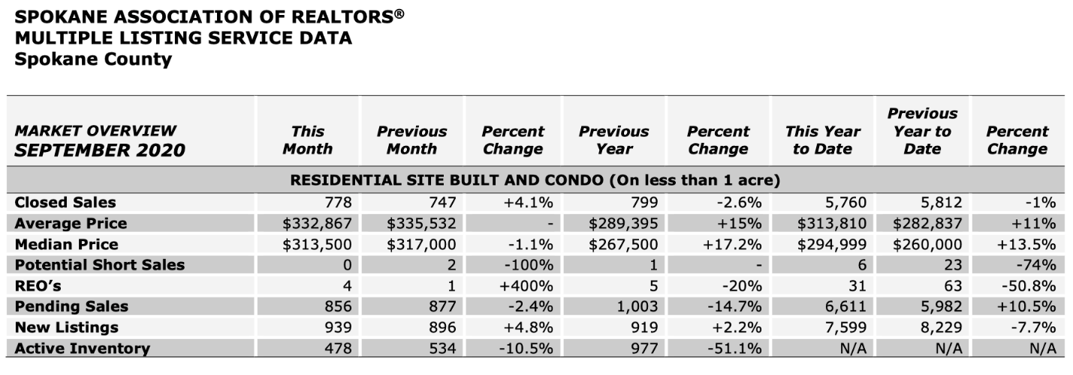

The above is an excerpt of the Spokane Association of REALTORS’® **September 2020** Residential Market Activity Report. Access to the full report each month is a benefit of your association membership. See the full report online here (after you log in to the member portal): [**https://www.spokanerealtor.com/mls/market-activity-mls-statistics**](https://www.spokanerealtor.com/mls/market-activity-mls-statistics)

**SEPTEMBER LOCKBOX STATISTICS**

