**MAY 2021**

**LOCAL REAL ESTATE PRICES SET RECORD**

*Spokane County's median-home price broke records again in April as it soared to a historic high of $356,500.*

*The April average-home price represents a 27.3% increase over the mark for April 2020, which was $280,091, according to data provided from the Spokane Association of Realtors.*

*The new median closing price also came in higher than March, which was $341,750.*

*While the median home price has continued to climb as a result of demand outpacing the number of available properties, it remains below the western region's median home price, which includes larger metro areas, such as Los Angeles, Seattle and Las Vegas.*

*The median price in the West was $493,300 in March, according to the National Association of Realtors. April data is not yet available.*



Read the full article in ***The Spokesman-Review***, [online here](https://www.spokesman.com/stories/2021/may/08/spokane-countys-median-home-price-reaches-record-h/).

**AMERICA’S HOTTEST HOUSING MARKET**

REALTOR.COM® and the Wall Street Journal (both owned by News Corp) are out with a new ranking of the Top Real Estate Markets of 2021.

Two Inland Northwest cities are in the top five:

**1 - Coeur d'Alene, ID**

2 - Austin, TX

3 - Springfield, OH

4 - Billings, MT

**5 - Spokane, WA**

*The top markets are a mix of higher-end, outdoorsy, resort areas; smaller cities that have been growing at a breakneck pace; and places that provide a more affordable alternative to larger urban areas that are still just barely within commuting distance.*

Read more about the new rankings [**online here**](https://www.realtor.com/news/trends/2021-these-are-emerging-as-the-new-top-10-real-estate-markets/).

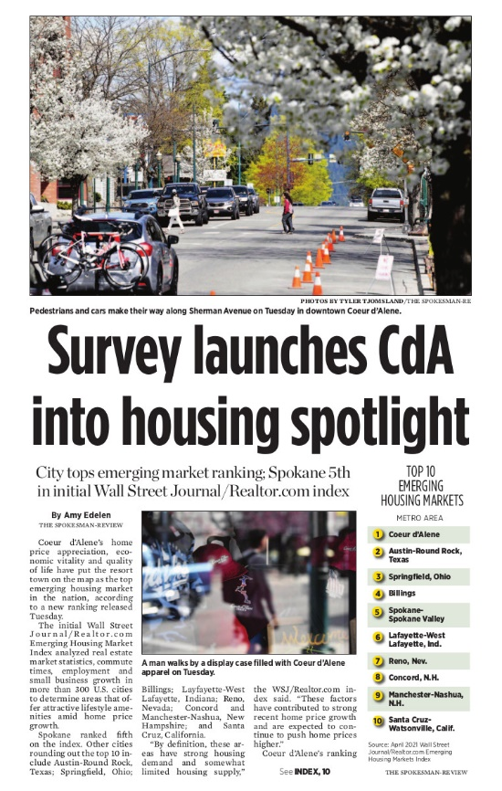

***The Spokesman-Review***  reported this story the day it happened. You can read its local article [**online here**](https://www.spokesman.com/stories/2021/apr/28/wall-street-journalrealtorcom-names-coeur-dalene-t/).

**MAJOR WINS ON 2120 PRIORITIES**



The Washington State Legislature adjourned its 2021 session on the evening of Sunday, April 26th.

This was the first-ever fully virtual session in Washington State history.

Still, the Washington REALTORS® lobbying and volunteer leadership team reports major wins on both of its session priorities:

1. Minimize tax impacts to REALTORS® and their clients, and
2. Help increase inventory of homes and condos.

Read the Washington REALTORS® 2021 Legislative Session Recap [**online here**](https://files.constantcontact.com/4fd76739001/a902c5ca-81d7-42c8-8f4e-6c33573062d7.pdf).

**BUYER/SELLER GUIDES**



The Spokesman-Review published two special real estate inserts in its Wednesday newspaper, last week - one with buyer content, one with seller content.

The SAR Communications Committee served as a focus group for the newspaper this past spring, offering ideas and suggestions for story ideas from their collective experience in the field as working brokers.

The SAR has a limited quantity of printed copies available for members - please call ahead to arrange pick-up since the building remains closed by the state pandemic shutdown.  326-9222

Electronic copies are available below:

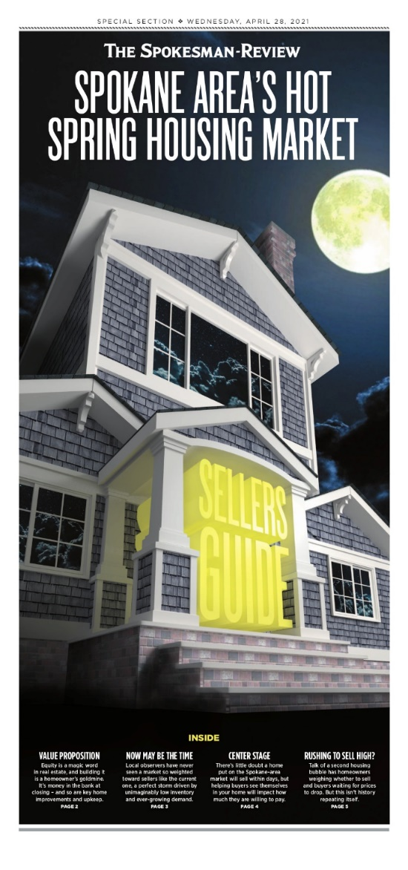

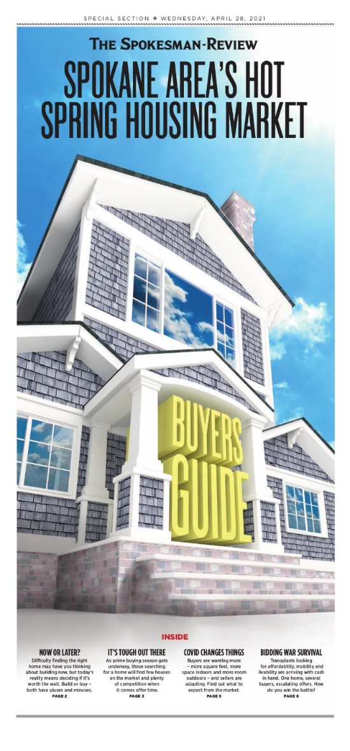

The Buyer's Guide (pictured left, above) is [**online here**](https://www.spokanerealtor.com/wp-content/uploads/2021/04/Spokesman-Review_20210428_EBuyersGuide.pdf).

The Seller's Guide (pictured right, above) is [**online here**](https://www.spokanerealtor.com/wp-content/uploads/2021/04/Spokesman-Review_20210428_TSellersGuide.pdf).

**VIRTUAL LEGAL SYMPOSIUM**



**May 25-26**

Washington REALTORS® is excited to bring another quality education symposium featuring seven industry lawyers presenting on current events in real estate.

The lawyers will cover recent RLTA Amendments by the Legislature, the latest forms revisions, "Crazy Things in Crazy Markets," and more.

Up to 7.5 clock hours are available, depending on attendance.

[](https://www.warealtor.org/education/symposiums/legal-symposium)

**BROKER RISK REDUCTION**



**Hot Topics in Broker Risk Reduction**

**Katie Johnson, General Counsel and Chief Member Experience Officer**

[kjohnson@nar.realtor](mailto:kjohnson@nar.realtor)

May 2021

Please take some time to review the hot topics from NAR General Counsel.  The link to this page addresses the following hot topics with Risk Reduction Tips, Resources, and Updates:

* Multiple Offers
* Fair Housing
* ADA Website Accessibility
* TCPA & DNC:  Texting and Calling
* COVID-19
* Wire Fraud
* Clear Cooperation Policy Litigation
* Class Action Antitrust Litigation
* DOJ Action and Settlement

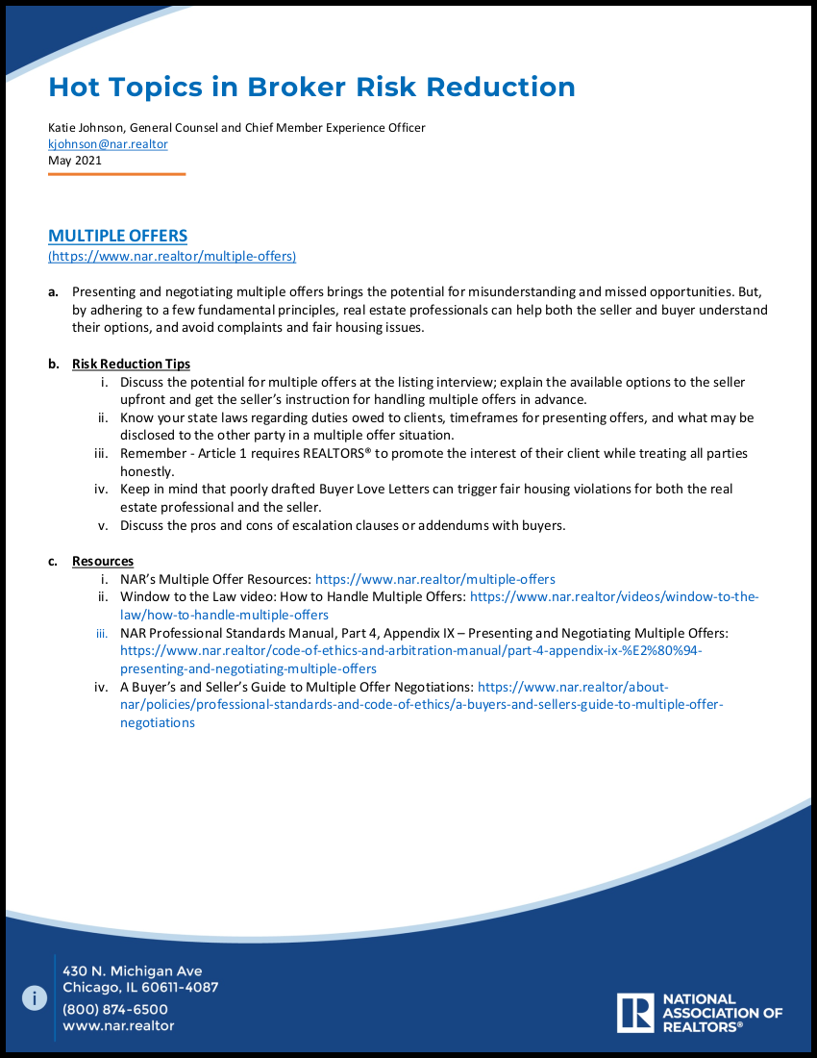

[**Read this document online or download a copy here**](https://cdn.nar.realtor/sites/default/files/documents/2021-05-07-Hot-Topics-in-Broker-Risk-Reduction-May-2021.pdf)

**2021 FAIR HOUSING CONFERENCE**

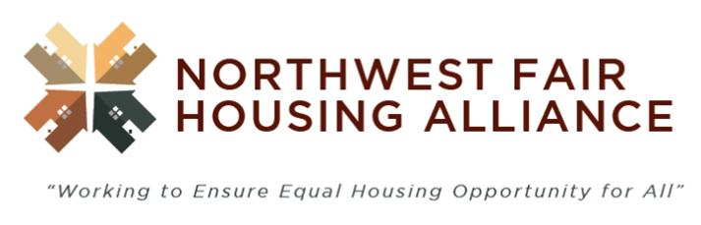

**May 20 & 27**

The Northwest Fair Housing Alliance will hold a virtual housing conference, 8:30 a.m.-1:30 p.m. **Thursday May 20**, and 8:30-11:30 a.m. **Thursday, May 27**, online.

On the first day of the conference, guests will learn about protecting immigrant and refugee neighbors from discrimination, housing justice for formerly incarcerated people, and supporting vulnerable and underserved populations in accessing and maintaining housing.

The conference is free to attend.

See the entire schedule and register [**online here**](https://www.eventbrite.com/e/2021-inland-northwest-fair-housing-virtual-conference-housing-justice-tickets-149775413293).

**Special SAR event!**

**5:30 p.m.; Thursday, May 27th**

Join the session on **Equitable Home-ownership Opportunities** presented by the Spokane Association of REALTORS® at the 2021 Inland Northwest Housing Virtual Conference online here:

[](https://us02web.zoom.us/webinar/register/WN_88oVl5lLQF-b6EPFMI09XQ)

**PERSONAL INVITATION TO VISIT FAIRHAVEN**

Fairhaven is a virtual place, but the lessons you learn there can make a real difference in your business.

The platform takes real estate professionals to the fictional town of Fairhaven, where agents work to close four deals while confronting situations in which discrimination is a factor.

As agents advance through the simulation, they receive feedback on their performance that they can use in real-life situations.

The course takes 60 to 100 minutes to complete and can be paused or retaken, as necessary.

Visit Fairhaven now:

[**https://fairhaven.realtor/**](https://fairhaven.realtor/)

See long-time SAR member **Terry Sullivan's** personal invitation to visit Fairhaven in this two-minute video, online here:

[](https://youtu.be/7w4thpSGlmQ)

|  |
| --- |
|  |

**DATA ACCURACY IMPORTANT**

**HERE ARE THE MOST COMMON ERRORS REPORTED ON LISTINGS IN THE MLS IN 2021 THROUGH APRIL**

Everyone benefits by having accurate, timely and objective property information in the MLS. Your listings are also going to public websites (i.e. company websites, realtor.com, etc.) and if incorrect data is input into the MLS, the incorrect information is going out to the public.

The following information should be double checked to assure correct information:

* Area/Grid. Many times the area is input for the grid number. The result can be a valley property showing up on the north side. Please be sure to double check your grid number. Grid 000 is an actual grid, so don’t put that in if you are unsure of the grid number. (60 reported in 2021)
* Public remarks are only to be used to describe the physical traits of the property. Contact information or websites of any kind belong in the Agent remarks only. (28 reported in 2021)
* Make sure all status changes are reported by the next business day. Contingencies must be reported even if the property is still being marketed. A contingent status is an active status. (20 reported in 2021)
* Address incorrect. Town, county or zip code incorrect. (16 reported in 2021)
* All listings must have an Exhibit A uploaded by the next business day after input. (13 reported in 2021)
* Releasing a property and relisting it within 30 days. (13 reported in 2021)
* Map not showing property in correct location. (7 reported in 2021)
* Primary photo on improved properties (excluding new construction) must be the exterior of the structure. This means that condominiums must have a primary photo of the building (not a sign out front, picture of the view or the living room). (5 reported in 2021)
* Sub-Type of property. Condos and manufactured homes are sometimes mistakenly listed as a residential site built property. (3 reported in 2021)
* Style of construction. A manufactured home is not to be marked as a 1 story or a split level marked as a 2 story. (2 reported in 2021)

|  |
| --- |
| **2021 SAR REALTOR® Awards Nominations** |
| **NEW!**  **Deadline: June 1st**      Applications are now being accepted for all 2021 SAR REALTOR® Awards!    You and your REALTOR® colleagues will decide who will be our honorees for:    2021 REALTOR **®** of the Year  **Steve Flinn** REALTOR **®** Achievement  REALTOR **®** Community Service  Affiliate of the Year  Partner of the Year  Spokane's Citizen of the Year    **The deadline by which you must submit nominations to the SAR for them to be considered is Tuesday, June 1st.**  The nomination form is included in this newsletter.    The 2021 SAR REALTOR® Awards will be announced and presented at the SAR's Quarterly Meeting & Luncheon at Centerplace - **August 19th**.    More details to come**!** |

|  |
| --- |
| **2020 Gary Fox Memorial Award** |
| **NEW!**  **Deadline: June 1st**    Nominations are now being accepted for the **2020 Gary Fox Memorial Designated/Managing Broker Award**.    This award recognizes a Designated Broker or Managing Broker who serves as an example of loyalty, ethical behavior, and leadership in the real estate profession.    **The deadline to submit applications to the SAR is Tuesday, June 1st.**    The nomination form is included in this newsletter.      The 2020 Gary Fox Memorial Designated/Managing Broker Award honoree will be announced and presented at the SAR's Quarterly Meeting & Luncheon at Centerplace - August 19th.    More details to come**!** |

|  |
| --- |
| **2021 James S. Black Memorial Scholarship** |
| **NEW!**  **Deadline: June 1st**    Applications are now being accepted for the **2021 James S. Black Memorial Scholarship**.   This scholarship helps members pay for tuition and expenses leading to professional designations such as GRI, CRS, CPM, SIR, or MAI.  **The deadline to submit applications to the SAR is Tuesday, June 1st.**    The nomination form is included in this newsletter.      The 2021 James S. Black Memorial Scholarship will be announced and presentedat the SAR's Quarterly Meeting & Luncheon at Centerplace - **August 19th**.  More details soon! |

|  |
| --- |
| **2021 SAR Legacy of Service Award** |
| SAR-100-Badge      **NEW!**  **Deadline: June 1st**    Your SAR is now accepting nominations for its ***2021SAR Legacy of Service Award***.    This award is created as a "Lifetime Achievement" award to honor those REALTOR® members who are respected in our profession by colleagues and serve our profession through various Association committees.    Additionally, this award honors those who spend the majority of their years as active REALTORS® mentoring newer members, helping to define regulations within our field, all the while giving back to the community.    **The deadline to submit nominations to the SAR is Tuesday, June 1st.**    The nomination form is included in this newsletter.      The ***2021 SAR Legacy of Service Award*** will be presented at the SAR's Quarterly Meeting & Luncheon at Centerplace - **August 19th**.     We'll have more details to share soon! |

**LUAU ON THE BLUFF**



**Thursday, June 3**

**First Live Gathering of 2021!**

REMEMBER:  
Social distancing and wear your face mask.


**Thank you to our Sponsors:**

**Banner Bank**

**Condron Homes**

**Flagstar Bank**

**Spokane County Title**

**Spokane Teachers Credit Union**

**Synergy One Lending**

The SAR proudly presents the **Luau on the Bluff** - our first live REALTOR® event of 2021!

[](https://www.eventbrite.com/e/sar-luau-on-the-bluff-tickets-153550065379)The evening will include some great Pacific Island-inspired food, live music, silent auction, door prizes, a "best-dressed" contest, and a gorgeous sunset view of the valley! Proceeds from our event will be going to Family Promise of Spokane.

Tickets $35 through May 26th; or at the door on June 3rd - $50.

**APRIL MARKET STATISTICS**

Close sales of single-family homes on less than one acre including condominiums totaled 612 for April 2021. That number is up 20.5% compared to April 2020 when 508 closed sales were reported. The average closed sales price for this April was $392,566 up $29.3% from April last year. The median closed sales price was $356,500 up 27.3% over April 2020 when the median closed sales price was $280,091.

Year to date closed sales through April 2021 total 2,106 up 3.7% over the closed sales through April 2020 which was 2,030. The year-to-date average closed sales price is $368,100 through April, up 24.3% compared to last year when the average closed sales price was $296,098. The median closed sales price through April is up 21.2%, $335,000 v. $276,294.

Inventory as of this report remains tight at 188 single family homes including condominiums on the market. Last year at this time inventory totaled approximately 602 properties. New construction sales are up 2.8% compared to last year, 331 v. 322.

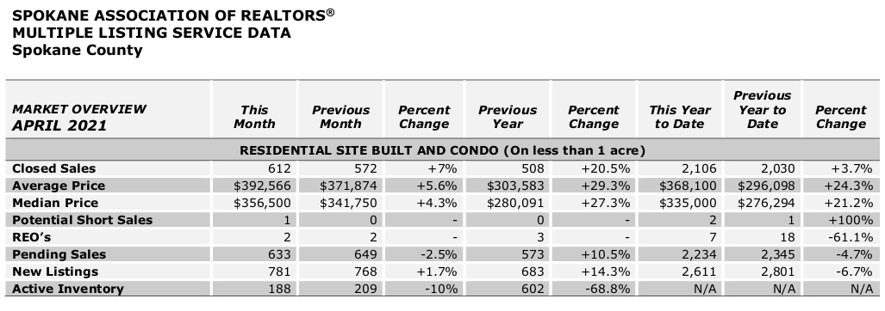

The above is an excerpt of the Spokane Association of REALTORS’® **April 2021** Residential Market Activity Report. Access to the full report each month is a benefit of your association membership. See the full report online here (after you log in to the member portal): [**https://www.spokanerealtor.com/mls/market-activity-mls-statistics**](https://www.spokanerealtor.com/mls/market-activity-mls-statistics)

**APRIL LOCKBOX STATISTICS**





