**JUNE 2021**



**Thursday, July 15th**

**Down River Golf Course**

The annual SAR Golf Tournament is coming soon!

Teams of four will shotgun start at 7:30 a.m. on **Thursday, July 15th**, at Down River Golf Course.

First-come, first-served - enter today!



The event flyer (pictured) is included with this newsletter.

**MEDIAN HOME PRICE SURGES**

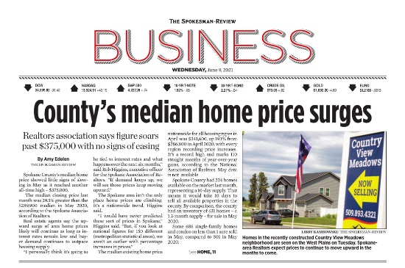

*Spokane County's median home price showed little signs of slowing in May as it reached another all-time high - $375,000.*

*The median closing price last month was 29.5% greater than the $289,900 median in May 2020, according to the Spokane Association of Realtors.*

*Real estate agents say the upward surge of area home prices likely will continue as long as interest rates remain low and buyer demand continues to outpace housing supply.*



 Read the entire article in Wednesday's edition of ***The Spokesman-Review*** (pictured above), [**online here**](https://www.spokesman.com/stories/2021/jun/08/spokane-countys-median-home-price-continues-record/).

**PROPERTY VALUES JUMP 12.6%**

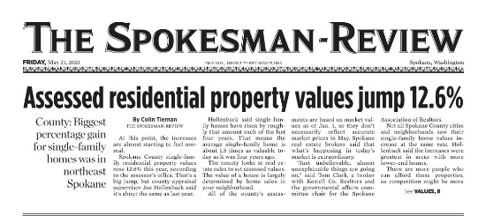

*At this point, the increases are almost starting to feel normal.*

*Spokane County single-family residential property values rose 12.6% this year, according to the assessor's office.*

*That's a big jump, but county appraisal supervisor Joe Hollenback said it's about the same as last year.*

*Hollenback said single-family homes have risen by roughly that amount each of the last four years.*

*That means the average single-family home is about 1.5 times as valuable today as it was four years ago.*

Read the entire article in ***The Spokesman-Review*** [**online here**](https://www.spokesman.com/stories/2021/may/21/single-family-home-assessed-values-up-126-in-spoka/).

**SAR AWARD DEADLINE EXTENDED**

The SAR Board of Directors, at its June meeting, extended the deadline for all SAR award nominations. **The new deadline is Friday, June 25th** – at the end of next week. The SAR awards offer acknowledgement of past performance and encouragement of future performance among members of your team and colleagues in our profession. Please take a few minutes to consider who you feel is worthy of recognition and submit your nominations today!

|  |
| --- |
| **2021 SAR REALTOR® Awards Nominations** |
| **Deadline: Friday, June 25th**      Applications are now being accepted for all 2021 SAR REALTOR® Awards!    You and your REALTOR® colleagues will decide who will be our honorees for:    2021 REALTOR **®** of the Year  **Steve Flinn** REALTOR **®** Achievement  REALTOR **®** Community Service  Affiliate of the Year  Partner of the Year  Spokane's Citizen of the Year    **The deadline by which you must submit nominations to the SAR for them to be considered is Friday, June 25th.**  The nomination form is included in this newsletter.    The 2021 SAR REALTOR® Awards will be announced and presented at the SAR's Quarterly Meeting & Luncheon at Centerplace - **August 19th**.    More details to come**!** |

|  |
| --- |
| **2020 Gary Fox Memorial Award** |
| **Deadline: Friday, June 25th**    Nominations are now being accepted for the **2020 Gary Fox Memorial Designated/Managing Broker Award**.    This award recognizes a Designated Broker or Managing Broker who serves as an example of loyalty, ethical behavior, and leadership in the real estate profession.    **The deadline to submit applications to the SAR is Friday, June 25th.**    The nomination form is included in this newsletter.      The 2020 Gary Fox Memorial Designated/Managing Broker Award honoree will be announced and presented at the SAR's Quarterly Meeting & Luncheon at Centerplace - August 19th.    More details to come**!** |

|  |
| --- |
| **2021 James S. Black Memorial Scholarship** |
| **Deadline: Friday, June 25th**    Applications are now being accepted for the **2021 James S. Black Memorial Scholarship**.   This scholarship helps members pay for tuition and expenses leading to professional designations such as GRI, CRS, CPM, SIR, or MAI.  **The deadline to submit applications to the SAR is Friday, June 25th.**    The nomination form is included in this newsletter.      The 2021 James S. Black Memorial Scholarship will be announced and presentedat the SAR's Quarterly Meeting & Luncheon at Centerplace - **August 19th**.  More details soon! |

|  |
| --- |
| **2021 SAR Legacy of Service Award** |
| SAR-100-Badge      **Deadline: Friday, June 25th**    Your SAR is now accepting nominations for its ***2021SAR Legacy of Service Award***.    This award is created as a "Lifetime Achievement" award to honor those REALTOR® members who are respected in our profession by colleagues and serve our profession through various Association committees.    Additionally, this award honors those who spend the majority of their years as active REALTORS® mentoring newer members, helping to define regulations within our field, all the while giving back to the community.    **The deadline to submit nominations to the SAR is Friday, June 25th.**    The nomination form is included in this newsletter.      The ***2021 SAR Legacy of Service Award*** will be presented at the SAR's Quarterly Meeting & Luncheon at Centerplace - **August 19th**.     We'll have more details to share soon! |

**RETIREMENT SUMMIT**

[](https://www.nar.realtor/center-for-realtor-financial-wellness/financial-wellness-live)

**Every Wednesday in July**

Are you set for retirement?

Each REALTOR® has a unique vision for retirement.

Proactive planning is the first step towards bringing that vision to life.

Register now to attend NAR's Center for REALTOR® Financial Wellness Retirement Summit, featuring Morgan Stanley® experts.

This four-part virtual series in **July** will help you shape your vision for retirement and develop steps to ensure your finances are set for the long-term.

Join **Mike Engel**, Institutional Consulting Director and Director of Corporate Retirement, and **Jim Phillips**, SVP Wealth Management Financial Advisor and Senior Investment Management Consultant, as they talk about retirement basics, tips for pre-retirees, and investment strategies for independent contractors.

The event consists of four one-hour webinars, every Wednesday in July.

The first session:

**Wednesday, July 7th, at 11 a.m.**

**Retirement Planning Basics**

**(Targeted for New Agents)**

Saving enough for a comfortable retirement is one of most people's greatest financial goals-and challenges. This session covers the basics, such as planning ahead, learning the essential tenets of investing and understanding popular retirement accounts.

[**Learn more online here.**](https://www.nar.realtor/center-for-realtor-financial-wellness/financial-wellness-live)

**MEMBER BENEFIT: TECH HELPLINE**



Slow computer?

Printing issues?

Smartphone questions?

The Tech Helpline is available through your membership and offers free unlimited computer help Monday through Friday, 9 a.m. - 5 p.m.

You're paying for this in your dues - you may as well get some value for it!

Toll free,[**online chat**](http://chat.techhelpline.com/), or [**email**](mailto:support@techhelpline.com).

You can get help with software, internet, hardware, and other tech tools and gadgets. Email [**support@techhelpline.com**](mailto:support@techhelpline.com) (have your NRDS ID handy) or call **1-866-610-8939**.

NAR: UPDATED DRONE RULES



Updated FAA rules expand the legal operational capabilities of drones and provide flexibility for operators who use them in their businesses, including real estate professionals.

Learn about these new rules and get tips for contracting with a drone photographer in this video.

See the new four-minute video online here:

[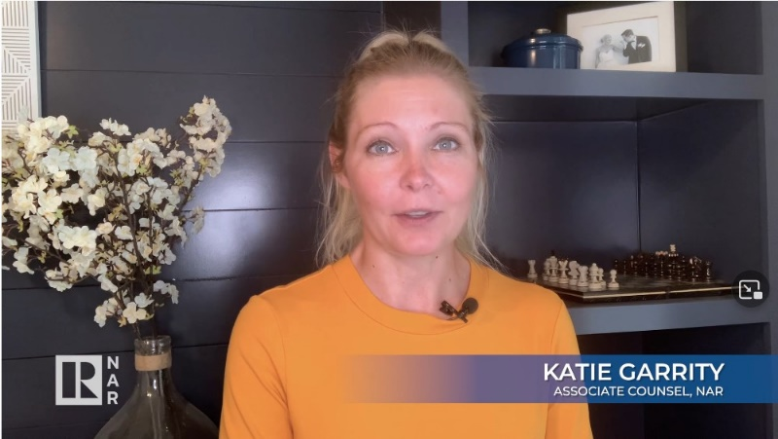](https://www.nar.realtor/window-to-the-law/rules-expand-options-for-drone-photography)

**MAY MARKET STATISTICS**

Closed sales of single-family homes on less than one acre, including condominiums, totaled 686 for May 2021. May’s closed sales are up 36.9% compared to May last year. The sales figures for last year reflect purchases during the first couple of months of the pandemic. The average closed sales price for May 2021 was $407,343 up 31.7% from the May 2020 average closed sales price of $309,303. The median closed sales price for May was $375,500 up 29.5% from last May when the median closed sales price was $289,900.

Year-to-date closed sales through May 2021 total 2,822 up 10% over the closed sales through May 2020 of 2,565. The year-to-date average closed sales price through May is $377,582 an increase of 26.5% over last year’s average closed sales through May of $298,564. The median closed sales price through May 2021 is up 23.3%, $345,152 v. $279,900.

Inventory is up slightly from last month. As of this report 224 single family homes on less than one acre, including condominiums, were on the market. Last year as of the May report 631 properties were on the market. New construction sales reported to the SAR/MLS jumped 76% compared to May last year. Year-to-date through May new construction sales are up 11.6%.



The above is an excerpt of the Spokane Association of REALTORS’® **May 2021** Residential Market Activity Report. Access to the full report each month is a benefit of your association membership. See the full report online here (after you log in to the member portal): [**https://www.spokanerealtor.com/mls/market-activity-mls-statistics**](https://www.spokanerealtor.com/mls/market-activity-mls-statistics)

**MAY LOCKBOX STATISTICS**





