**JANUARY 2020**

**WASHINGTON REALTORS® HILL DAY – NEXT WEEK!**

**January 18-21**

**Support Housing Solutions for Washington**

The Washington REALTORS® 2021 Hill Day is next week - virtual, of course, so that means it’s easier than ever to attend!

2021 SAR President **Eric Johnson** and 2021 SAR Governmental Affairs Chair **Tom Clark** are here with a personal invitation in this one-minute video:

|  |
| --- |
| [2021 Washington REALTORS® Hill Day](https://youtu.be/_HmC0gennXc) |
| **2021 Washington REALTORS® Hill Day** |

[](https://www.warealtor.org/events/legislative-day)

We need REALTORS® from across the state to participate in this year's "**My Neighbor**" campaign, and virtually lobby your State Legislators about:

* Removing racial covenants
* Incentivizing cities to build more attainable housing
* Ensure Accessory Dwelling Units are an available housing tool in our rural areas



The SAR Governmental Affairs Committee has prepared a briefing paper for SAR Members on this year's state legislative session.

You'll find that [**online here**](https://www.spokanerealtor.com/govt-affairs-brief/2021-leg-update/).



Get your copy of the Washington REALTORS® First Time Attendee booklet for Hill Day (pictured above) [**online here**](https://files.constantcontact.com/4fd76739001/3a03c345-83f7-476a-9d1b-4d8732056b13.pdf).



[**Click here to learn more about the Washington REALTORS® Day on the Hill, the issues we are championing, and ways you can virtually lobby your State Legislators.**](https://www.warealtor.org/events/legislative-day)

**WASHINGTON REALTORS VIRTUAL INSTALLATION**

**January 20th**

Spokane Broker **Tom Hormel** will be installed as the 86th president of Washington REALTORS®, next week - **January 20th at 4:00 p.m.**

Tom is the first WR president from Spokane in 15 years, and the first to be installed virtually in the 86-year history of the association.

Attend the virtual installation event for 2021 Washington REALTORS® President **Tom Hormel** (an SAR member), 2021 Washington REALTORS® Vice President for Governmental Affairs **Eric Johnson** (an SAR member), 2021 Washington REALTORS® Vice President-elect Membership **Ken Sax** (an SAR member), and the new members of our Washington REALTORS® Board of Directors.



**The virtual installation event will take place at 4:00 p.m. Wednesday, January 20th, on Zoom as part of the Washington REALTORS® Hill Day events.**

**The event program (pictured) is included among the attachments to this newsletter.**

**Attendance is free but you must register for credentials to access the live video feed.**

[](https://www.warealtor.org/events/legislative-day)

**M1 TO REPLACE NRDS**

NAR will launch M1 (Members First) at the end of this month, replacing NRDS (National REALTOR® Database System).

This change is being made to make sure the member data used by their local associations, state associations, and national association is the most up to date and accurate information.

As part of this process, NAR will send email verifications to its 1.4 million active REALTOR®/REALTOR® Associates currently included in NRDS. These emails will be sent in batches of 100,000 per day, beginning **January 22**, and take approximately two weeks to send them all.

Please alert your team members of this coming change **and let them know this is not a scam**.

When you get your email verification:

The Sender will be: National Association of REALTORS® [verifyemail@nar.realtor](mailto:verifyemail@nar.realtor)

The Subject of the Email will be: Please confirm your email address for the National Association of REALTORS®.

**MEDIAN HOME PRICE JUMPS 15.3%**

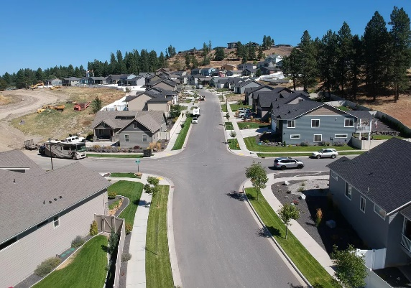

|  |
| --- |
|  |

*Despite a global pandemic, Spokane County's housing market shattered records in 2020 as low inventory and high demand caused the median home price to soar to its highest level in history - issues that likely will have a continuing impact through this year.*

Read the complete article in ***The Spokesman-Review***, [**online here**](https://www.spokesman.com/stories/2021/jan/12/it-performed-better-than-we-thought-spokane-county/).

**DATA ACCURACY IMPORTANT**

**HERE ARE THE MOST COMMON ERRORS REPORTED ON LISTINGS IN THE MLS IN 2020**

Everyone benefits by having accurate, timely and objective property information in the MLS. Your listings are also going to public websites (i.e. company websites, realtor.com, etc.) and if incorrect data is input into the MLS, the incorrect information is going out to the public.

The following information should be double checked to assure correct information:

* Area/Grid. Many times the area is input for the grid number. The result can be a valley property showing up on the north side. Please be sure to double check your grid number. Grid 000 is an actual grid, so don’t put that in if you are unsure of the grid number. (201 reported in 2020)
* Make sure all status changes are reported by the next business day. Contingencies must be reported even if the property is still being marketed. A contingent status is an active status. (149 reported in 2020)
* Public remarks are only to be used to describe the physical traits of the property. Contact information or websites of any kind belong in the Agent remarks only. (109 reported in 2020)
* All listings must have an Exhibit A uploaded by the next business day after input. (56 reported in 2020)
* Address incorrect. Town, county or zip code incorrect. (48 reported in 2020)
* Primary photo on improved properties (excluding new construction) must be the exterior of the structure. This means that condominiums must have a primary photo of the building (not a sign out front, picture of the view or the living room). (28 reported in 2020)
* Sub-Type of property. Condos and manufactured homes are sometimes mistakenly listed as a residential site built property. (28 reported in 2020)
* Active/No Show listings must have the date that showings will be available in the Agent Remarks. (21 reported in 2020)
* Marketing a property that is not listed in the MLS and does not have an MLS Exempt Listing form on file with the MLS office (21 reported in 2020)
* Style of construction. A manufactured home is not to be marked as a 1 story or a split level marked as a 2 story. (8 reported in 2020)
* Virtual Tour links must go directly to the virtual tour of the property. (1 reported in 2020)
* Branded virtual tours must not be put in the Virtual Tour – Non-Branded field.
* If a Form 22B has been completed, the status needs to be Contingent–Bump Clause (CTGB) instead of Pending–Inspection (PNDI). If a Form 22SS has been completed, the status needs to be Contingent–Short Sale (CTGS) instead of Pending–Inspection (PNDI).

**SAR BEGINS 2021 WITH NEW LEADERSHIP**



The **2021 SAR Leadership Directory** (pictured) is included as an attachment to this newsletter.

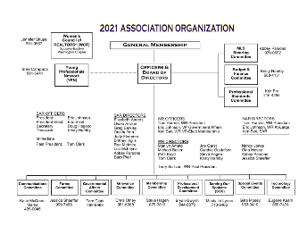

The **2021 SAR Leadership Chart** (pictured) is included as an attachment to this newsletter.

**DECEMBER MARKET STATISTICS**

The residential activity remained strong. 727 residential closed sales on less than one acre, including condominiums, were reported for December 2020. Compared to December 2019 sales are up 6.7%, 727 v. 681. The average closed sales price was $337,961 up 17.1% from December last year when the average closed sales price was $288,527. The median closed sales price for this December was $315,000 up 22.8% from the median closed sales price of $256,500 for December 2019.

Our year end residential closed sales are up 2.2% from 2019, 8,150 v. 7,976. Our 2020 average closed sales price comes in at $321,347 up 13.3% from the closed sales price for 2019 of $283,540. The year-end median closed sales price was right at $300,000, up 15.4% from last year’s median closed sales price of $260,000.

Inventory continues to be at record lows. Seems like we have seen saying this all year. As of this report, our inventory of single-family homes on the market was 236 properties. This is less than a two-week supply. New construction sales finished the year up 18.3%, 1,085 v. 917.



The above is an excerpt of the Spokane Association of REALTORS’® **December 2020** Residential Market Activity Report. Access to the full report each month is a benefit of your association membership. See the full report online here (after you log in to the member portal): [**https://www.spokanerealtor.com/mls/market-activity-mls-statistics**](https://www.spokanerealtor.com/mls/market-activity-mls-statistics)

**DECEMBER LOCKBOX STATISTICS**



