**FEBRUARY 2021**

**MARCH 3rd FORMS REVISIONS**

**This newsletter includes important information about upcoming forms changes, including: Legal Bulletin, Samples of Revised Forms, & Forms Update Classes.**

**Please read through this information carefully and be in touch with your SAR if you have any questions.**  
  
There are many NWMLS/Statewide forms being revised and several new forms that are being released on **March 3, 2021**. There are significant revisions to the Purchase and Sale Agreements, the Financing Addendum, the Inspection Addendum, and the Escalation Addendum. Other forms revisions are not substantive and include minor clarifications and updates to outdated vernacular.    
  
Legal Bulletin 219, which summarizes the forms revisions, and SAMPLE versions of the revised forms are linked below for review purposes – in both clean and redline formats:

* [**Legal Bulletin 219**](http://members.nwmls.com/library/content/legalbulletins/Legal%20Bulletin%20219%20-%202021%20Forms%20Revisions.pdf)
* [**Revised forms - redline format**](http://members.nwmls.com/library/content/legalbulletins/NWMLS_FormsRevision_Redlines_321%20(002).pdf)
* [**Sample Revised Forms – clean format**](http://members.nwmls.com/library/content/legalbulletins/NWMLS_RevisedForms_321.pdf)
* [**Sample New Forms – clean format**](http://members.nwmls.com/library/content/legalbulletins/NWMLS_NewForms_321.pdf)

Many forms will be available for order in hard copy from NWMLS on February 23, 2021 - please allow extra time for printing and shipping. The forms will be published for use on TransactionDesk on **March 3, 2021**.

**FORMS CLASSES**

****Washington REALTORS® is offering a series of online, interactive classes with our Legal Hotline lawyer that will go over what you need to know for the new 2021 forms revisions.

Forms revisions will be published for use by members on **March 3rd** so register today!

Upcoming Dates for this class: **February 16, February 19, February 23, February 25, March 1, March 2, March 4, March 9, March 11.**

3.0 clock hours

**Some dates are already full; more classes are being added. Register now for best choice!**

[](https://warealtorportal.ramcoams.net/Education/History/Classes.aspx?selmenid=men2&_cldee=dG9tQHNwb2thbmVyZWFsdG9yLmNvbQ%253d%253d&recipientid=contact-d6629aa847db4f7bbb0eb4a0fe07ed4a-27658cc6e91440f2a392c1637cc9869d&utm_source=ClickDimensions&utm_medium=email&utm_campaign=Get%2520the%2520Facts%25202016&esid=1e757b92-076b-eb11-9c4e-00155d0079cd)

**SPOKANE REGIONAL HOUSING NEEDS SUMMIT**



**THIS WEEK!**

**Wednesday, February 17th, 1 p.m.**

Join us for an in-depth conversation about housing needs and challenges in the Spokane area with local, regional, and national experts.

***Spokane Region Housing Needs Summit 2021*** will be held online **Wednesday, February 17th, at 1 p.m.**, convened by your Spokane Association of REALTORS®.

Attend this important program and take away a market-based needs assessment for the Spokane region.

Find more information and a registration link online here:

[](https://www.spokanerealtor.com/spokane-summit-2021/)

**SPOKANE COUNTY EASES TO PHASE 2**

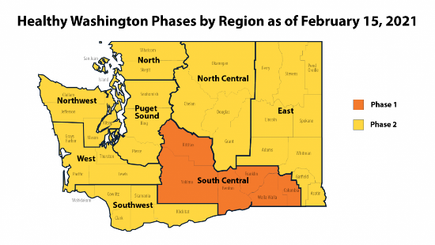Governor **Jay Inslee**, last week, eased the East Region (Spokane County) to Phase 2 - effective Sunday (2/14).

[**Read the governor's news release online here.**](https://www.governor.wa.gov/news-media/inslee-announces-five-regions-progress-phase-2)

 

Governor Jay Inslee on Twitter 2/11:

*Those regions progressing will be able to do so starting Sun., Feb. 14. This creates more options for restaurants to make Valentine's Day special for couples who hoped they could have a night out. (And if it's a first date that doesn't go well, remind them to stay 6 feet away).*

Opening indoor dining, museums, and concert halls is the biggest change, though these will be limited to 25% capacity.

Limited, in-person open houses are now be permitted.

Brokers must ensure that no more than ten (10) people are on site, including the broker, and that all other required protocols are followed (face coverings, social distancing, sanitation, etc.).

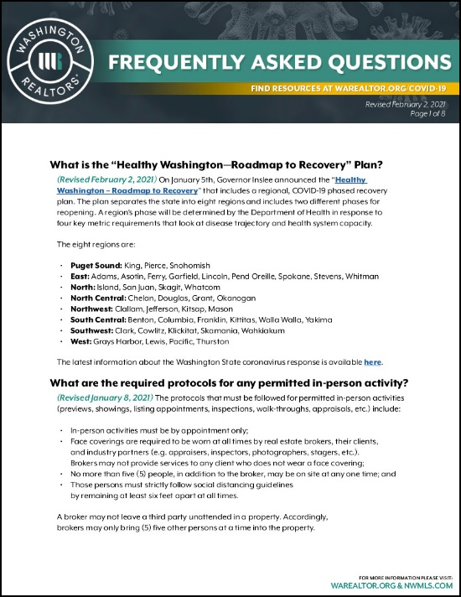

For clarification on which real estate activities are now permitted, and the protocols required for permitted activities, please consult the new **WR FAQ - REVISED FEBRUARY 2** document, included with this newsletter.

**INVENTORY AT ALL-TIME LOW**

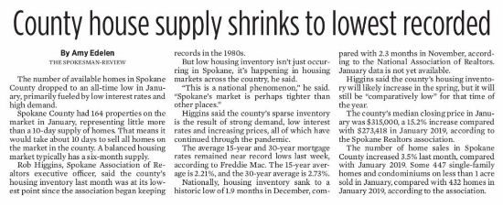*The number of available homes in Spokane County dropped to an all-time low in January, primarily fueled by low interest rates and high demand.*

*Spokane County had 164 properties on the market in January, representing little more than a 10-day supply of homes. That means it would take about 10 days to sell all homes on the market in the county. A balanced housing market typically has a six-month supply.*

*Rob Higgins, Spokane Association of Realtors executive officer, said the county's housing inventory last month was at its lowest point since the association began keeping records in the 1980s.*



Read the entire article in ***The Spokesman-Review***, [**online here**](https://www.spokesman.com/stories/2021/feb/10/spokane-countys-housing-inventory-shrinks-to-histo/).

**WCR: DIVERSITY AND INCLUSION**



The Women's Council of REALTORS® Spokane-Eastern Washington convened a terrific and valuable program, this month: ***Diversity and Inclusion - Fair Housing for All.***

This four-member panel puts you in the middle of a discussion on two of the most important words in your business today.

Panel members and guests connected virtually from St. Louis, Chicago, Seattle, and Spokane.

The video from the event is online here:

[**https://youtu.be/xzmDxI9Bam0**](https://youtu.be/xzmDxI9Bam0)

**2021 REALTOR® CODE OF ETHICS**

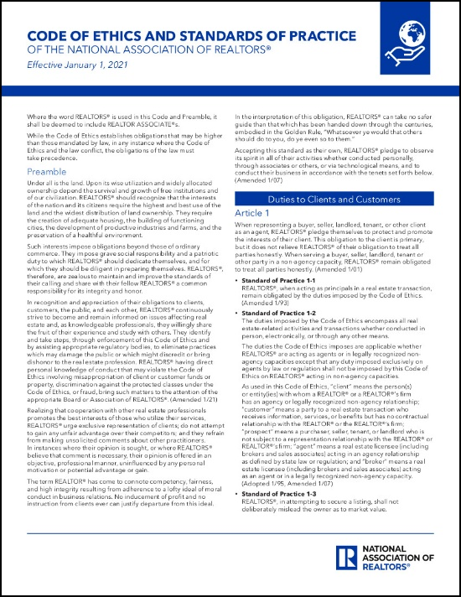"Under all is the land."

Do you recognize that sentence opens our Code of Ethics?

"The Code," as it's often called, is newly updated for 2021 - adding the Code of Ethics' applicability to discriminatory speech and conduct.

Download your copy of the **2021 National Association of REALTORS® Code of Ethics and Standards of Practice** (pictured above) [**online here**](https://files.constantcontact.com/4fd76739001/d96a6a06-01b3-4c0b-abaa-8171c169de65.pdf).

The deadline for staying current with your Code of Ethics requirement in the current cycle is **December 31st** - the end of this year.

Check your status and sign up for virtual Code classes [**online here**](https://www.nar.realtor/about-nar/governing-documents/code-of-ethics/code-of-ethics-training).

**COMMIT TO C2EX TODAY!**



Have you made the REALTORS® Commitment to Excellence?

Commitment to Excellence (C2EX) from the National Association of REALTORS® empowers REALTORS® to evaluate, enhance and showcase their highest levels of professionalism.

It's not a course, class or designation - it's an Endorsement that REALTORS® can promote when serving clients and other REALTORS®.

We are very proud to announce that there are now over 50,000 members participating in the program!

You can commit, too!

Visit the C2EX website to learn more [**online here**](https://www.c2ex.realtor/).

**RPR: REDESIGNED, REORGANIZED, AND REFRESHED FOR YOUR SUCESS COMING FEBRUARY 23RD**



RPR has some exciting news for REALTORS® … In two short weeks, we’ll unveil our biggest product update ever!

Based on input from REALTORS® like you, we’re launching a refreshed version of the RPR website. It will soon feature a cleaner, eye-pleasing look and feel, while also offering an easier and more intuitive user experience.

We’re confident that you’re going to love it! And in no time you’ll be using it to build your business, “wow” your clients and close more deals.

We’re also pretty sure you don’t just want to read about it… Watch this quick video to get a sneak peek at the newly redesigned RPR: [**https://youtu.be/MXCMv_kdZqM**](https://youtu.be/MXCMv_kdZqM)

Read more about the redesigned, reorganized and refreshed RPR and sign up for a preview webinar online here: [**http://blog.narrpr.com/news/rpr-refresh/**](http://blog.narrpr.com/news/rpr-refresh/)

**JANUARY MARKET STATISTICS**

447 closed sales of single-family homes on less than one acre, including condominiums were reported for January 2021. This number is up 3.5% compared to January 2020 when 432 closed sales were reported. The average sales price for January was $347,475 up 21.5% compared to January last year when the average sales price was $285,887. The median sales price was up 15.2%, $315,000 this January compared to $273,418 for January 2020.

These numbers also reflect year to date totals.

Inventory continues to be at record low levels. As of this report inventory of single-family homes on less than one acre, including condominiums total 164 properties, less than a two-week supply. New construction reported closed sales for January total 59 compared to 72 last January.



The above is an excerpt of the Spokane Association of REALTORS’® **January 2021** Residential Market Activity Report. Access to the full report each month is a benefit of your association membership. See the full report online here (after you log in to the member portal): [**https://www.spokanerealtor.com/mls/market-activity-mls-statistics**](https://www.spokanerealtor.com/mls/market-activity-mls-statistics)

**JANUARY LOCKBOX STATISTICS**





