**DECEMBER 2020**

|  |
| --- |
| **Dear SAR Managing Broker:** THANK YOU for the privilege of serving as your association president this year – the 109th in our organization’s history. We’ll remember this as the year of the global pandemic, to be sure – an event that will continue well into next year – but we should also remember this as the year of resilience. We could have taken the governor’s declaration in March that REALTORS® were “non-essential” sitting down, but we stood up and used our collective voice in Olympia to re-assert that home ownership is essential; we could have gone through the year disconnected from one another as our traditional voices were silenced, but we found new voices and stayed connected via the President’s Roundtable, virtual classes, virtual committee meetings, and the first virtual SAR Annual Meeting and REALTOR® Awards ceremony in our history. To put it simply, I am proud of us and what we accomplished together this year. I hope you are, too.  Warmly,  **Tom Clark**, 2020 President  Spokane Association of REALTORS® |

**REMINDER:**

**The SAR Offices are open by "appointment only" under government order through, at least, January 4th. Please call in advance so arrangements can be made to accommodate your request.**

(509) 326-9222

[**front@spokanerealtor.com**](mailto:front@spokanerealtor.com)

**SPOKANE MAKES TOP TEN LIST**

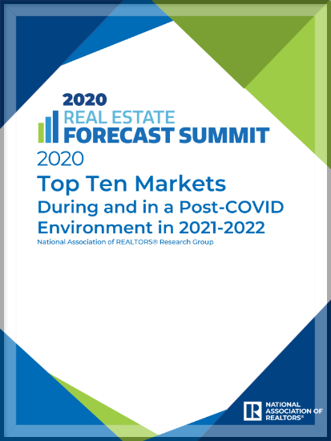

NAR, last week, named Spokane-Spokane Valley to its 10 markets that have shown resilience during this pandemic period and are expected to perform well in a post-COVID-19 environment in the next two years.

A copy of the report (pictured) is included in this newsletter.

The release of this report was covered in an article in Sunday's edition of ***The Spokesman-Review*** reported on the release of this report in its Sunday’s edition – typically the largest circulation of the week.

Read it [**online here**](https://www.spokesman.com/stories/2020/oct/11/spokanes-housing-market-to-remain-competitive-this/).

**SHUTDOWN TO CONTINUE THROUGH AT LEAST JANUARY 4TH**

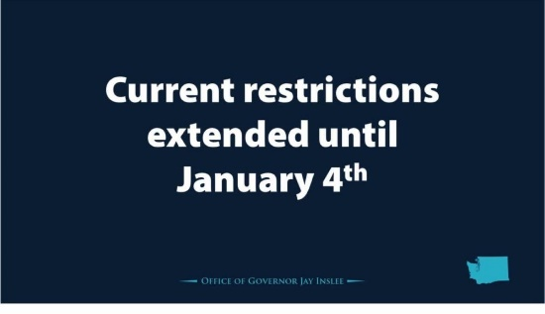

Governor Inslee has announced a **three-week extension through January 4th** of the November 16th restrictions put in place to curb the surge in new COVID-19 cases.

As a reminder, these restrictions impact real estate in the following ways:

* All real estate open houses are suspended.
* Professional services should work from home. If you are unable to work from home, those services will be limited to 25% of building occupancy and closed to the general public.
* Please note that private home showings are still permitted by appointment with no more than five (5) people, in addition to the broker, on site with strict social distancing.

**To be clear, real estate is still in business.**

REALTORS® have proven that we can conduct business safely and effectively under these guidelines.

[**See the latest Washington REALTORS® pandemic information online here.**](https://www.warealtor.org/covid-19)

**DATA ACCURACY IMPORTANT**

**HERE ARE THE MOST COMMON ERRORS REPORTED ON LISTINGS IN THE MLS**

Everyone benefits by having accurate, timely and objective property information in the MLS. Your listings are also going to public websites (i.e. company websites, realtor.com, etc.) and if incorrect data is input into the MLS, the incorrect information is going out to the public. **Numbers are through November 17, 2020**.

The following information should be double checked to assure correct information:

* Area/Grid. Many times the area is input for the grid number. The result can be a valley property showing up on the north side. Please be sure to double check your grid number. Grid 000 is an actual grid, so don’t put that in if you are unsure of the grid number. (182 reported in 2020)
* Make sure all status changes are reported by the next business day. Contingencies must be reported even if the property is still being marketed. A contingent status is an active status. (134 reported in 2020)
* Public remarks are only to be used to describe the physical traits of the property. Contact information or websites of any kind belong in the Agent remarks only. (98 reported in 2020)
* All listings must have an Exhibit A uploaded by the next business day after input. (55 reported in 2020)
* Address incorrect. Town, county or zip code incorrect. (39 reported in 2020)
* Primary photo on improved properties (excluding new construction) must be the exterior of the structure. This means that condominiums must have a primary photo of the building (not a sign out front, picture of the view or the living room). (28 reported in 2020)
* Sub-Type of property. Condos and manufactured homes are sometimes mistakenly listed as a residential site built property. (27 reported in 2020)
* Active/No Show listings must have the date that showings will be available in the Agent Remarks. (21 reported in 2020)
* Marketing a property that is not listed in the MLS and does not have an MLS Exempt Listing form on file with the MLS office (19 reported in 2020)
* Style of construction. A manufactured home is not to be marked as a 1 story or a split level marked as a 2 story. (7 reported in 2020)
* Virtual Tour links must go directly to the virtual tour of the property. (1 reported in 2020)
* Branded virtual tours must not be put in the Virtual Tour – Non-Branded field.
* If a Form 22B has been completed, the status needs to be Contingent–Bump Clause (CTGB) instead of Pending–Inspection (PNDI). If a Form 22SS has been completed, the status needs to be Contingent–Short Sale (CTGS) instead of Pending–Inspection (PNDI).



**Your 2021 SAR annual dues are due January 1st, 2021.**

You should have received an email regarding this.

If you did not receive this email, please call the SAR at **326-9222** or continue with the online payment process here.

To pay your 2021 SAR annual dues online, click on the graphic below, which will bring up the login screen for the SAR member portal:

[](https://sarportal.ramcoams.net/Sales/orders.aspx)

Once online, use the Review and Pay Balance section to make your payment online.

Alternately, you may retrieve an invoice while online to pay by mail send to **1924 North Ash Street, Spokane WA 99205**.

**Thank you for your continuing membership in your SAR!**

**2021 MLS FEE INCREASE**

Your SAR Board of Directors approved, at its December 9th meeting, a $2.00 per month increase on MLS fees for 2021. This will assist in meeting the increased costs of operating SAR’s MLS. The last increase in MLS fees was six years ago.

1st Quarter MLS Fees for 2021 have been invoiced and posted to the SAR Member Portal.  **Payment must be received on or before January 15, 2021**.

In order to pay your 1st Quarter MLS Fees online, go to the MLS Dashboard and click on the SAR Payments icon.  You can also update your payment profile to reflect the new cc number etc.

**When paying online** do not combine your Annual SAR Dues with your Quarterly MLS Fees.  They must be paid separately.



**2021 Installation Virtual Ceremony**

**Thursday, January 7th**

**10 a.m.**

Join your colleagues and friends as we say "thank you" to **Tom Clark** for his service to the association as immediate past president and install **Eric Johnson** as our association's 2021 president - our 110th president in association history.

Of course, this event will be convened live via Zoom; credentials will be shared with all who register.

The event will also feature installation of the 2021 Spokane Association of REALTORS® officers and directors, 2021 Spokane-Eastern Washington Chapter of the Women's Council of REALTORS® (WCR) officers and directors, and 2021 Young Professionals Network (YPN) officers and directors.

We hope you'll make time in your busy schedule to help support our 2021 installation; our new president's 2021 message will be a great way to start the year!

**We will be doing three drawings at the end of the meeting - must be present (still connected) to win**

**$50, $100 or $150! To be entered into the drawing you MUST preregister by Tuesday Jan 5th, 2021**

[](https://www.spokanerealtor.com/login/?cobaltsrc=https://sarwidget.ramcoams.net/Education/History/Classes.aspx)



Thank you to the 100+ REALTORS® that attended the Washington REALTORS® Building Community event on **November 19th**!

We had three wonderful speakers who gave our attendees information to help them have important conversations surrounding diversity, equity and inclusion in real estate.

We were so impressed with our speakers that we thought we'd share the recording for free with all our members (recording is without clock hours).

Feel free to share with your fellow brokers!

[**The video is online here.**](https://events7.mediasite.com/Mediasite/Play/c1d004f0c5bf4dd29ffeb3db88a5f4f51d4a-4ab5b82c74684)

**NOVEMBER MARKET STATISTICS**

687 residential closed sales on less than one acre, including condominiums, were reported for November 2020. Compared to November 2019, residential closed sales were up 11.7%, 687 v. 615. The average closed sales price was $335,963 up 20% from November last year when the average closed sales price was $279,746. The median closed sales price for this November was $309,500 up 16.8% from the median closed sales price from a year ago.

Year to date closed sales through November are up 1.3%, 7,387 v. 7,295. The year-to-date average closed sales price through November is $319,852 up 13% compared to last year’s year to date closed sales price of $283,074. Median closed sales price through November is $299,900 compared to last year’s closed sales price through November of $260,000, an increase of 15.3%.

Inventory continues to be at record lows. As of this report, with 335 residential single-family properties on the market, supply is less than one month at approximately a 15 day supply. New construction sales are up nearly 16% through November 2020 compared to same period last year.



The above is an excerpt of the Spokane Association of REALTORS’® **November 2020** Residential Market Activity Report. Access to the full report each month is a benefit of your association membership. See the full report online here (after you log in to the member portal): [**https://www.spokanerealtor.com/mls/market-activity-mls-statistics**](https://www.spokanerealtor.com/mls/market-activity-mls-statistics)

**NOVEMBER LOCKBOX STATISTICS**





