OCTOBER 2019

SAR Oktoberfest
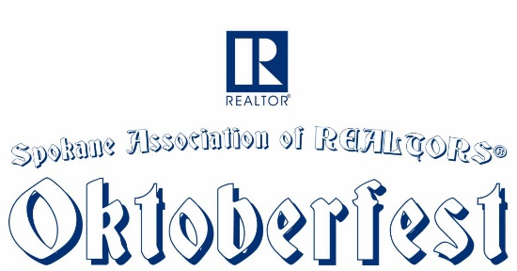
Early Registration extended through Monday 10/21

EVENT NEXT WEEK
Thursday 10/24

Our Oktoberfest Party will be replacing our Annual Christmas Party.

Come join us at Shriners Event Center for an evening of German food by Das Stein Haus. The evening will include DJ music by the Backwood Beatz Band, Silent Auction, Door Prizes, Dancing, Photo Booth & No-host bar.

Casual attire - though feel free to wear your dirndl or lederhosen, if you like.

Proceeds from the evening will go to Meals on Wheels.

The objective of Meals on Wheels is to provide the proper nutrition to those individuals who cannot meet the need on their own.

Special thanks to our terrific sponsors this year: Banner Bank, Condron Homes, Canopy Credit Union, Lucent Law, WFG National Title Co., Spokane County Title, DIRECTORS Mortgage, Old Republic Home Protection, LeaderOne Financial, Cornerstone Home Lending.

Download the SAR Oktoberfest event flyer among the supporting documents to this newsletter.

PUBLIC TRANSIT AFFECTS RE VALUE

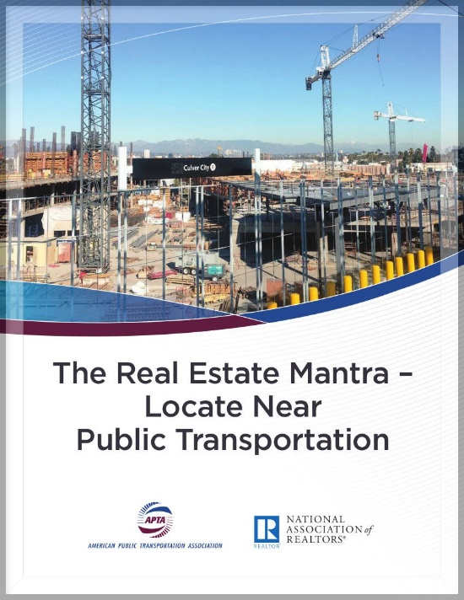
Neighborhoods located within a half-mile of public transit services outperformed those in areas farther from public transit based on several factors, according to a report released this week by the American Public Transportation Association and the National Association of Realtors®.

The report highlights the critical role public transportation plays in determining real estate values, revealing that commercial and residential real estate market sales thrive when residents have mobility options close by.

Download a copy of the report - The Real Estate Mantra - Locate Near Public Transportation - online here.

BROKER ALERT: WORKER’S COMP

Washington REALTORS® Legal Hotline lawyer Annie Fitzsimmons interviews Julie Black with the Department of Labor & Industries. In this video, Julie debunks a misconception that because brokers are independent contractors, they are not covered workers under worker's comp.

Annie and Julie discuss the consequences (which can be quite severe if a broker gets injured or a firm gets audited) and what firms need to do to get compliant.

Watch Annie's new eight-minute video online here:

https://youtu.be/UAvKVokq6gU

CRS CLASS IN SPOKANE

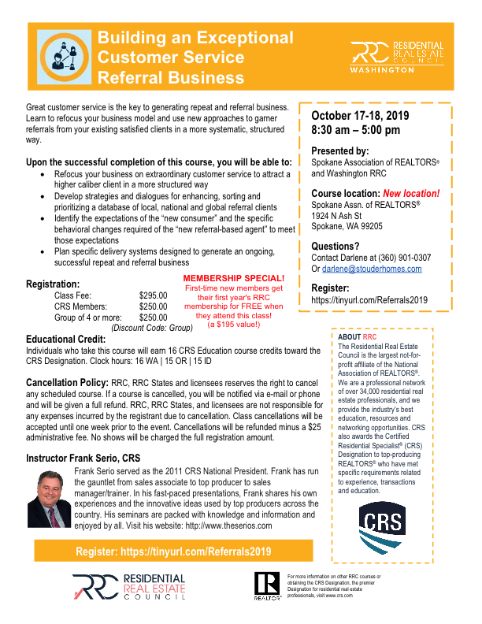
October 17-18

Building an Exceptional Customer Service Referral Business
Class: 8:30 a.m. to 5:00 p.m.
Location: SAR / 1924 North Ash Street

16.0 clock hours

Download the class flyer (pictured) from among the supporting documents to this newsletter.

Create RPR® “Wow” Moments for your Brokers

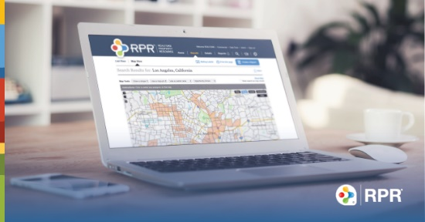
Did you know that you can add your company branding to all of the reports that your brokers are creating with RPR®?
It’s all part of RPR’s Broker Tool Set, a member benefit that you can easily start today.

Broker Tools even allows you to add important company information such as culture, philosophy, market share statistics and customized PDF pages to your agents’ reports.

http://blog.narrpr.com/broker/enroll

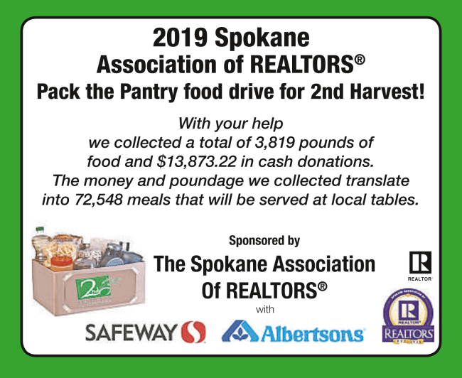

EDUCATION EXCELLENCE AND ANNUAL MEETING
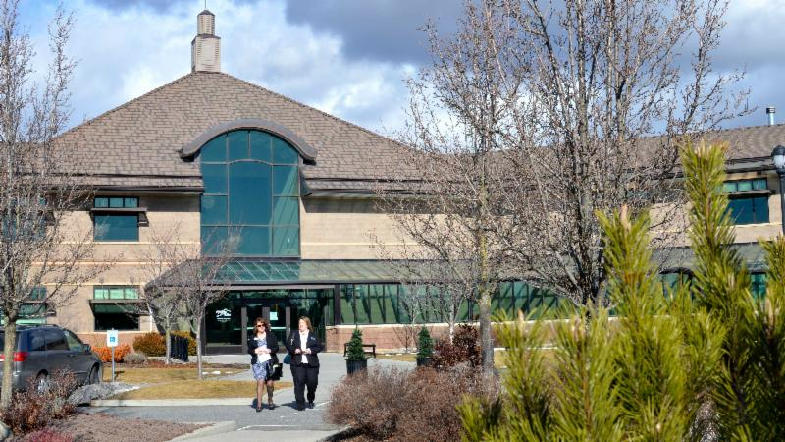
Thursday, November 21st at Centerplace in Spokane Valley

Early-bird registration accepted through November 14th!

Join your friends and colleagues for the SAR's final Education Excellence and Annual Membership meeting of 2019.

This event is bundled with four main events:

Top Shelf Business Practices
in the morning

Quarterly Business Meeting with
Buffet Lunch at 11:30a.m.

Social Media Marketing for REALTORS®
in the afternoon

Attend the day and go home with 6.5 clock hours! Attendance for clock hours will be proctored - extended absence from class(es) will disqualify you from credit.

Register via the SAR Member Portal, online here: https://sarportal.ramcoams.net/

See the event flyer among the supporting documents to this newsletter.

CODE OF ETHICS

FREE!

The SAR purchased the Webinar on National Real Estate Ethics Day June 27, 2019, in support of REALTORS® Relief Foundation.

Proceeds from this event will help families who have endured unimaginable loss.

We offer each office access to the Webinar to show in your office at no charge through December 31, 2019.

This class will not include clock hours; however, it will count towards NAR Code of Ethics requirement.

If you offer this class in your office, you will need to send Tami your sign in sheet from the class, so she can record it on the NAR website.

If you would like additional information, please email Tami @ tami@spokanerealtor.com or call 326-9222.
SEPTEMBER MARKET STATISTICS

It took nine months, but for the first time this year residential closed sales on less than one acre including condominiums were greater for this month’s report than the same month in 2018. 799 closed sales were reported for September this year compared to 744 closed sales in September 2018, an increase of 7.4%. September’s average closed sales price was $289,395 while the median closed sales price was $267,500. These prices are up 11.5% and 13.8% respectively.
Year to date closed sales are down 9.1% through September. 5,824 closed sales have been reported YTD compared to 6,387 closed sales last year through September. The year to date average closed sales price is $282,693, up 11.2% over last year when the average closed sales price through September was $254,182. The year to date median closed sales price is $260,000 up 11.2% from last year’s median through September of $233,786.
Inventory saw a slight increase under our method (CTGI now reported as PNDI). Active inventory totals 977 properties, a 1.2 month supply as of this report, up slightly from last month. New construction closed sales reported to the Association showed a healthy increase over last September and new construction closed sales through September total 650 down just 3 sales from last year over the same time period.

The above is an excerpt of the Spokane Association of REALTORS’® September 2019 Residential Market Activity Report. Access to the full report each month is a benefit of your association membership. See the full report online here (after you log in to the member portal): https://www.spokanerealtor.com/mls/market-activity-mls-statistics

SEPTEMBER LOCKBOX STATISTICS

