**MAY 2019**

**WASHINGTON REALTORS® LEGISLATIVE UPDATE**

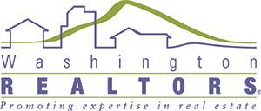

Washington REALTORS® CEO, **Steve Francks**, and Government Affairs Director, **Nathan Gorton**, discuss our successes and goals arising from the latest legislative session, including getting REALTORS® exempt from the B&O Tax increase, defeating a dual agency bill, protecting REALTORS® Independent Contractor Status and more.

See the new 16-minute **PART ONE** video, online here:

|  |
| --- |
| [egislative Update With Big Wins This Session](https://youtu.be/rDnpdMOGXHY) |
| **Legislative Update With Big Wins This Session** |

https://mlsvc01-prod.s3.amazonaws.com/4fd76739001/5366fd80-e7dc-48e1-906d-2cbcfa257fe0.jpg

Washington REALTORS® CEO, **Steve Francks**, and Government Affairs Director, **Nathan Gorton**, are back for **PART TWO** on the discussion of our successes and goals arising from the latest legislative session.

In this video, they talk more about the legislative successes surrounding the Unlock the Door for Affordable Homeownership campaign.

They also explain legislation around condominium liability reform, self-help housing, government assisted housing programs, responsible urban density & cluster zoning and homelessness and housing policy issues.

See the new 12-minute **PART TWO** video online here

|  |
| --- |
| [egislative Update 2019 - Part 2](https://youtu.be/kULihmLnEEg) |
| **Legislative Update 2019 - Part 2** |

**LEGAL SYMPOSIUM**

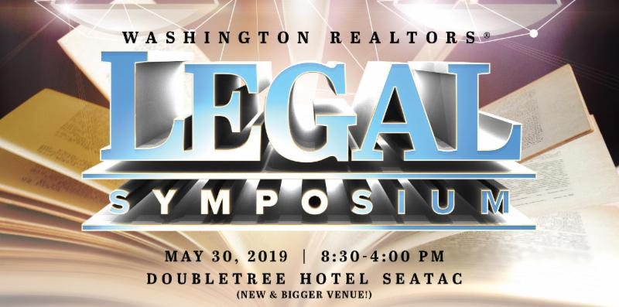**Thursday, May 30th**

The Washington REALTOR® Legal Symposium features SIX real estate attorneys from around the state.

This event sells out so we've moved it to an even bigger venue in SeaTac. REALTORS® and real estate licensees from all over the state, join us for a day of real estate legal education focused on current trends and issues. 7.5 CE, parking, and lunch are included.  
  
THE REAL ESTATE ATTORNEY LINEUP:  
WR Legal Hotline Lawyer **Annie Fitzsimmons**   
**Justin Haag**, General Counsel for the NWMLS   
**Mark Schedler**, Williams Kastner   
**Hunter Jeffers**, Stoel Rives   
**Chris Osborn**, Stoel Rives   
**David Daniel**, Demco Law Firm

**[Learn more online here](https://www.facebook.com/events/437154377057593/" \t "_blank)**.

**HOMEBOT**

****Have you heard of Homebot?

Paragon has partnered with Homebot to maximize your client relationship.

With the Homebot integration, you will be delivering a whole new service level to your clients and prospects.

Homeowners love the service so much, they will actively invite friends and family to register and generate new referral business to you.

To sign up for Homebot, log into Paragon, click on the "Resource" tab and select "Access Homebot."

**2019 REALTORS® CONFERENCE AND EXPO**

"Imagine the Possibilities" is the theme for this year's event.

The tagline and design concept is meant to be inspirational and fun.

It connects with San Francisco's culture and vibe - both past and present - in that the city has been (and continues to be) known for opportunity and innovation.

This is also what attendees can expect at this year's event - the opportunity to obtain innovative tools that will enhance their businesses.

IMAGINE what four days can do for you!

**[Visit the event website online here.](https://www.conference.realtor/" \t "_blank)**

**SAR GOLF TOURNAMENT**

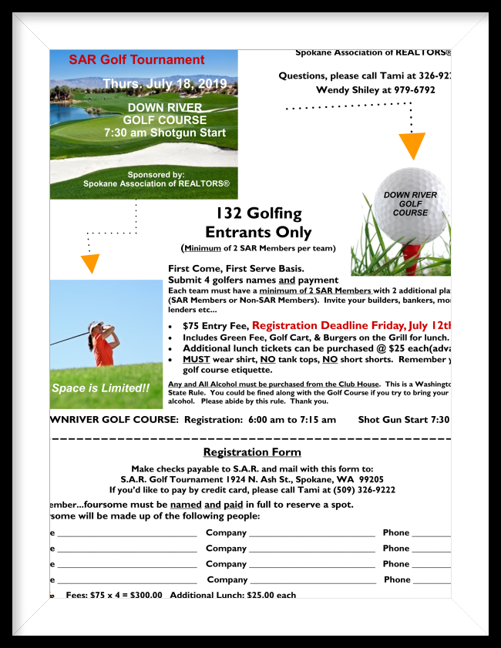**Thursday, July 18th**

**Down River Golf Course**

The annual SAR Golf Tournament is coming soon!

Teams of four will shotgun start at 7:30 a.m. on Thursday, July 18th, at Down River Golf Course.

First-come, first-served - enter today!

See the event flyer (pictured) among the supporting documents to this newsletter.

**2019 SAR THIRD GRADE ESSAY/POSTER CONTEST**

**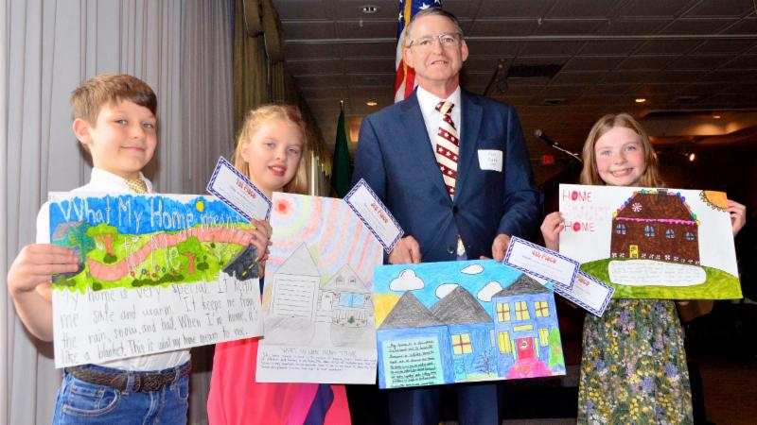**

The SAR Third Grade Essay/Poster Committee joyfully announces the winners of its 2019 contest - which were displayed at the SAR Awards Luncheon, this week.

Pictured, left to right: **Riley**, Sunrise Elementary - First Place; **Alli**, Great Northern School - Third Place; **Maddie**, Meadow Ridge Elementary - Fourth Place (not pictured - poster held by **Glen Carey**, SAR Third Grade Essay/Poster Contest Committee Chair); **Kinzie**, Chattaroy Elementary - Second Place.

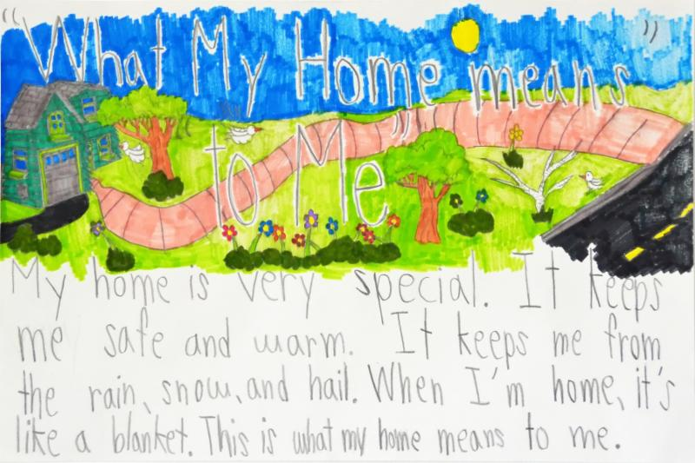

**FIRST PLACE** (pictured)

**Riley** - Sunrise Elementary

*My home is very special. It keeps me safe and warm. It keeps me from the rain, snow, and hail. When I'm home, it's like a blanket. This is what my home means to me.*

**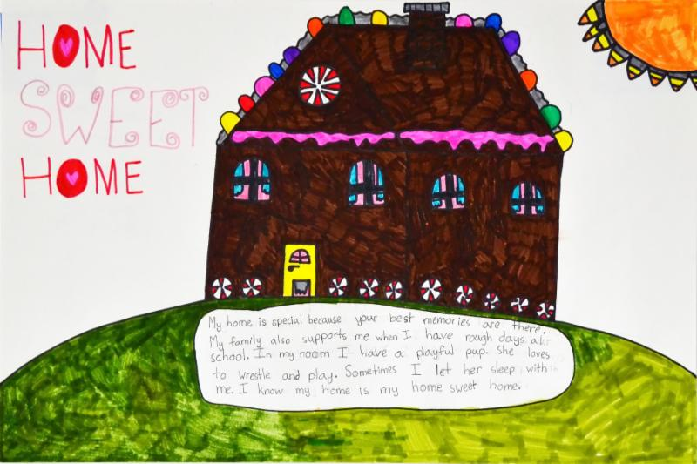SECOND PLACE** (pictured)

**Kinzie** - Chattaroy Elementary

*My home is special because your best memories are there. My family also supports me when I have rough days at school. In my room I have a playful pup. She loves to wrestle and play. Sometimes I let her sleep with me. I know my is my home sweet home.*

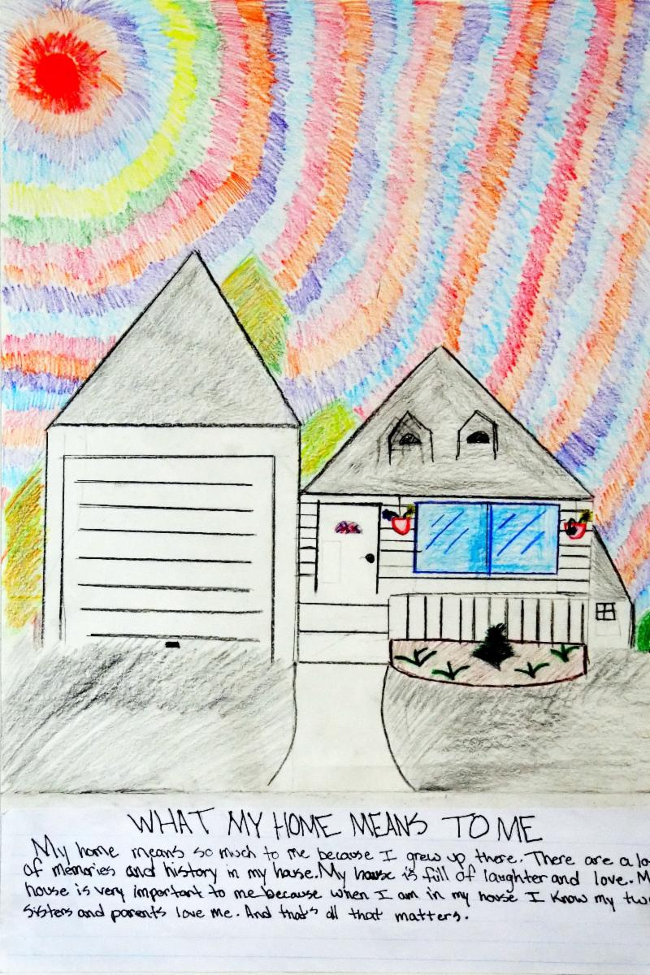**THIRD PLACE** (pictured)

**Alli** - Great Northern School

*My home means so much to me because I grew up there. There are a lot of memories and history in my house. My house is full of laughter and love. My house is very important to me because when I am in my house I know my two sisters and parents love me. And that's all that matters.*

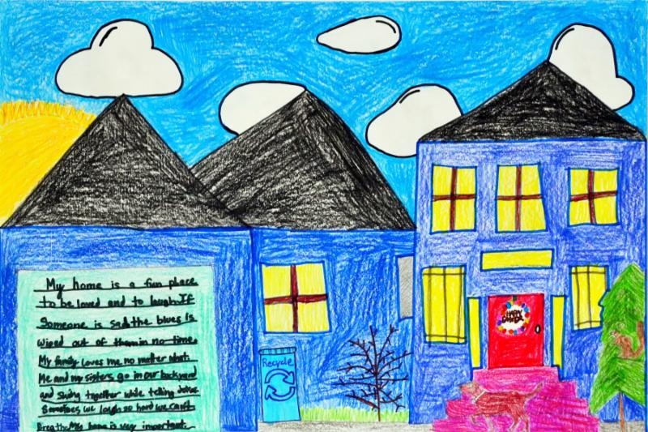

**FOURTH PLACE** (pictured)

**Maddie** - Meadow Ridge Elementary

*My home is a fun place to be loved and to laugh. If someone is sad the blues is wiped out of them in no-time. My family loves me no matter what. Me and my sisters go in our backyard and swing together while telling jokes. Sometimes we laugh so hard we can't breathe. My home is very important.*

**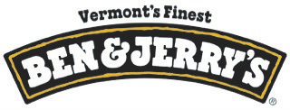**

The 1st Place winner receives an ice cream party for his/her classroom.

We offer a special **thank you** to Ben & Jerry's for generously donating the Ice Cream Party!

https://mlsvc01-prod.s3.amazonaws.com/4fd76739001/5366fd80-e7dc-48e1-906d-2cbcfa257fe0.jpg

Reproductions of this year's Third Grade Essay/Poster contest winning entries are now framed and displayed in the lobby of the SAR (pictured), and will remain up until next year's event.

This gesture offers a celebration of our annual contest committee effort, and a reminder of the importance of the work our member REALTORS® do in our community bringing families home every day.

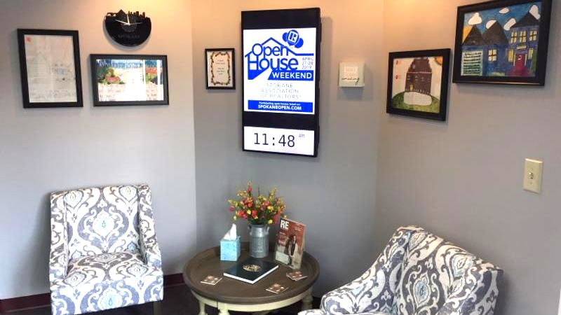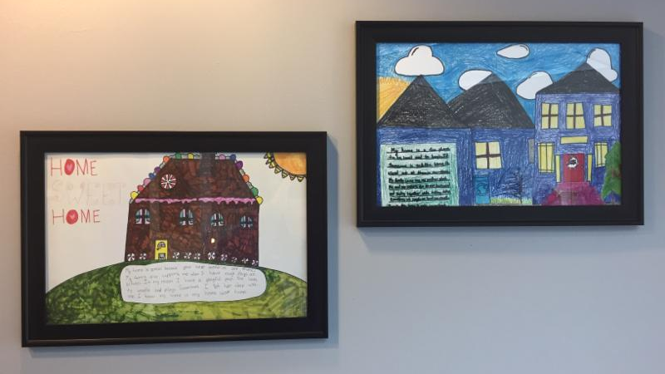

**APRIL MARKET STATISTICS**

Closed sales of single-family homes on less than one acre including condominiums totaled 568 for April 2019. Compared to April 2018 closed sales are down 7%, when 611 closed sales were reported. The average closed sales price is up 7.5% from April last year $273,820 compared to $254,378 for last April. The median closed sales price for April was $254,975 compared to $231,095 last year, up 10.3%.

Year to date through April closed sales total1,795,down 14% compared to the same period in 2018. The average closed sales price through April is $266,219 up 11.8% compared to 2018 when the average closed sales price was $238,183. The year to date median sales price is $245,000 compared t $219,000 last year, up 11.9%.

Inventory as of this report is down 7% compared to April 2018. Current inventory as of this report shows 1,083 properties. Year to date new listings total 2,813 compared to 3,245 last year, down 13.3%. New construction sales are down 4.6% compared to last year through April, 229 v240.

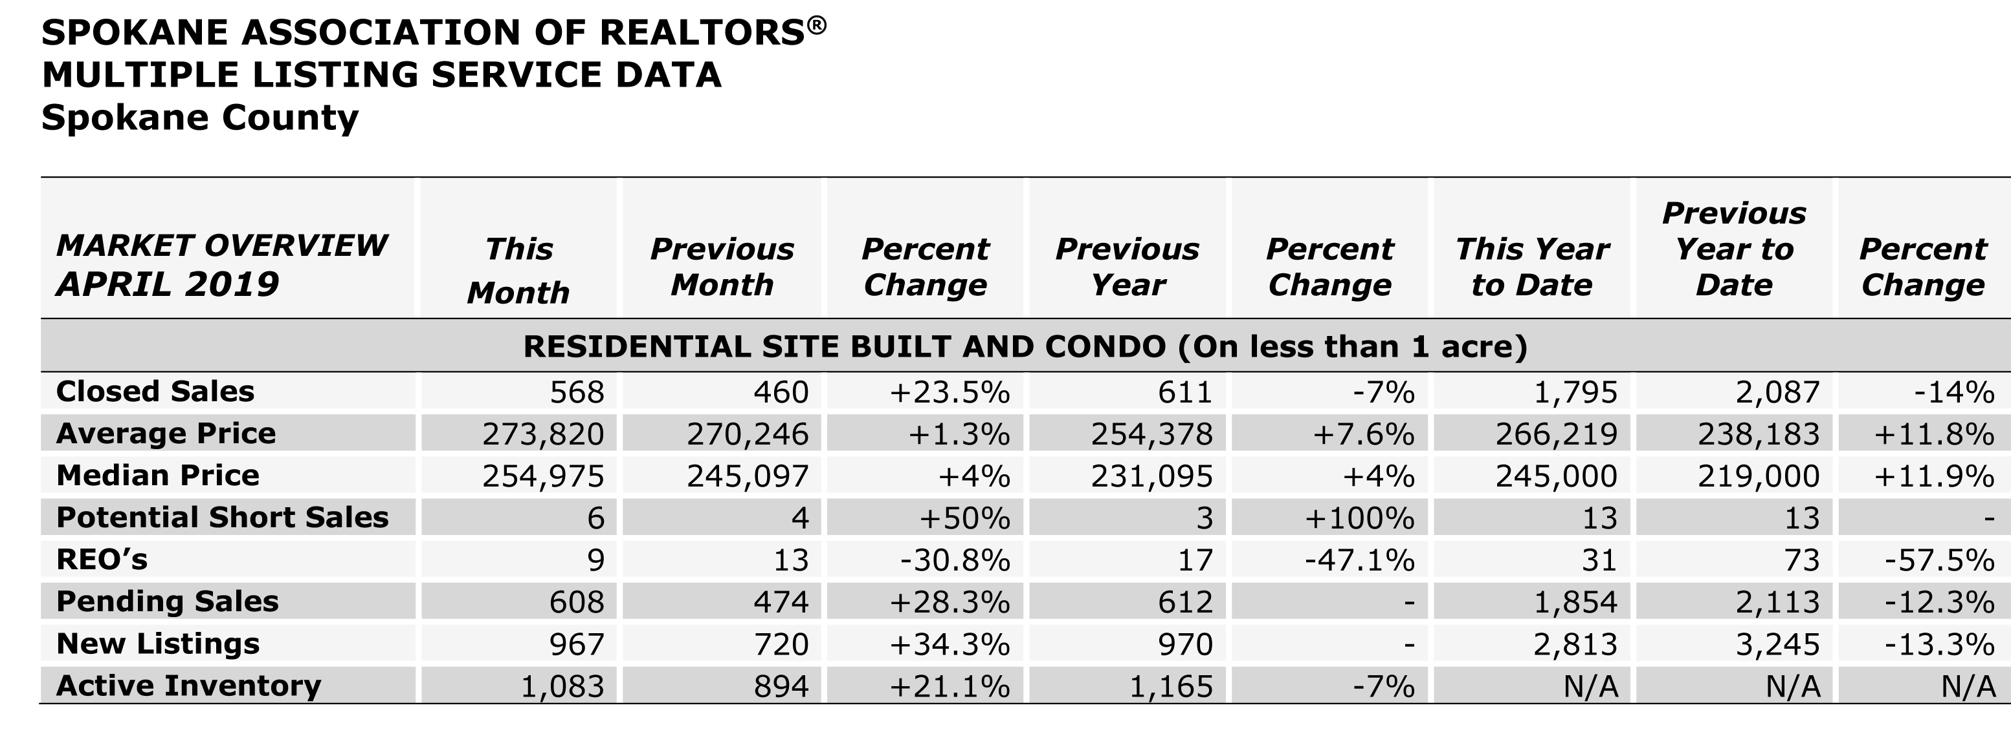

The chart above is an excerpt of the Spokane Association of REALTORS’® **April 2019** Residential Market Activity Report. Access to the full report each month is a benefit of your association membership. See the full report online here (after you log in to the member portal): [**https://www.spokanerealtor.com/mls/market-activity-mls-statistics**](https://www.spokanerealtor.com/mls/market-activity-mls-statistics)

**APRIL LOCKBOX STATISTICS**

