MARCH 2020

SAR COVID-19 BULLETIN

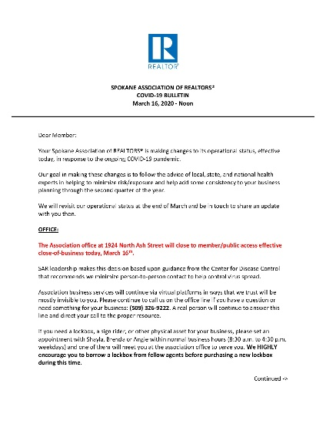
The Association office at 1924 North Ash Street will close to member/public access effective close-of-business today, March 16th.

SAR leadership makes this decision based upon guidance from the Centers for Disease Control that recommend we minimize person-to-person contact to help control COVID-19 spread.

The SAR’s COVID-19 Bulletin is offered with this newsletter.

A HAND OF KINDNESS

If you or any members of your staff ever find themselves facing food insecurity during this or any other time of hardship, please invite them to be in touch with 2nd Harvest – our Food Drive partners.

Our friends at 2nd Harvest offer this link to get in touch: https://2-harvest.org/i-need-food-assistance/

From Heidi Wieber at 2nd Harvest: “I know these are uncertain times for everyone. Thank you for helping us to get the word out about where folks can find help if they need it.”

SAR EDUCATION EXCELLENCE / QUARTERLY MEMBERSHIP MEETING CANCELLED!
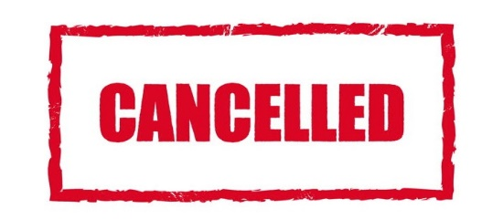

The SAR Education Excellence / Quarterly Membership Meeting scheduled for this week - Thursday, March 19th - is cancelled.

SAR leadership makes this decision in response to the Coronavirus situation, based on advice and counsel from various trusted partners - including local and state health officials and Washington REALTORS®.

If you have already paid for this class on your credit card, you will receive an automatic refund of the full amount.

Meanwhile, if you need a Core Curriculum class for your business, we recommend taking it from the CE Shop - a Washington REALTORS® preferred vendor.

Go directly to this class in the catalog online here.

Enter PROMO CODE MAR25 for a 25% discount.

KEEPING THE WORKPLACE SAFE

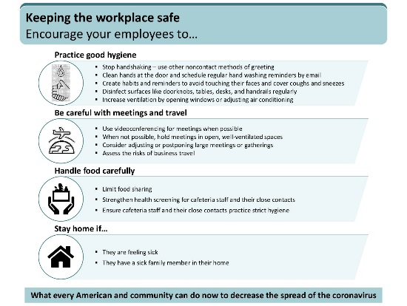
The Centers for Disease Control (CDC) offers a great poster: “Keeping the workplace safe” (pictured). You can print and post this in your office to encourage behavior among your team members that will minimize their risk of exposure to Coronavirus.

The PDF includes four posters and is offered as an attachment to this newsletter.
CORONAVIRUS – WASHINGTON REALTORS
"We are suspending all non-essential staff and leadership travel at the State Association level through March 31.

We are also cancelling or rescheduling WR classes, meetings and other events between now and the end of March.

We will revisit this situation at that time and make any adjustments as warranted."

Kitty Wallace, 2020 Washington REALTORS® President

Washington REALTORS® has collected a variety of resources on Coronavirus of particular value to REALTORS® in Washington state.

Visit this resource online here.

CORONAVIRUS FOR REALTORS®
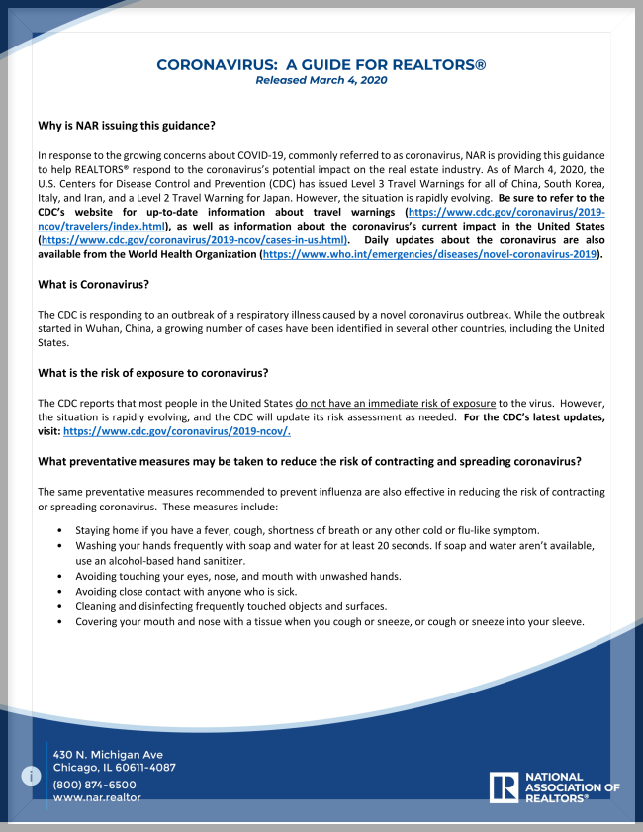
NAR, last week, published "Coronavirus - A Guide for REALTORS®"

The document comes in response to the growing concerns about COVID-19, commonly referred to as Corona Virus.

NAR is providing this guidance to help REALTORS® respond to the Corona Virus's potential impact on the real estate industry.

This document is offered as an attachment to this newsletter.

IMPORTANT FORMS REVISION

IMPORTANT!

The Spokane Addendum to Purchase and Sale Agreement (SAR-SA) is revised and now available on TransactionDesk and ZipForms.

Please read the Memo from Brian Balch, Layman Law Firm, PLLP, explaining the revisions.

Read the memo and see the sample forms as attachments to this newsletter.

FAIR HOUSING: SERVICE AND COMFORT ANIMALS

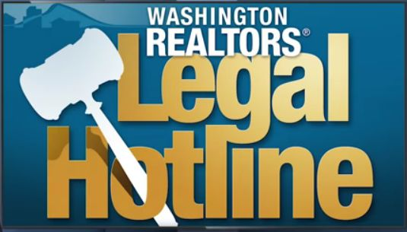
The Fair Housing Act recently received a number of revisions.

One of the topics trending on the Legal Hotline concerns comfort animals.

Washington REALTORS® Legal Hotline lawyer Annie Fitzsimmons brings us clarifications on these new revisions.

We recorded highlights from her recent class on this topic and others so that you can stay informed.

See the new 22-minute video online here:

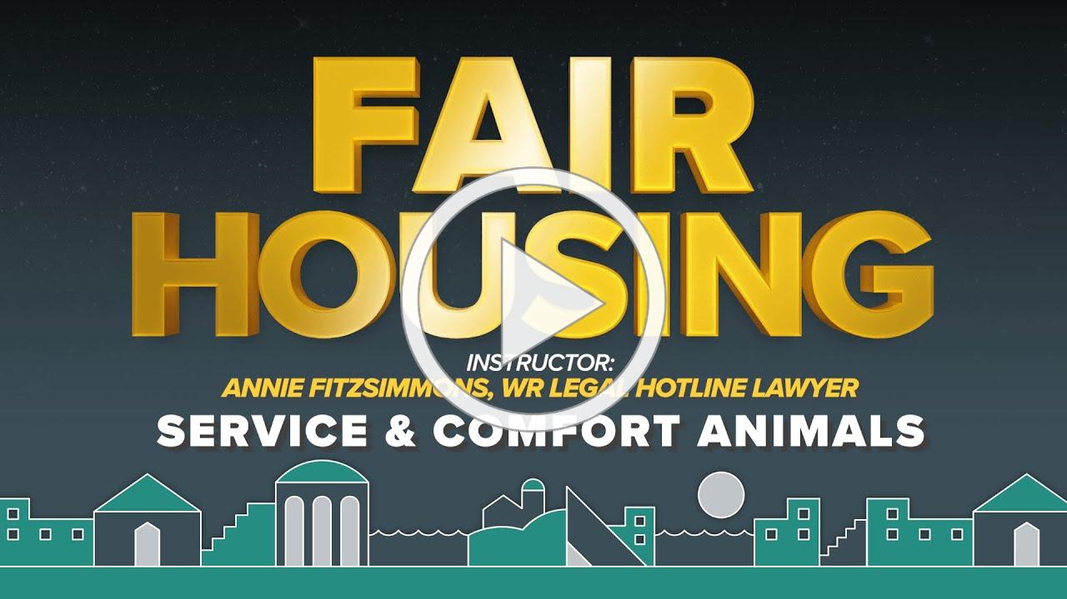
Fair Housing: Service and Comfort Animals NEW

2020 INLAND NORTHWEST FAIR HOUSING CONFERENCE

THIS EVENT IS CANCELLED DUE TO COVID-19 SOCIAL DISTANCING
Look for it to be re-scheduled this fall.

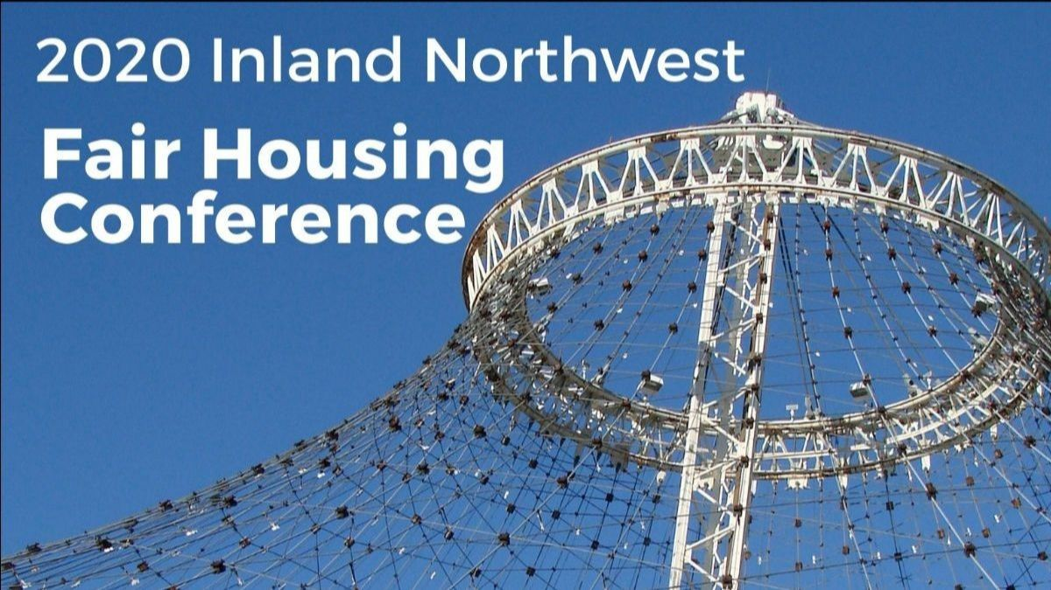
Thursday, April 23
Spokane Convention Center

Plan to participate in the 2020 Inland Northwest Fair Housing Conference - this year sponsored, with a panel presentation, by your Spokane Association of REALTORS®!

The SAR panel presentation - Why Owning a Home is More Important than Ever - runs from 10:30 a.m. to noon.

The program description: New information reveals why owning your own home is more important than ever before. Join us for a panel discussion to learn how you can learn more about achieving the dream of home ownership.

The draft agenda is offered as an attachment to this newsletter.

NAR CYBERSECURITY CHECKLIST

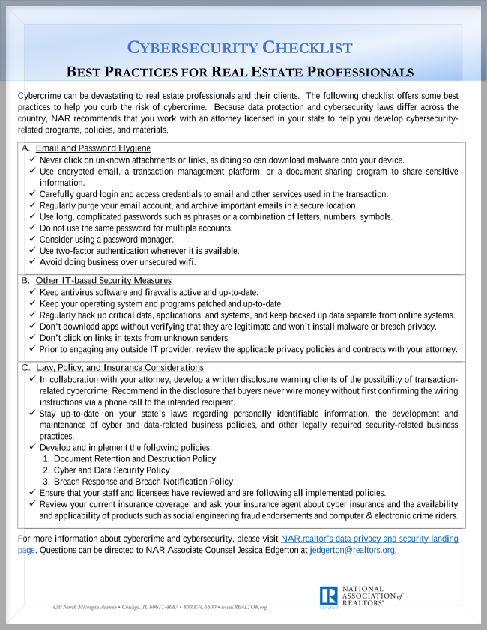
Cybercrime can be devastating to real estate professionals and their clients.

This checklist offers some best practices to help you
curb the risk of cybercrime.

Because data protection and cybersecurity laws differ across the country, NAR recommends that you work with an attorney licensed in your state to help you develop cybersecurity-related programs, policies, and materials.

Download a copy of NAR's Cybersecurity Check-list (pictured) online here.

ALL_NEW HOMESNAP PRO IS HERE
The wait is over: The All-New Homesnap Pro just launched!

- Find homes for your buyers that other agents won't by leveraging unlimited
homeowner contact information and property history.

- Dominate your market by identifying seller leads in your preferred zips with advanced
property heatmaps and Likelihood to List scoring.

- Streamline your client collaboration with in-app messaging, client alerts, and more.

We're excited to bring you a tool that you can have right at your fingertips, on every device (computers, laptops, tablets, and smartphones).

Start exploring the All-New Homesnap Pro so you can get the most out of this incredible benefit!

Check out Homesnap Pro here.

2020 CENSUS

The National Association of Realtors® has signed on as a National Partner for the upcoming 2020 Census.

NAR is asking the 1.4 million Realtors® nationwide to help drive Census participation in their respective communities.

"NAR is able to provide tremendous value to our members because of the research we produce examining trends in communities across this country. But the usefulness of that information relies on current, accurate data from the federal government," said NAR President Vince Malta, broker at Malta & Co., Inc., in San Francisco. "Full participation in the Census is in many ways the only way to ensure that data is correct."

Download NAR's Census participation graphic (pictured) online here - and share it with your clients to help get the word out.

SAVE THE DATE!
APRIL 25-26

FEBRUARY MARKET STATISTICS

Closed sales of single-family homes on less than one acre including condominiums as of this report were 421. Closed sales are up 3.7% compared to February 2019 when 406 sales were reported. The average closed sales price for February was $288,091, up 10.7% when compared to February 2019 when the average closed sales price was $260,210. Median price was up 12% compared to February 2019, $268,675 v. $239,950 respectively.
Year to date closed sales through February are up 12.4%, 868 sales through February 2020 compared to 772 over the same period last year. Year to date average closed sales price through February 2020 is $285,900 up 10.8% over $258,125 average closed sales price through February last year. Median closed sales price through February is up 14.2%, $270,000 v. $236,497.
Inventory remains tight. We have a 1.1months supply of housing as of the date of this report. The total of single-family homes including condominiums on the market as of this report was 452. New construction closed sales reported to the SAR MLS totaled 73 for February and year to date total 147 an increase of 30% over 2019.

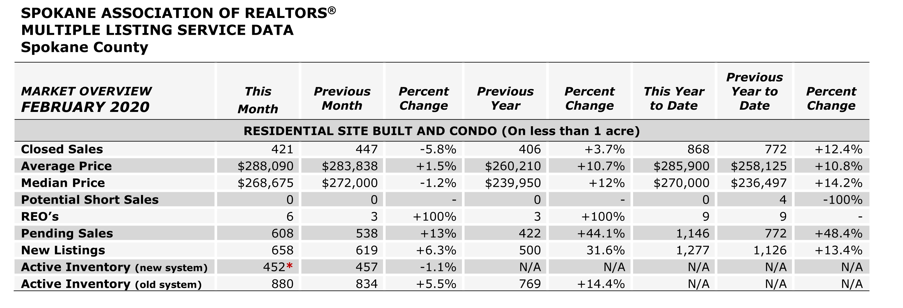

The above is an excerpt of the Spokane Association of REALTORS’® February 2020 Residential Market Activity Report. Access to the full report each month is a benefit of your association membership. See the full report online here (after you log in to the member portal): https://www.spokanerealtor.com/mls/market-activity-mls-statistics

FEBRUARY LOCKBOX STATISTICS

