**JULY 2020**

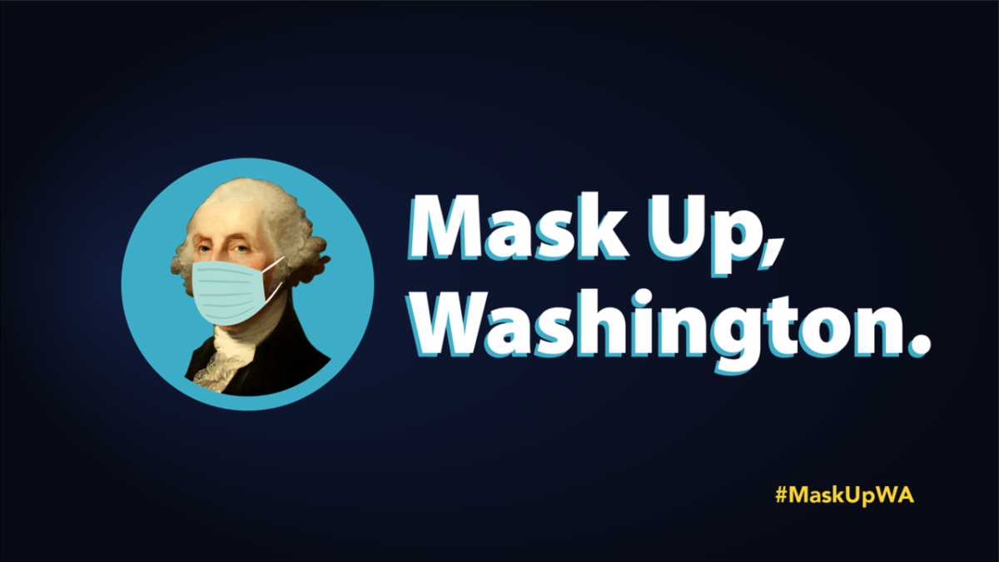

All Washington state businesses (since July 7th) are required to demand that all customers and employees comply with the statewide face covering requirement.

The  [**statewide order**](https://www.doh.wa.gov/Portals/1/Documents/1600/coronavirus/Secretary_of_Health_Order_20-03_Statewide_Face_Coverings.pdf) requires that masks be worn inside any building or business open to the public, outdoor public areas when six feet of social distancing cannot be maintained, and other settings.

No goods or services are to be furnished to customers not in compliance with statewide face covering requirements.

Individuals with certain health or medical conditions are excepted and are not required to produce documentation of the condition to be considered exempt.

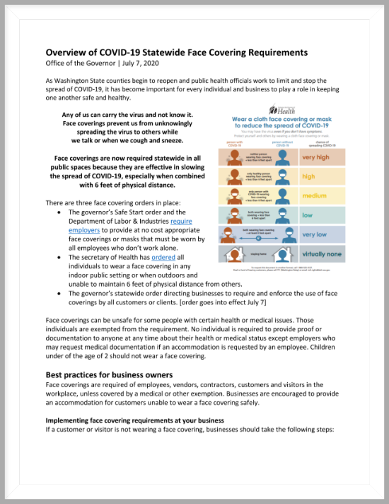

What is considered a mask and how should you wear it for maximum effect?

View the full **Face Covering Requirements** document from the governor's office (pictured above) [**online here**](https://files.constantcontact.com/4fd76739001/5fce2589-55c7-4fd2-b8e2-6f8e0960a250.pdf).

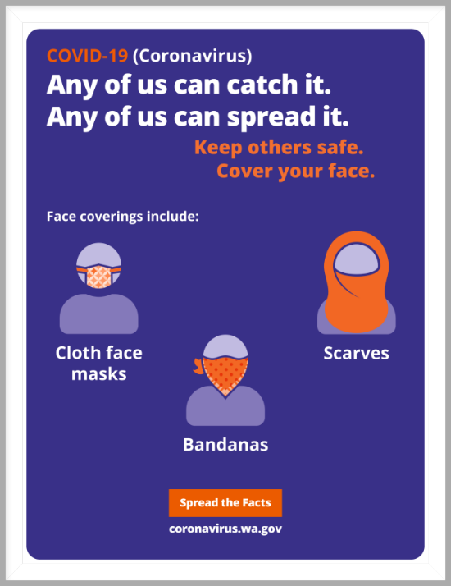

A [**face mask requirement**](https://files.constantcontact.com/4fd76739001/546910e0-f747-42a5-bb17-d0ac8fbf74da.pdf) is in effect across Washington State until further notice.

The Washington State Joint Information Center offers this poster (pictured above) to help you remind yourself and colleagues in your office to mask up for yourselves and your clients - the poster is [**online here**](https://files.constantcontact.com/4fd76739001/0704ec31-0d41-4722-87cc-6f6ecec7e944.pdf).

**MANAGING BROKERS:**

Please make sure your brokers are following Phase 2 protocols when showing properties – the association is getting reports that some are not. Specifically, we need to remind that:

1. All showings require an appointment
2. REALTORS® are to be present at all showings (do not let your clients into a home without YOU)
3. No more than 3 people on site at any time

Open houses are still not allowed at any time while we are in Phase 2.

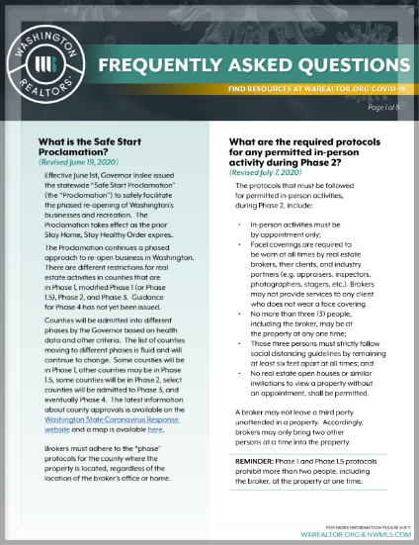

**NEW!**

**Updated July 7th**

Washington REALTORS® and the Northwest Multiple Listing Service continue to revise the FAQ guidance document for Brokers as information changes.

The current version of this document is **new as of July 7th**.

Download this document (pictured above) [**online here**](https://files.constantcontact.com/4fd76739001/d6678e0c-9cab-44ed-85b8-046f91c1e010.pdf).

**BE THE REALTOR® YOUR CLIENTS THINK YOU ARE**

2020 SAR President **Tom Clark**, Kestell Company REALTORS® (right) and 2020 SAR Communications Committee Chair **Laura Branning**, EXIT Real Estate Professionals (left) have created a video message about broker behavior in the field during a time of pandemic.

They share what has been reported to the SAR with some general advice for us all.

The short message: *someone is always watching*.

See the new six-minute video online here:

|  |
| --- |
| [Be the REALTOR® your clients think you are.](https://youtu.be/mGhey_QmiEE) |
| **Be the REALTOR® your clients think you are.** |

**PAYCHECK PROTECTION PROGRAM**

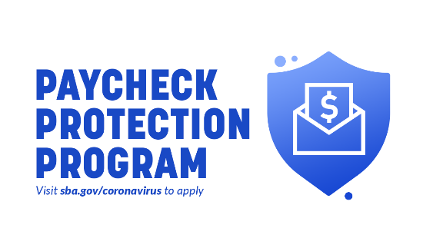The federal Paycheck Protection Program (PPP) has reopened and will close again **August 8th**.

PPP is a loan designed to provide a direct incentive for small businesses to keep their workers on the payroll during the pandemic. The Small Business Administration (SBA) will forgive loans if all employee retention criteria are met, and the funds are used for eligible expenses.

Read more about PPP online here:

[**https://www.sba.gov/funding-programs/loans/coronavirus-relief-options/paycheck-protection-program**](https://www.sba.gov/funding-programs/loans/coronavirus-relief-options/paycheck-protection-program)



The Washington State Department of Licensing (DOL) has launched a new online system for licensees to manage their professional and business licensing information.

Helpful instructions and videos about **Secure Access Washington** (SAW) accounts, how to access the new system, setting up an account, and how to link licenses [**can be found online here**](https://www.dol.wa.gov/business/accountaccess.html).

If you are having technical difficulties with the new system, please contact the Command Center at: 360-664-0200 option 7 or email at [**DOLelicensingsupport@dol.wa.gov**](mailto:DOLelicensingsupport@dol.wa.gov).

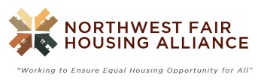

The Northwest Fair Housing Alliance has announced that its **2020 Inland Northwest Fair Housing Conference** will be **fully virtual** this year**.**

Instead of events happening all on one day, this year's events are being scheduled between **August 27th** and **October 1st** - all online.

The early edition of the program includes an impressive list of speakers and topics and promises to engage on several important aspects of the law.

[**Read more and register online here.**](https://nwfairhouse.us13.list-manage.com/track/click?u=097bf4b0ffe9c7325772005d7&id=5e123ca25b&e=e85d4b4a23)

**RIGHT TOOLS, RIGHT NOW**

In light of the challenges presented by [**COVID-19**](https://www.nar.realtor/coronavirus), and its impact on the real estate industry, NAR is taking steps to support members through these uncertain times.

The Right Tools, Right Now initiative, which was activated once before in 2009, makes new and existing NAR products and services available for **FREE or at significant discounts** – right now – and is available to REALTORS® and REALTOR® Associations.

Visit the NAR **Right Tools, Right Now** website online here:

[**https://www.nar.realtor/right-tools-right-now**](https://www.nar.realtor/right-tools-right-now)

**REALTOR SAFETY PROTOCOLS**

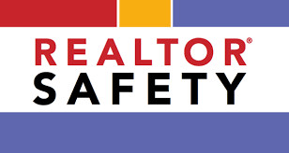**Carl Carter, Jr.**, REALTOR® and Founder of the Beverly Carter Foundation, shares the importance of following safety protocols and best practices while working in the industry.

Hear key tips all real estate professionals should implement into their business to reduce the risk of safety incidents in the industry.

This webinar recording is from last week - **Tuesday, June 23rd** - and lasts about an hour.

|  |
| --- |
| [Beverly & Beyond: The Best Tips Learned Since Losing My Sweet Mom](https://youtu.be/LnB4pmcx2dI) |
| **Beverly & Beyond:**  **The Best Tips Learned Since Losing My Sweet Mom** |



**DUE BY FRIDAY, JULY 31ST**

Things are the way they are because someone decided they be that way. Perhaps you have thought that something could be done a different way, that there is a better way.

Here is your chance – nominate yourself or a fellow Broker to serve on your association board for 2021-2022.

There are five, two-year terms available on the board.   
  
Nominees for directorships must be REALTOR® members of the Association who have:

(i)     served on a minimum of two (2) standing committees within the seven (7) years prior to the time of the election;

(ii)   served on one (1) standing committee within the three (3) years prior to the time of the election; or

(iii)who are currently serving, or within the one (1) year prior to the time of the election have served, as President of the Young Professionals Network or President of the Women's Council of REALTORS®.

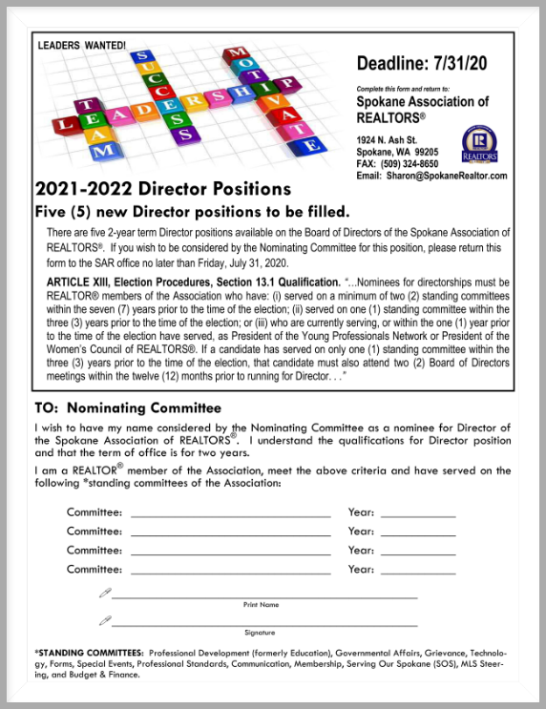If a candidate has served on only one (1) standing committee within the three (3) years prior to the time of the election, that candidate must also attend two (2) Board of Directors meetings within the twelve (12) months prior to running for Director.

To place a name in nomination with the Nominating Committee, please complete the application, offered below.

You may FAX your completed form to the SAR at 324-8650, mail to:  SAR, 1924 N Ash, Spokane, WA 99205, or Email to [**Sharon@SpokaneRealtor.com**](mailto:sharon@spokanerealtor.com) by **Friday, July 31st**.

If you have questions, please contact [**Tom Clark**](mailto:spokanetom@comcast.net) at 499-9999 or [**Sharon Houston**](mailto:sharon@spokanerealtor.com) at 326-9222.

Thank you for participating in the leadership of your association!

The **2021-2022 SAR Director Nomination Form** is attached to this newsletter.

**JUNE MARKET STATISTICS**

**A strong comeback is reflected in June 2020 numbers.** 713 residential closed sales of single-family homes on less than one acre, including condominiums, were reported for this June. Compared to May 2020 closed sales were up 35.6% reflecting this strong comeback. Compared to June 2019 sale are down 7.5%. The average closed sales price is up 7.4% compared to June last year, $310,623 v $289,187. The median closed sales price for this June was $295,000 up 11.1% compared to June’s 2019 median closed sales of $265,623.

Closed residential sales through June 2020 totaled 3,261 down 1% from the same time last year when 3,283 closed sales were reported. The average closed sales price through the first half of 2020 is $301,085 up 9.3% compared to last year’s closed sales price of $275,445 over the same period. Median half year closed sales price is $281,000 up 10.2% compared to last year’s median closed sales price of $255,000.

Inventory supply as of this report is down to one month. As of this report 728 homes were on the market. New construction closed sales total 437 compared to 389 over the same period last year, an increase of 12.3%.

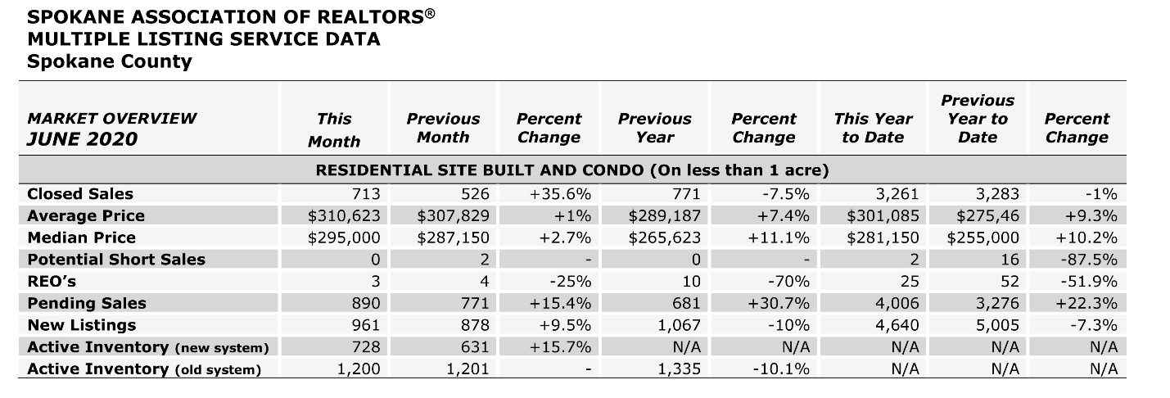

The above is an excerpt of the Spokane Association of REALTORS’® **June 2020** Residential Market Activity Report. Access to the full report each month is a benefit of your association membership. See the full report online here (after you log in to the member portal): [**https://www.spokanerealtor.com/mls/market-activity-mls-statistics**](https://www.spokanerealtor.com/mls/market-activity-mls-statistics)

**JUNE LOCKBOX STATISTICS**



