**JULY 2019**

**REVISED STATEWIDE FORMS**

**Available Now!**

Revised statewide forms were released on **July 1, 2019**.

Here’s some good news: life as you know it and the way you use the forms have not changed, as a result.

The even better news is that the statewide forms are improved, enabling you to deliver even better results for your clients.

The information below will explain the form revisions, almost all of which occurred within the boilerplate.



Read more about our new state-wide forms online here:

[**https://www.spokanerealtor.com/govt-affairs-brief/forms/**](https://www.spokanerealtor.com/govt-affairs-brief/forms/)

If you have questions related to any of the forms revisions and you are a REALTOR® member, submit your questions to the Washington REALTORS® Legal Hotline lawyer: **[legalhotline@warealtor.org](mailto:legalhotline@warealtor.org" \t "_blank)**.

**MLS CHANGES – EFFECTIVE AUGUST 1ST**

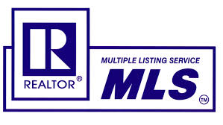

**COMING AUGUST 1ST**

Watch for MLS changes that take effect on **August 1st**:

We've prepared instructions and talking points on each change.

You'll find ***The Way you Report Contingent and Pending Sales***, and ***The Way you Input Open Houses***, among the supporting documents to this newsletter.

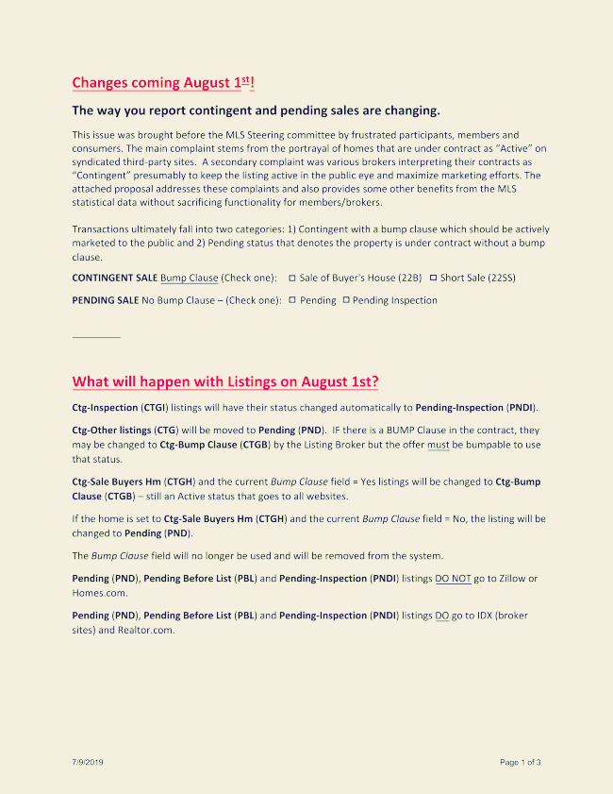



**Code of Ethics Webinar**   
The SAR purchased the Webinar on National Real Estate Ethics Day June 27, 2019 in support of REALTORS® Relief Foundation. Proceeds from this event will help families who have endured unimaginable loss.

We would like to offer each office access to the Webinar to show in your office at no charge.

This class will not include clock hours, however it will count towards NAR Code of Ethics requirement.

If you offer this class in your office, you will need to send Tami your sign in sheet from the class, so she can record it on the NAR website.

If you would like additional information, please email Tami @ [tami@spokanerealtor.com](mailto:tami@spokanerealtor.com) or call 326-9222.

**LEGAL HOTLINE**

Can a Seller unilaterally terminate a listing agreement?

Can listing firm refuse seller's request to terminate a listing agreement?

Can a firm unilaterally terminate a listing agreement?

Washington REALTORS® Legal Hotline Lawyer answers.

See the new six-minute video online here:

[**https://youtu.be/9ApVnAUHSp0**](https://youtu.be/9ApVnAUHSp0)

**ANNIE’S COMING TO TOWN**

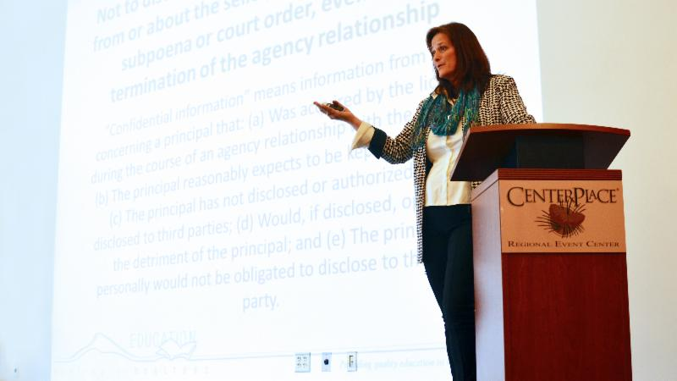**SAVE THE DATE:**

**Thursday, August 22nd!**

**Annie Fitzsimmons**, Washington REALTORS® Legal Hotline attorney (pictured), is coming to Spokane to teach two classes on **Thursday, August 22nd**: *Don't Get Whacked by the WAC's* – and – *Is it Friend & Faux? RE-fraud Schemes you Need to Know.*

You won't want to miss these interactive and energetic classes with Annie!

Download the event flyer from among the attachments to this newsletter.

The SAR Quarterly Membership Meeting will be held during the lunch break.

**Lunch  & meeting are included with class registration fee for only $40.**

**Lunch & meeting only without class is $20**

Register online through the Member Portal, here:

[](https://sarportal.ramcoams.net/)

**NOT ENOUGH HOMES**



The July-August edition of REALTOR® magazine is just out with a cover story on inventory: ***Not Enough Homes***.

The U.S. is about 2.5 million units short based on long-term growth projections, Freddie Mac estimates.

**Laurie Goodman**, vice president of housing finance policy at the Urban Institute, calls the housing shortage a crisis.

The Institute has found a shortfall of about 350,000 units per year due to underbuilding since 2009.

The result will be "a huge deficit in housing over the next decade," she says.

Read the article online here:

[**https://magazine.realtor/news-and-commentary/feature/article/2019/07/unlocking-inventory**](https://magazine.realtor/news-and-commentary/feature/article/2019/07/unlocking-inventory)

**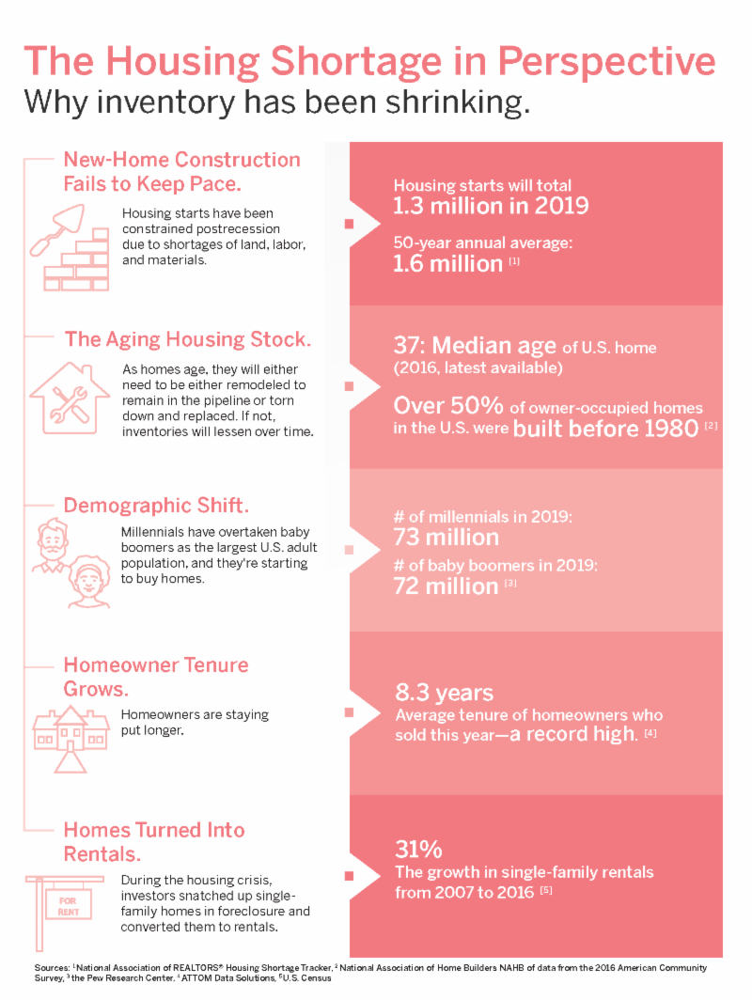**

NAR is just out with a new infographic, ***The Housing Shortage in Perspective - Why Inventory has been Shrinking.***

See the new infographic (pictured), online here:

[**https://magazine.realtor/sites/default/files/asset/document/1906\_housing\_shortage.pdf**](https://magazine.realtor/sites/default/files/asset/document/1906_housing_shortage.pdf)

**SAR NIGHT AT THE BALLPARK**



**Saturday, August 17th**

Spokane Association of REALTORS®

**Game Date:**

**Saturday, August 17**

Promotion:

Armed Forces Appreciation & Fireworks Night

First Pitch:

6:30 PM

Gates to the ballpark open one hour prior to first pitch

Tickets just $11

[**http://spokaneindians.tix.milbstore.com/store\_contents.cfm?store\_id=106&dept\_id=1601&product\_id=117378**](http://spokaneindians.tix.milbstore.com/store_contents.cfm?store_id=106&dept_id=1601&product_id=117378)

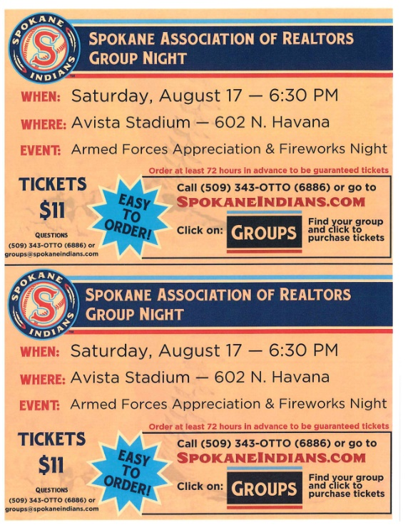

Download the **Spokane Association of REALTORS® Group Night** promotional flyer for this event (pictured) to share with your office colleagues and associates among the supporting documents to this newsletter.

**JUNE MARKET STATISTICS**

764 residential closed sales of single-family homes on less than one acre, including condominiums, were reported for this June. Compared to June last year when 923 closed sales were reported sales were down 17.2%. The average closed sales price for June was $289,308. Compared to June last year, when the average sales price was $268,039, the average sales price is up 7.9%. The median sales price for June compared to June 2018 is up 8.2%, $265,000 v. $245,000.

Closed residential sales through the first half of 2019 totaled 3,244 sales, down 14% over the same period in 2018 when 3,772 sales were reported. The year to date average sales price is $275,968 which is up 9.9% compared to the first six months of 2018 when the average sales price was $251,071. The year to date median sales price through June is $255,000 up 10.9% compared to June last year when the median sales price was $230,000.

Inventory continues to lag behind last year. As of this report the current inventory was 1,335 properties, down 6.1% from last year at this time when there were 1,422 residential properties on the market. New construction sales reported to the Spokane MLS are down 8.4%, 372 v. 406 through June.

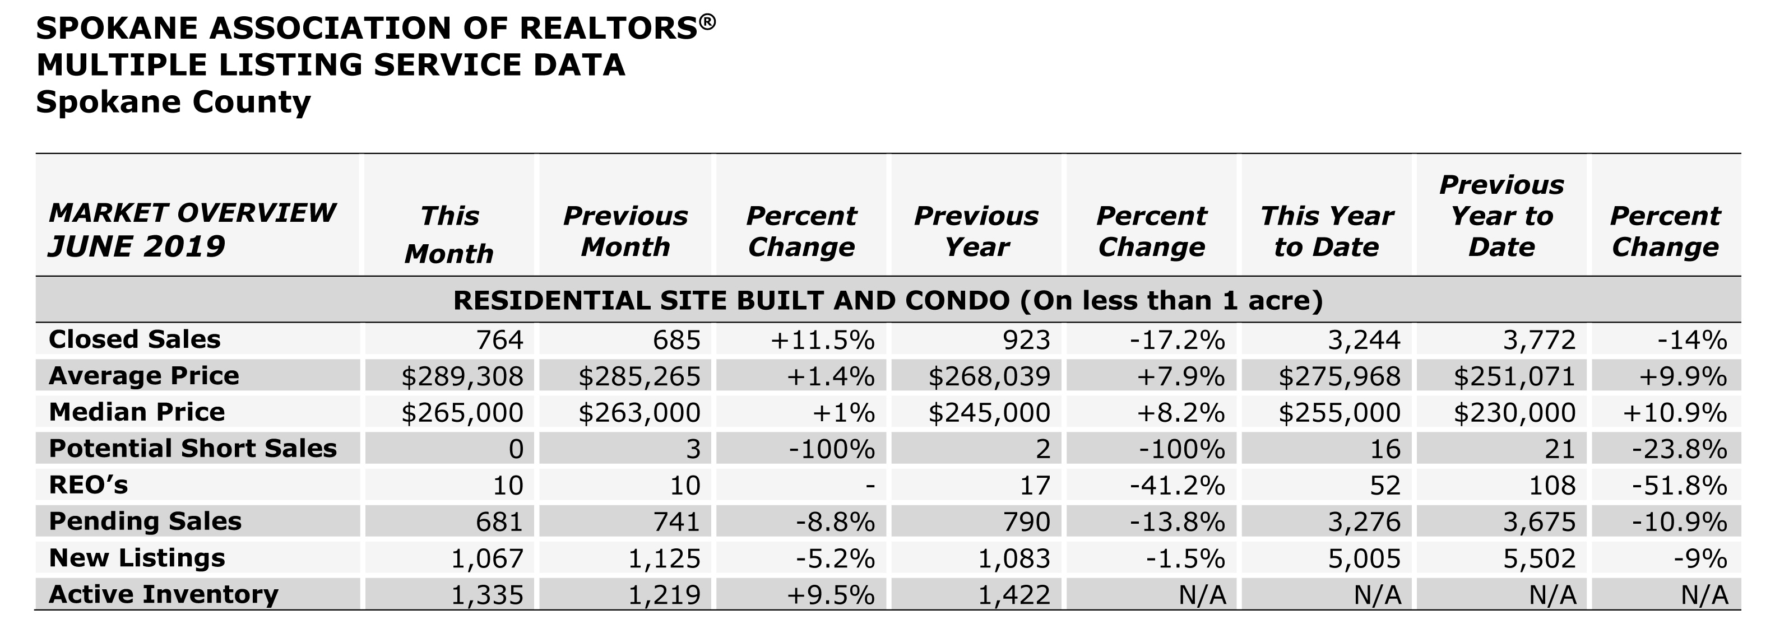

The above is an excerpt of the Spokane Association of REALTORS’® **June 2019** Residential Market Activity Report. Access to the full report each month is a benefit of your association membership. See the full report online here (after you log in to the member portal): [**https://www.spokanerealtor.com/mls/market-activity-mls-statistics**](https://www.spokanerealtor.com/mls/market-activity-mls-statistics)

**JUNE LOCKBOX STATISTICS**

