JANUARY 2020

CLOSED SALES IN PARAGON NOW BROKER-LOADED

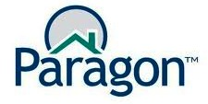
Brokers and staff with listing input access can now report closed sales directly in Paragon.

This feature went live on Monday, January 6, 2020.

If you are one of those who will be doing this, here are several things to keep in mind:

- Closed sales must be reported by the next business day after recording.
- FSBO sales must still be sent to the SAR/MLS for closed sales reporting.
- Duplicate listings may only be reported once. Send an email to the SAR/MLS and the SAR/MLS staff will remove the duplicate listing from the system.
- Closed sales may still be emailed or faxed to the SAR/MLS office to be input at no charge.
- Closed Sales must continue to be reported by 10 a.m. on the first working day of the month to ensure that they are included in the monthly statistical reports. (For example, all January 2020 sales must be reported by 10 a.m. on February 3, 2020 to be included in the January numbers.)

NEW STATE LAWS EFFECTIVE JANUARY 1ST

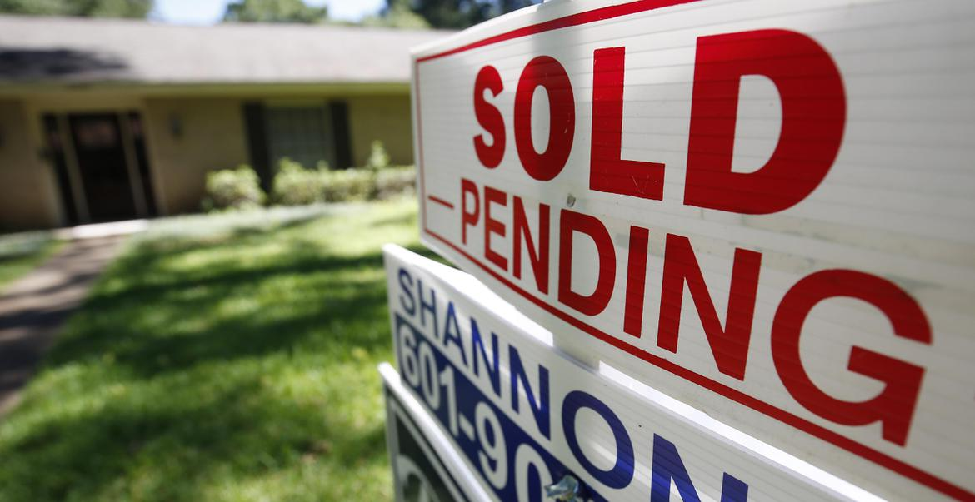
New state laws, effective January 1st, will affect your work as a REALTOR® in Washington:

- The real estate excise tax changes from a flat 1.28% of the sales price to a sliding scale. For the first $500,000, the tax is 1.6%; for the amount between $500,000 to $1.5 million, the tax is 1.78%; for the amount between $1.5 million and $3 million it's 3.25%, and for the amount over $3 million it's 3.5%. This includes .5% for the County and City portion.
- A person buying a home without any smoke detectors installed in it must be provided at least one smoke detector by the seller.
- The buyer of a home near a working forest must be notified by the seller, with an explanation to the buyer that normal forest practices are protected against lawsuits under the state Right to Farm Act.
- Children must be in a booster seat until they are four feet nine inches tall, or 13 years old, whichever comes first - think clients with children in your car.

Read more in The Spokesman-Review online here.

THAT’S WHO WE R® – ADVOCACY MESSAGE

Your Spokane Association of REALTORS® has created a new advocacy message to help consumers better understand who we are and what we do.

This message was paid for with an advocacy grant from the National Association of REALTORS®.

Be among the first to see the message online here.

This is also posted to the SAR Facebook page - you can share it from there.

Watch for this message in your favorite local television newscasts in coming days.

Watch the new 30-second message online here.

That's Who We R®

Add this video to your website with this code:

<iframe width="976" height="549" src="https://www.youtube.com/embed/GcflZg5hb7Q" frameborder="0" allow="accelerometer; autoplay; encrypted-media; gyroscope; picture-in-picture" allowfullscreen></iframe>

LEGAL HOTLINE: HOME SALE CONTINGENCY

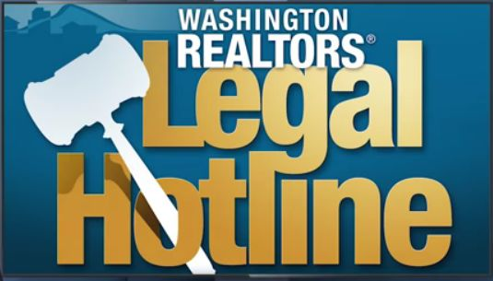
Washington REALTORS® uploaded five episodes of its epically-popular Legal Hotline series about one of the most difficult and form-intensive parts of a real estate transaction: Home Sale Contingency.

Washington REALTORS® Legal Hotline lawyer Annie Fitzsimmons and Spokane Broker and Instructor Ken Sax discuss the forms involved and the strategies for both the Buyer Representative and the Seller Representative.

Here is Part 1 on Theory - 11-minutes:

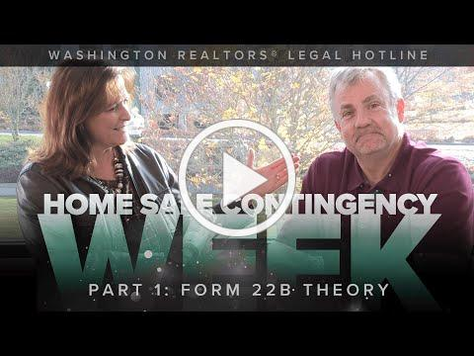
Home Sale Contingency Week, Part 1: Theory

Watch all of the segments in this video series on the Washington REALTORS® YouTube channel, online here.

GRIDMAPS BACK IN STOCK!

Spokane County grid maps are back in stock and available now at your SAR!

Call or email ahead for bulk orders.

Email: front@spokanerealtor.com

or call 509-326-9222.

2020 REALTOR® CODE OF ETHICS

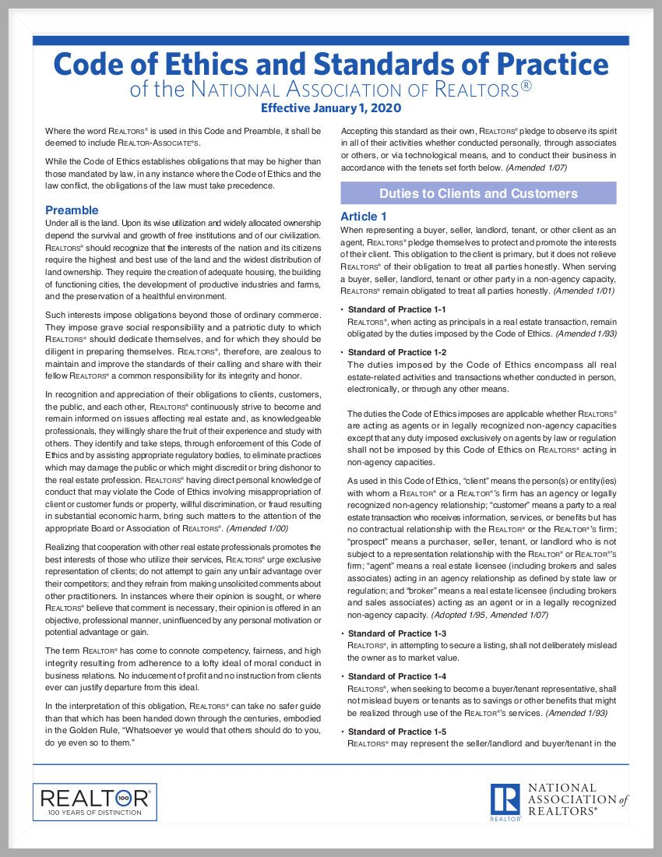
"Under all is the land."

What important document begins with these words?

If you answered the REALTOR® Code of Ethics, you are correct!

The Code of Ethics and Standards of Practice of the National Association of REALTORS® was adopted in 1913 as one of the first codifications of ethical duties adopted by any business group.

The Code ensures that consumers are served by requiring REALTORS® to cooperate with each other in furthering clients' best interests.

NAR has just released its newly updated version of our COE for 2020, effective January 1st.

Download your copy of the brand-new 2020 REALTOR® Code of Ethics for posting in your office online here.

SHARE YOUR REALTOR® PRIDE

Sharing your REALTOR® pride has just gotten a whole lot easier.

A new app - PhotoFy - lets you quickly and easily personalize a selection of content from the National Association of REALTORS®' popular That's Who We R advertising campaign to share on social media (see example above).

The campaign uses the iconic block R logo, representing membership in the National Association of REALTORS®, to differentiate REALTORS® from non-member agents.

Check it out online here.

SAR 109 YEARS

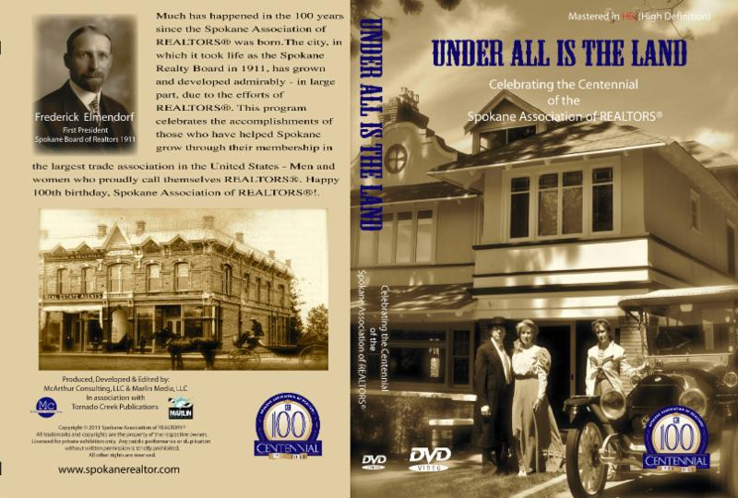
2020 is the 109th year of the Spokane Association of REALTORS®.

The SAR began as the Spokane Realty Board over lunch in Davenport's Restaurant on the first of September in 1911.

To help celebrate its centennial in 2011, the SAR commissioned Under All is the Land (pictured above).

You can watch this 30-minute video online here:
https://youtu.be/sA1eRgJ4QCo

DECEMBER MARKET STATISTICS

Wow! 654 single-family homes on less than one acre including condominiums were reported as closed sales for December 2019. This number is up 8.8% over December 2018 when 601 closed sales were reported. The average sales price for December was $288,794, up 19.2% over December’s 2018 average sales price, which was $242,335. The median closed sales price for December was $257,999 up 15.5% over December 2018 when the median prices was $222,500.
2019 closed sales total 7,922 is down 5% from 2018 sales of 8.343. The average closed sales price for 2019 was $283,600 up 11.2% for 2018’s average sales price of $254,969. The median sales price for 2019 was $260,000 up 10/7% from the median closed sales price for 2018 of $234,900.
As we close out the second decade of the 21st century, inventory continues to be our headwind. The inventory as of this report totals 596 homes on the market. Based on December’s sales this is a .9 month’s supply. A bright spot for sales in 2019 was closed sales of new construction, which is up 8.9% for the year.

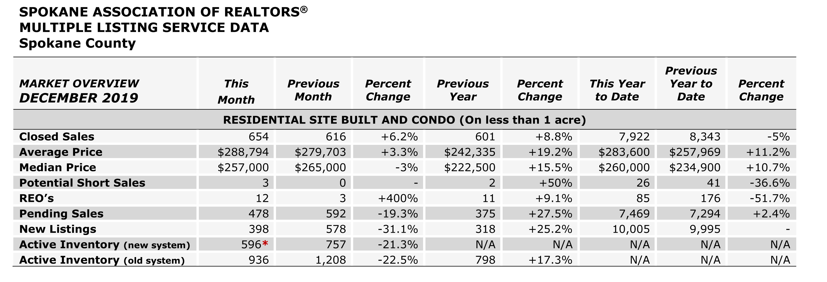

The above is an excerpt of the Spokane Association of REALTORS’® December 2019 Residential Market Activity Report. Access to the full report each month is a benefit of your association membership. See the full report online here (after you log in to the member portal): https://www.spokanerealtor.com/mls/market-activity-mls-statistics

DECEMBER LOCKBOX STATISTICS

