FEBRUARY 2020

REAL ESTATE MARKET FORUM

Thursday, February 27th
Spokane Convention Center
The Spokane-Kootenai Real Estate Research Committee invites all SAR members, affiliates, and friends to attend its 2020 Real Estate Market Forum: Thursday, February 27th.
Please note that advance registration ends at noon on Friday, February 21.
This popular event is always well-attended (see last year's event pictured above), and brings some of the smartest minds in regional market research and development to the same microphone to share what they know about, and what they predict for, the regional economy in the new year.
Keynote speaker is Ryan Harneteaux, Project Director, Katerra - the five-year old technology-driven offsite construction company.
Check the event website for the latest information on continuing education credit for Washington and Idaho Real Estate Licensees and Appraisers.

See the event flyer, offered with this newsletter, for program and speaker information.

EDUCATION EXCELLENCE / MEMBERSHIP MEETING
THURSDAY, MARCH 19th
Welcome to the first Education Excellence event and Quarterly Membership Meeting of the new year!
Instructor Sabrina Jones-Schroeder will teach her excellent Core Curriculum class: Current Issues in Washington Real Estate (3.0 clock hours).

Watch Sabrina's one-minute welcome to her class online here:

Core Curriculum
Current Issues in Washington Residential Real Estate

We'll take a mid-morning break for brunch, convene a short Quarterly Membership Meeting, then return to the class.
You'll be done by 1:00 p.m.
Early-bird registration ends March 11th.

See the event flyer, offered with this newsletter, for event details and registration information.

SAR Bylaws Vote

BYLAWS VOTE
THURSDAY, MARCH 19, 2020

The Board of Directors of the Spokane Association of REALTORS® is submitting to the membership proposed Bylaw amendments.

The Bylaws will be voted on by the REALTOR® members present at the General Membership Meeting on Thursday, March 19, 2020
at CenterPlace

A redline copy of the Restated Bylaws of Spokane Association of REALTORS® is included among the attachments to this newsletter.

REALTOR® SAFETY

O'Callaghan also uses a phone app called Homesnap, which, when she's within 200 yards of a property, will show information about the property, as well as allow her to set a safety timer.

"You can say, 'I think I'm going to be in here for 30 minutes,' and you can set a contact; if that time expires and nobody's heard from you, (the app) will send a safety text, an alert, to that person," O'Callaghan says.

The app can also send an instant safety alert, somewhat like using a panic button.

Read the full article online here.

THAT’S WHO WE R® – ADVOCACY MESSAGE

Your Spokane Association of REALTORS® has created a new advocacy message to help consumers better understand who we are and what we do.

This message was paid for with an advocacy grant from the National Association of REALTORS®.

Be among the first to see the message online here.

This is also posted to the SAR Facebook page - you can share it from there.

Watch for this message in your favorite local television newscasts in coming days.

Watch the new 30-second message online here:

That's Who We R®

Add this video to your website with this code:

<iframe width="976" height="549" src="https://www.youtube.com/embed/GcflZg5hb7Q" frameborder="0" allow="accelerometer; autoplay; encrypted-media; gyroscope; picture-in-picture" allowfullscreen></iframe>

Legal Hotline: Property Disclosure Woes
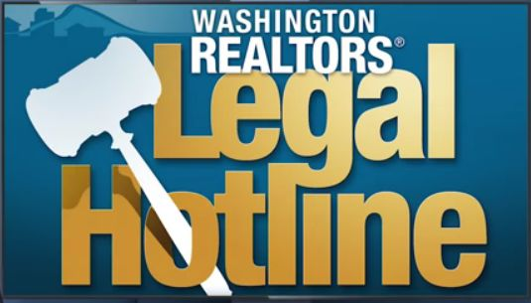
Washington REALTORS® Legal Hotline lawyer Annie Fitzsimmons answers the following common question:

"What does the listing broker or seller have to disclose with respect to the condition of seller's property?"

See Annie's all-new seven-minute video online here:

Seller's Property Disclosure Woes

GRIDMAPS BACK IN STOCK!

Spokane County grid maps are back in stock and available now at your SAR!

Call or email ahead for bulk orders.

Email: front@spokanerealtor.com

or call 509-326-9222.

2020 CENSUS

The National Association of Realtors® has signed on as a National Partner for the upcoming 2020 Census.

NAR is asking the 1.4 million Realtors® nationwide to help drive Census participation in their respective communities.

"NAR is able to provide tremendous value to our members because of the research we produce examining trends in communities across this country. But the usefulness of that information relies on current, accurate data from the federal government," said NAR President Vince Malta, broker at Malta & Co., Inc., in San Francisco. "Full participation in the Census is in many ways the only way to ensure that data is correct."

Download NAR's Census participation graphic (pictured above) online here - and share it with your clients to help get the word out.

Veterans Chronicle
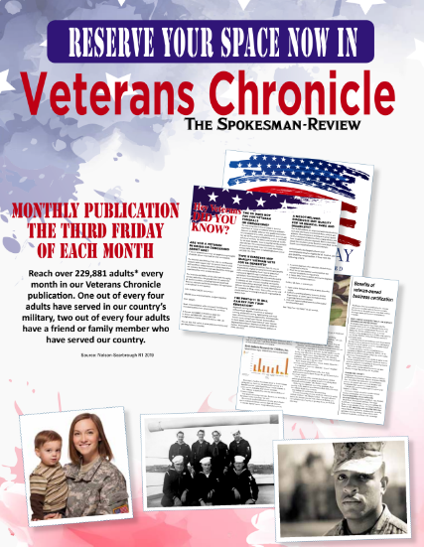
Our friends at The Spokesman-Review share word that their Veterans Chronicle - an idea the SAR brought to the newspaper two years ago - will continue and expand this year.

This monthly insert to the daily newspaper "will have even more content, more tips for veterans' benefits, and more success stories of local veterans," according to The Spokesman-Review.

This is a great opportunity for you to promote your business to this important and growing local population.

Download the flyer with details about this opportunity (pictured above) online here.

JANUARY MARKET STATISTICS

Closed sales of single family homes on less than one acre, including condominiums, reported for January 2020 total 432. This number is up 18% when compared to the 366 closed sales reported in January 2019. The average closed sales price for January 2020 was $285,887, up 11.8% from the average closed sales price of $255,812 in January 2019. The median closed sales price compared to January last year was up 16.3%, $273,418 v. $235,000 respectively.

These numbers also reflect year to date totals.

Inventory as of this report totals 457 properties, slightly more than a one month supply. New construction closed sales reported show a substantial increase of 46.9% when compared to the closed sales reported in January 2019, 72 v. 49.

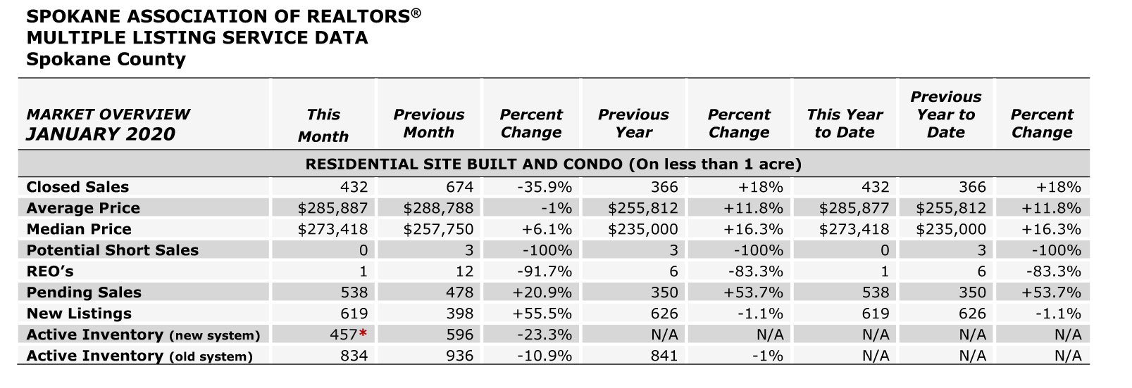

The above is an excerpt of the Spokane Association of REALTORS’® January 2020 Residential Market Activity Report. Access to the full report each month is a benefit of your association membership. See the full report online here (after you log in to the member portal): https://www.spokanerealtor.com/mls/market-activity-mls-statistics

JANUARY LOCKBOX STATISTICS

