DECEMBER 2019

SAR MEMBER SATISFACTION SURVEY

The Spokane Association of REALTORS® wants to hear from you!
The button below will take you to our 2019 member satisfaction survey.

Your responses will help us make sure our services are relevant and useful to you in 2020.

The survey is open to all SAR members until Sunday, December 22nd, at midnight.
When you complete this survey, your name will automatically be entered into a drawing to win one of four (4) Amazon gift cards valued at $250 each, or one of five (5) Amazon gift cards valued at $100 each.
Please take the survey now:

https://www.surveymonkey.com/r/SAR2019Survey

LOW INVENTORY, RISING PRICES
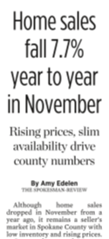
Although home sales dropped in November from a year ago, it remains a seller's market in Spokane County with low inventory and rising prices.

County home sales were down 7.7% last month compared with November 2018, according to data from the Spokane Association of Realtors.

Read the entire article in Tuesday's edition of The Spokesman-Review, online here.

BROKER LOAD OF CLOSED SALES IN PARAGON
Beginning on Monday, January 6, 2020, closed sales can be reported directly in the Paragon system by staff and brokers with listing input access.
- Closed sales must be reported by the next business day after recording.
- FSBO sales must still be sent to the SAR/MLS for closed sales reporting.
- Duplicate listings may only be reported once. Send an email to the SAR/MLS and the SAR/MLS staff will remove the duplicate listing from the system.
- Closed sales may still be emailed or faxed to the SAR/MLS office to be input at no charge.
- Closed Sales must continue to be reported by 10 a.m. on the first working day of the month to ensure that they are included in the monthly statistical reports. (For example, all January 2020 sales must be reported by 10 a.m. on February 3, 2020 to be included in the January numbers.)

FHA RAISES LOAN LIMITS
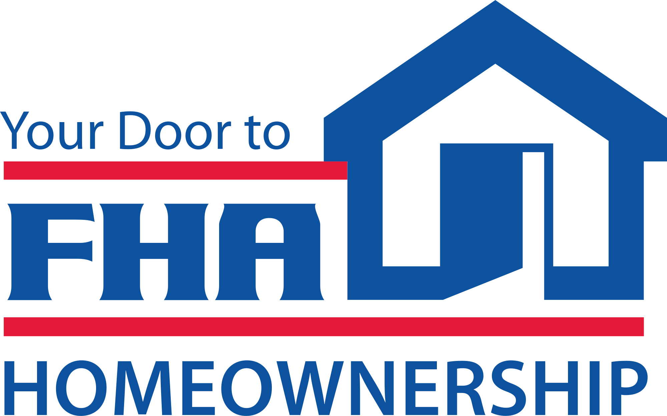
The Federal Housing Administration (FHA) has raised its 2020 loan limits. The FHA floor (the lowest FHA limit) for Spokane County is now $331,760.

For more information, check out the SAR’s Government Affairs Brief.

2020 SAR LEADERSHIP INSTALLATION OF OFFICERS AND MEMBER LUNCHEON

Thursday, January 9th!

It's time for your association's annual renewal ritual with the 2020 SAR Leadership Installation of Officers and Member Luncheon on Thursday, January 9th!

NEW LOCATION: DAVENPORT GRAND HOTEL

Join your colleagues and friends as we say thank you to Gina Mosey for her service to the association as immediate past president and install Tom Clark as our association's 2020 president - our 109th president in association history.

The flyer for this event is offered among the attachments to this newsletter.

HOME SALE CONTINGENCY WEEK
Washington REALTORS® uploaded five videos on its YouTube channel, last week - a full five episodes of its epically-popular Legal Hotline series - about one of the most difficult and form-intensive parts of a real estate transaction: Home Sale Contingency.

Washington REALTORS® Legal Hotline lawyer Annie Fitzsimmons and Spokane Broker and Instructor Ken Sax discuss the forms involved and the strategies for both the Buyer Representative and the Seller Representative.

Here is Part 1 on Theory - 11-minutes:

Home Sale Contingency Week, Part 1: Theory

Watch all of the segments in this video series on the Washington REALTORS® YouTube channel, online here.

LEGISLATIVE DAY 2020

January 22-23!

REGISTER NOW for the 2020 Washington REALTORS® Legislative Day in Olympia - January 22-23, next year.

Washington REALTOR® CEO Steve Francks and Government Affairs Director Nathan Gorton give us a sneak preview of the upcoming Legislative Session, REALTOR® priorities and how members can participate in this annual event.

Watch their five-minute video online here:

Legislative Update

Keep in touch with the SAR around the upcoming 2020 Legislative Day online here:

https://www.spokanerealtor.com/govt-affairs-brief/legislative-day/
The Washington REALTORS® Legislative Day is a long-standing tradition among broker members in Washington state.

In 2019, the REALTOR® message was "Unlock the Door for Affordable Home Ownership!"

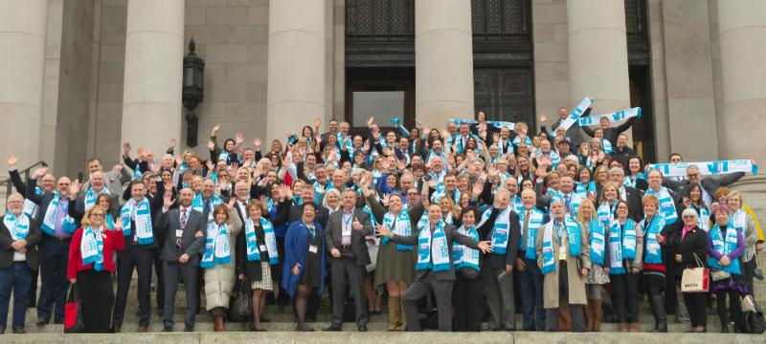
WR photo

SAR members joined member colleagues from across the state to deliver that message to the steps of the Capitol building (photo above) and directly to elected Members in face-to-face meetings with every Spokane-area legislator.

The Washington REALTORS® Legislative Day, or "Hill Day." is a chance for you to take the voice of Washington REALTORS® directly to lawmakers in our state capital as they begin their session as we did last year.

"Why should I go?"

Listen to the answer from a Spokane member broker who once asked that question, in this two-minute video:

Washington REALTORS® Legislative Day
You should go!
THAT’S WHO WE R® – ADVOCACY MESSAGE

Your Spokane Association of REALTORS® has created a new advocacy message to help consumers better understand who we are and what we do.

This message was paid for with an advocacy grant from the National Association of REALTORS®.

Be among the first to see the message online here.

This is also posted to the SAR Facebook page - you can share it from there.

Watch for this message in your favorite local television newscasts in coming days.

Watch the new 30-second message online here.

That's Who We R®

Add this video to your website with this code:

<iframe width="976" height="549" src="https://www.youtube.com/embed/GcflZg5hb7Q" frameborder="0" allow="accelerometer; autoplay; encrypted-media; gyroscope; picture-in-picture" allowfullscreen></iframe>

GRIDMAPS BACK IN STOCK!

Spokane County grid maps are back in stock and available now at your SAR!

Call or email ahead for bulk orders.

Email: front@spokanerealtor.com

or call 509-326-9222.

NOVEMBER MARKET STATISTICS

615 residential closed sales, including condominiums were reported for November 2019. Compared to November 2018, closed sales were down 7.7%, 615 v. 666. The average closed sales price was $279,749 up 5.9% compared to November 2018 closed sales price of $264,102. The median closed sales price for November 2019 was $265,000 up 10.4% from November last year when the median price was $240,000.
Year to date closed sales through November this year are down 6.1% from last year, 7,267 v. 7,742. The year to date average closed sales through November is $283,127 up 10.6% from last year at this time when the average year to date closed sales price was $255,950. The year to date median closed sales price is also up 10.6%, $260,000 v. $235,000.
Inventory under our new method of contingent inspection under the pending status reveals our inventory at 757 homes for sale that equates to a 1.2 months supply. Last year at this time using the old method we had a 1.6 months supply, still very tight. New construction closed sales reported to the Association through November total 847 up from 806 over the same period last year, an increase of 5.1%.

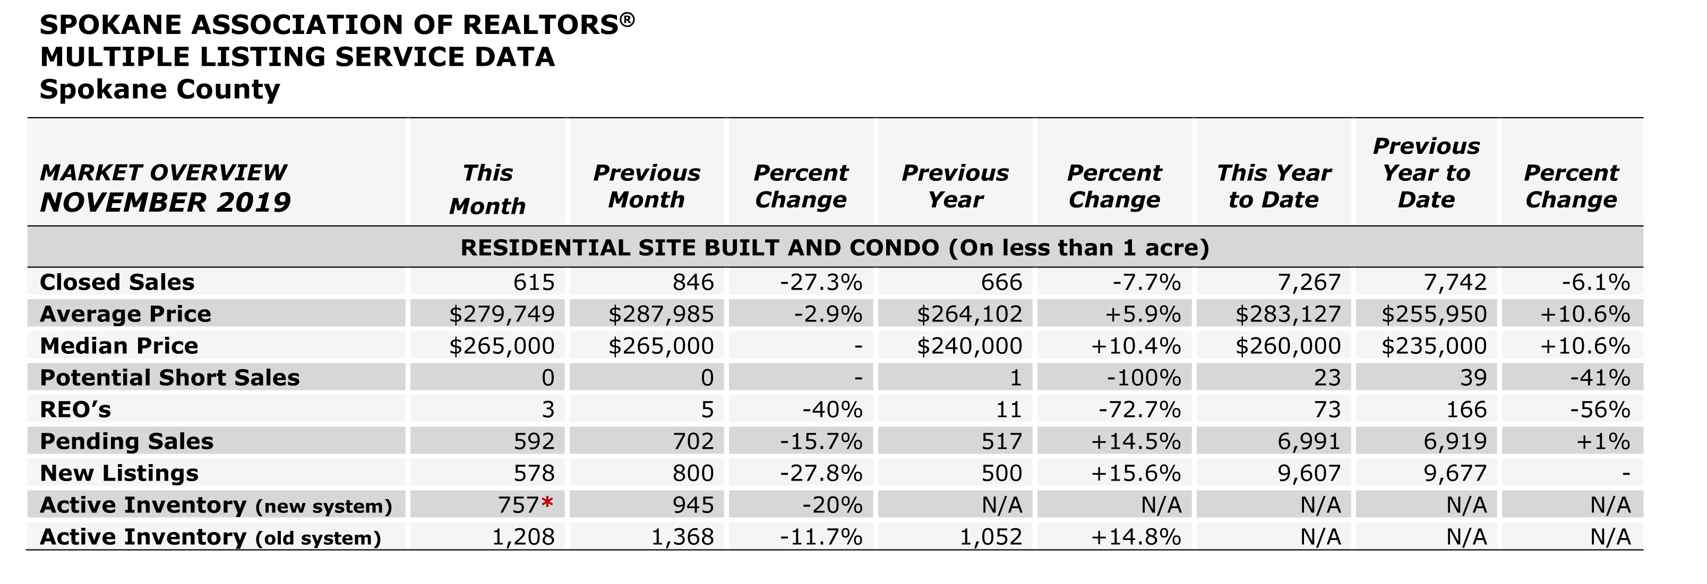

The above is an excerpt of the Spokane Association of REALTORS’® November 2019 Residential Market Activity Report. Access to the full report each month is a benefit of your association membership. See the full report online here (after you log in to the member portal): https://www.spokanerealtor.com/mls/market-activity-mls-statistics

NOVEMBER LOCKBOX STATISTICS

