AUGUST 2019

ANNIE’S COMING TO TOWN

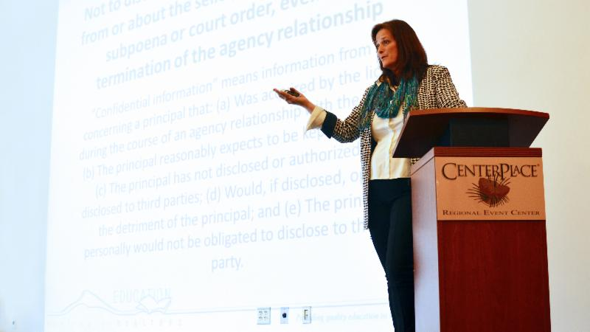
NEXT WEEK!
Thursday, August 22nd!
Annie Fitzsimmons, Washington REALTORS® Legal Hotline attorney (pictured), is coming to Spokane to teach two classes on Thursday, August 22nd: Don't Get Whacked by the WAC's – and – Is it Friend or Faux? RE-fraud Schemes you Need to Know.
You won't want to miss these interactive and energetic classes with Annie!

Download the event flyer from among the attachments to this newsletter.

The SAR Quarterly Membership Meeting will be held during the lunch break.

Lunch & meeting are included with class registration fee for only $40.

Lunch & meeting only without class is $20

Register online through the Member Portal, here:

SPOKANE MARKET AMONG HOTTEST IN COUNTRY

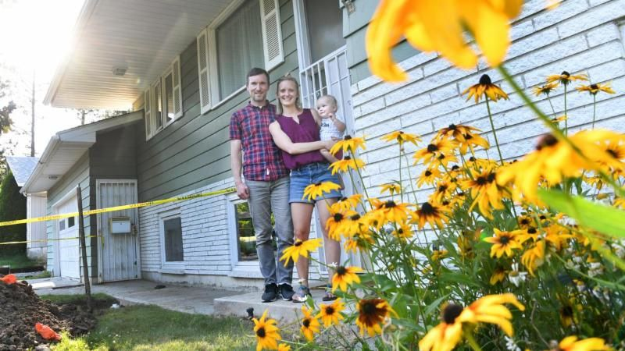
High demand, low inventory and multiple offers on homes are common in Spokane, which has become one of the hottest real estate markets in the nation.

Realtor.com named Spokane the third-hottest housing market in the nation in April - the most current data available from the online real estate listings website.

Ten of the hottest neighborhoods in the state are in Spokane County.

Read more in The Spokesman-Review, online here.

WASHINGTON REALTORS® FALL BUSINESS CONFERENCE
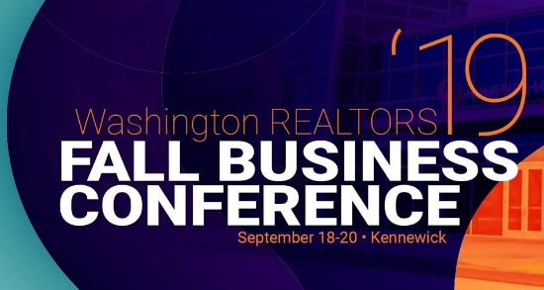

Registration is now open for the 2019 Washington REALTORS® Fall Business Conference - September 18-20 at the Three Rivers Convention Center in Kennewick.

If you’re a Washington REALTOR®, you are welcome to attend and find out what is happening at the committee and leadership levels of your association.

https://www.warealtor.org/events/conferences/2019/fall-business-conference

LEGAL HOTLINE: BUYER’S AGENCY AGREEMENT

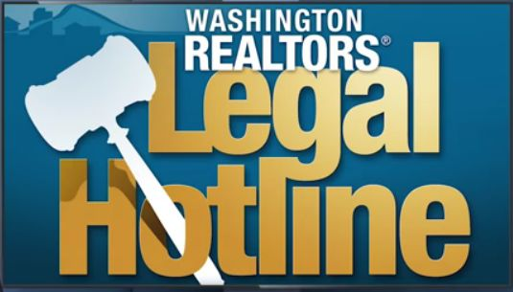
Washington REALTORS® Legal Hotline One-on-One series features a conversation between WR Legal Hotline lawyer Annie Fitzsimmons and Pili Meyer (Real Estate Instructor and Olympic Peninsula broker with 30+ years of real estate experience) on the subject of Buyer’s Agency Agreement – a document that is so essential to use in today’s market.

Each video is about 15-minutes long.

PART ONE: https://youtu.be/KoNuTsa-LxY

PART TWO: https://youtu.be/R3S-7xgwl2w

PART THREE: https://youtu.be/wTH9VRfsAAg
ANTI-TRUST LAWSUIT

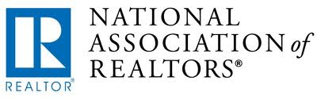
The National Association of REALTORS® is currently fighting an anti-trust lawsuit against our profession on your behalf.

The primary allegation is that home sellers are unfairly being required to pay the commissions of buyers' brokers while falsely suggesting the role of buyer broker has diminished over time.

NAR filed a motion to dismiss Moehrl v. NAR in May, which we believe demonstrated that the plaintiff's case was not legally viable.

In response, the class action attorneys filed an amended complaint in June.

While the new complaint presents additional plaintiffs and allegations, as well as revised arguments, the underlying foundation of it remains the same.

The plaintiffs' attorneys continue to misunderstand and mischaracterize the pro-competitive, pro-consumer MLS system, which - as you know - is designed first and foremost with the best interests of buyers and sellers in mind.

Several copycat lawsuits have since popped up around the country. NAR is fighting these as well.

NAR offers a Frequently Asked Questions document to help you answer questions from your clients and brokers about these lawsuits.

Find that resource online here.

SAR FOOD DRIVE
SAVE THE DATE!
September 5-6

Spokane Association of REALTORS® members will be out at the Spokane-area Albertsons/Safeway's grocery stores on September 5th & 6th for their annual food drive!

REALTORS® will be collecting food and cash donations to help Second Harvest stock shelves of partner food banks serving local neighborhoods.

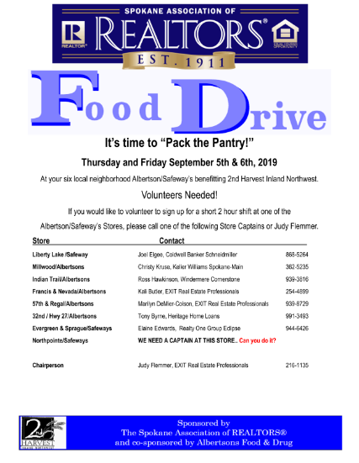
VOLUNTEERS NEEDED!

To volunteer for a short, two-hour shift at one of the Albersons/Safeway's stores as REALTORS® Pack the Pantry, please call one of our Store Captains.

The call list (pictured) is available among the supporting documents to this newsletter.

If you can't make your donation in person, make it online right now with Crowdrise - click on the logo below to enter your donation:

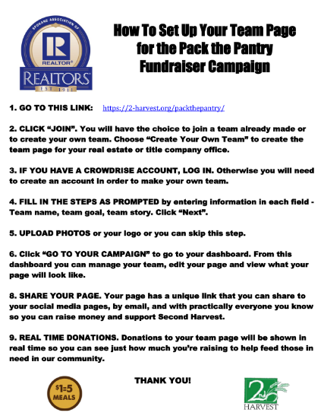
You can create your own Team Page on Crowdrise for a little competition and bragging rights with other offices.

See the Crowdrise setup instruction flyer (pictured) among the supporting documents to this newsletter.

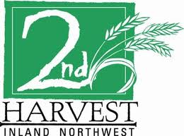

Remember for every $1 donated, Second Harvest provides 6 pounds of food - the equivalent of 5 meals for hungry people.

The gift of food changes lives and gives people an opportunity to succeed and thrive!

Thank you for your donation!

CRS CLASS IN SPOKANE

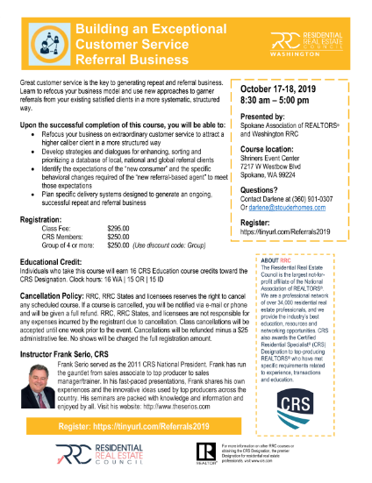
October 17-18

Building an Exceptional Customer Service Referral Business
Class: 8:30 a.m. to 5:00 p.m.

Location: Spokane, WA

16.0 clock hours

Download the class flyer (pictured) from among the supporting documents to this newsletter.

JULY MARKET STATISTICS

Closed residential sales of single-family homes on less than one acre, including condominiums reported to the Association for July totaled 850 sales. Compared to July last year closed sales were down 5.5%. The average closed sales price for July was $298,337. Compared to July last year when the average sales price was $259,059, the average sales price is up 15.2%. The median sales price was up 14.9%, $270,000 v. $235,000 respectively.
Year to date sales through July total 4,094 which is down 12.4% compared to 2018 through July when the closed sales totaled 4,671. The year to date average sales price for 2019 is $280,398 compared to $252,609 over the same period last year, an increase of 11%. Year to date median sales price is up 12.1% through July, $257,875 v. $230,000 respectively.
Inventory continues to be a head wind for our sales. As of this report our inventory stands at 1,428 homes compared to 1,466 homes at the same time last year, inventory is down 2.7%. New construction sales reported to the Association through July total 460 compared to 481 last year, down 4.4%.
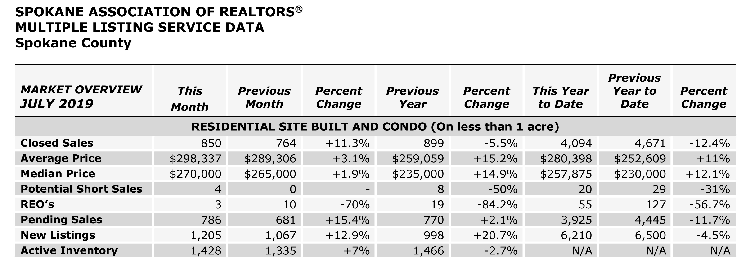

The above is an excerpt of the Spokane Association of REALTORS’® June 2019 Residential Market Activity Report. Access to the full report each month is a benefit of your association membership. See the full report online here (after you log in to the member portal): https://www.spokanerealtor.com/mls/market-activity-mls-statistics

JULY LOCKBOX STATISTICS

