MARCH 2019

2019 SAR LEADERSHIP LISTENING TOUR
Dear managing broker:

Sign up here for the 2019 SAR Leadership Listening Tour!

These office visits take 15-20 minutes for a team of SAR officers, directors, and committee chairs to visit with your brokers and staff to offer an update on association activities and listen to their needs, wants, and questions.

Click here to invite the 2019 SAR Leadership Listening Tour.

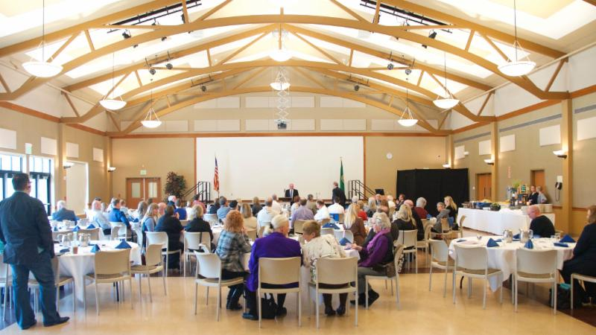
EDUCATION EXCELLENCE/QUARTERLY MEMBERSHIP MEETING

Mark your calendar now and plan to attend the first Education Excellence – Quarterly Membership Meeting on Thursday, March 21 (Early-bird Registration through March 17).

The education piece is: Professional Apps, Scripts, and other Tools to Aid the Client and Real Estate Professional - with Mike Selvaggio.

Check-in: 8:00 a.m.; class: 8:30 a.m. to 12:30 p.m. with break at 10:00 a.m. for breakfast and meeting
at CenterPlace Event Center in Spokane Valley. 3.0 clock hours for the class.

Register online here: https://www.spokanerealtor.com/calendar/

Watch a one-minute personal welcome to the event from Mike himself, online here:

SAVE THE DATES: April 27-28
Watch the Weekly Notices for details.

THAT’S WHO WE R

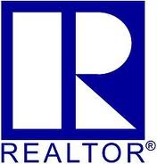
While many people know that a Realtor® helps buy and sell homes, what they may not know is that only a Realtor® is a member of the National Association of Realtors® and subscribes to its Code of Ethics.

It's the Realtor® Code of Ethics that inspired the association's powerful new "That's Who We R®" campaign, which launched this week.

The campaign aims to reinforce the value of Realtors® as advocates for property owners, engaged community members and trusted advisors with in-depth knowledge of the industry.

Read the NAR news release online here.

Visit the campaign information page online here.

See the one-minute "Inside the R" video online here:

Inside The R :60

PATHWAY TO PROFESSIONAL CONDUCT

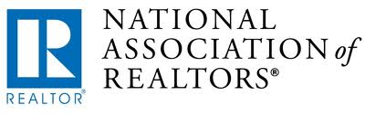
NAR created this brief, 10-minute video entitled "A Pathway to Professional Conduct: Respect Starts Here" to ensure that all members are versed on how to conduct themselves professionally in all parts of the business.

Watch the new 10-minute video online here:

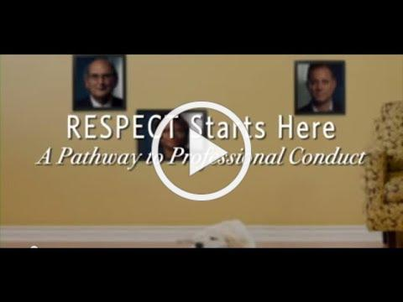
A Pathway to Professional Conduct

NAR: COMMITMENT TO EXCELLENCE

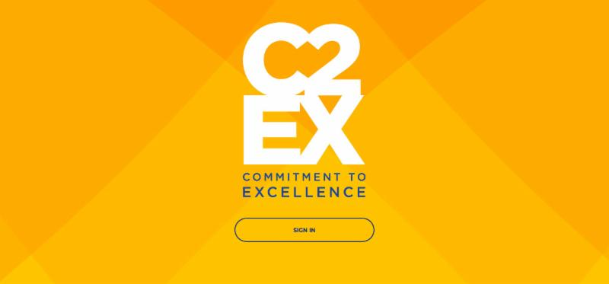
The National Association of REALTORS® just launched C2EX: Commitment to Excellence - a cutting-edge program that empowers REALTORS® to evaluate, enhance, and showcase the highest levels of professionalism.

Members start by taking the self-assessment that measures their proficiency in each of the elements of professionalism, known as the C2EX Competencies.

Based on their results, the platform will generate customized learning paths, recommend experiences, and provide tools and resources to increase their knowledge and enhance their skill sets.
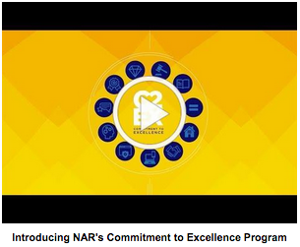
Find out more in this two-minute video:
https://youtu.be/hYYv_8IXm6Y

Then, make the commitment to excellence and take the self-assessment, online here: https://www.c2ex.realtor/

FEBRUARY MARKET STATISTICS

Even with the unusually cold and snowy February sales held steady for this February compared to February 2018, when 403 sales were reported. 401 closed sales of single family on less than one acre including condominiums were reported for this February. The average selling price was $260,469 for this February compared to $231,497 for February of 2018, an increase of 12.5%. The median sales price for February was $239,900, up 14.1% compared to February’s 2018 median sales price of $210,200.
Year to date sales through February are down 11.9%. Through February this year closed sales total 766 compared to 869 over the same period last year. Year to date average sales price is $258,267 up 13.4% when compared 2018’s year to date, through February, average sales price of $227,725. The year to date median sales price this year is $236,225 compared to last year when the median sales price was $209,500, an increase of 12.8%.
Inventory as of this report totals 769 properties compared to 924 at this time last year, a decrease in inventory of 16.8%. New construction closed sales reported to the MLS totaled 61. Significantly up from the 39 new construction sales reported last February. Year to date new construction sales are up 19.4%, 111 v. 93.

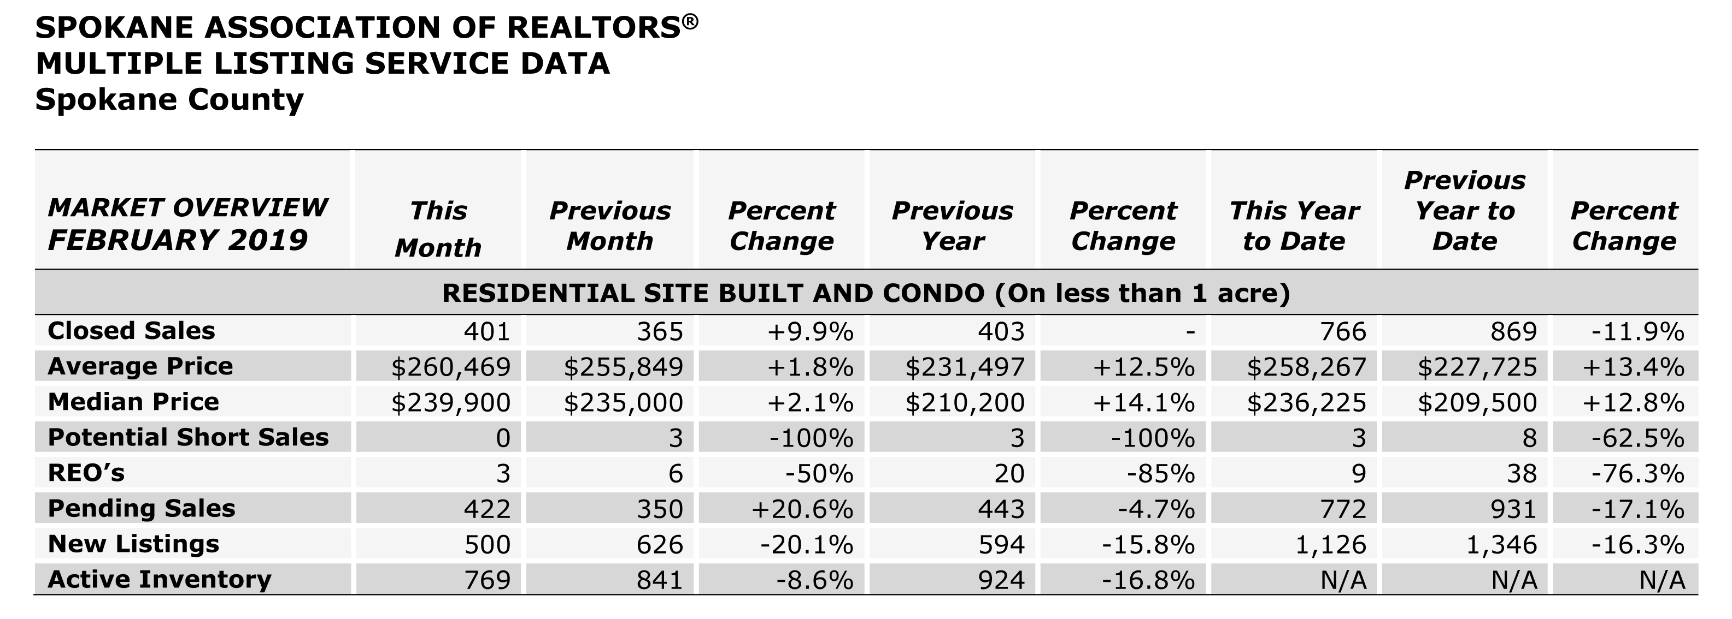

The above is an excerpt of the Spokane Association of REALTORS’® February 2019 Residential Market Activity Report. Access to the full report each month is a benefit of your association membership. See the full report online here (after you log in to the member portal): https://www.spokanerealtor.com/mls/market-activity-mls-statistics

FEBRUARY LOCKBOX STATISTICS

