FEBRUARY 2019

Dear managing broker:

Sign up here for the 2019 SAR Leadership Listening Tour! These office visits take 15-20 minutes for a team of SAR officers, directors, and committee chairs to visit with your brokers and staff to offer an update on association activities and listen to their needs, wants, and questions.

Click here to invite the 2019 SAR Leadership Listening Tour.

OFFICE ALERT
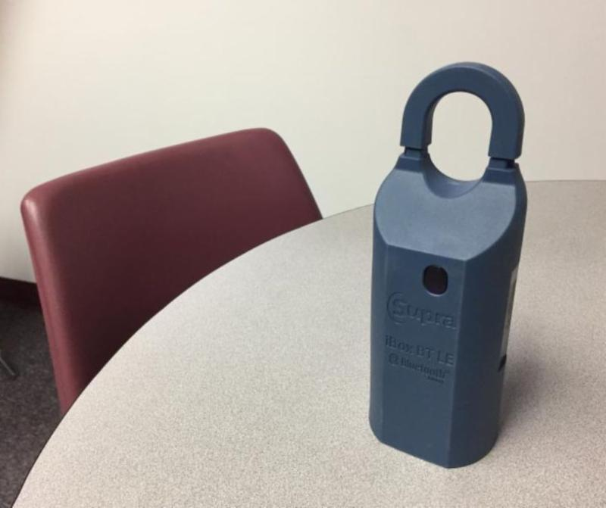
The SAR has had three reported lockboxes stolen from vacant houses in the past week.
The method-of-operation is to remove the lockbox either by breaking it off the doorknob or by cutting the hasp.
The criminal(s) then take the stolen lockbox to another site, cut/break it open, remove the key, and return to the house to steal appliances or other items of value.
All the houses reported hit in this way are vacant listings.
Please advise your brokers with vacant listings to visit the listing often to ensure the lock box has not been stolen.
Report any incident of lockbox theft to the police.
If your listing is hit, change the locks in the house as soon as possible to prevent further theft.
Report all such incidents to the SAR.
We are coordinating with Spokane Police crime analysis.
SPOKANE IN TOP TEN
Realtor.com recently released a list of 10 metro areas that experienced double-digit growth in housing prices last year.

The price growth in the Spokane area and the other markets came as 70 percent of the U.S.'s 200 largest housing markets experienced a slowdown.

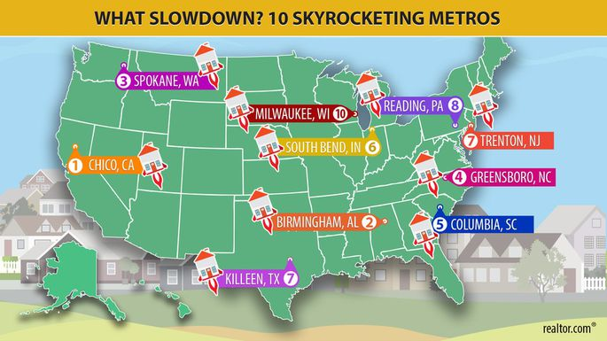
Spokane-area homes for sale in December had a median list price of $299,100, representing a 15 percent increase from the previous year, according to Realtor.com.

The price quoted by Realtor.com seemed high to Rob Higgins, executive officer for the Spokane Association of Realtors. He said it may have included properties with acreage.

(NOTE: REALTOR.COM® looks at median list prices. The SAR looks at median closed sales prices).

Read the full article in The Spokesman-Review, online here.

A closer look at the numbers . . .

[A recent article (February 12, 2019) in Nar’s REALTOR® magazine reports the national median single-family home price in the fourth quarter of 2018 was $257,6000, up four percent from a year ago. For comparison purposes, Spokane’s median single-family home price (Market Activity Report) in the fourth quarter of 2018 was $235,000, up 11.9% from a year ago. Ninety-two percent of the 178 metro markets measured saw an increase in single-family home prices. Fourteen metro areas saw double-digit increases (Spokane being one of the fourteen)]

2019 LEGISLATIVE DAY

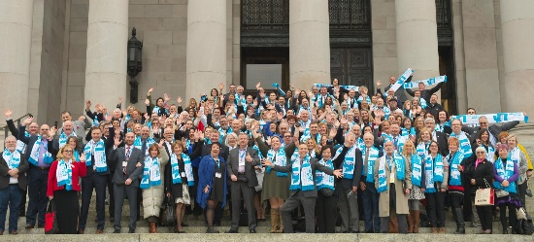
Over 500 REALTORS® adorned with "Unlock the Door for Affordable Home Ownership" scarves converged on Olympia for the Washington REALTORS® Legislative Day event, last month.

Over the course of two days, REALTORS® participated in governance meetings, installed our 2019 Leadership, networked and met with Legislators to discuss solutions for the acute housing affordability crisis in Washington State.

Read the Washington REALTORS® summary report on this year's Legislative Day (pictured), online here.

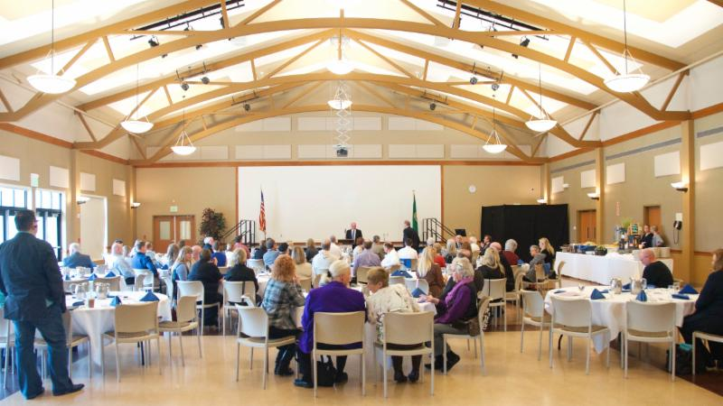
EDUCATION EXCELLENCE/QUARTERLY MEMBERSHIP MEETING

Mark your calendar now and plan to attend the first Education Excellence – Quarterly Membership Meeting on Thursday, March 21 (Early-bird Registration through March 17).

The education piece is: Professional Apps, Scripts, and other Tools to Aid the Client and Real Estate Professional - with Mike Selvaggio.

Check-in: 8:00 a.m.; class: 8:30 a.m. to 12:30 p.m. with break at 10:00 a.m. for breakfast and meeting
at CenterPlace Event Center in Spokane Valley. 3.0 clock hours for the class.

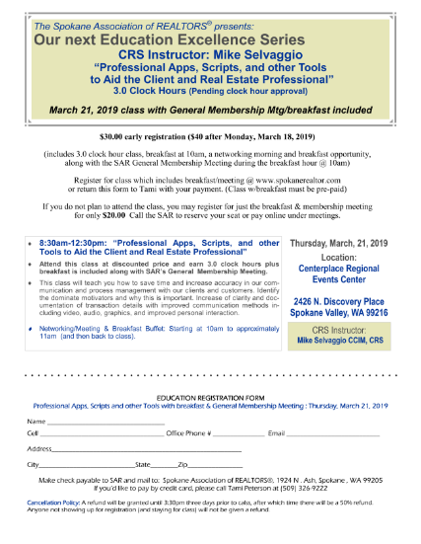
The event flyer (pictured) – suitable for posting and sharing in your office - is offered among the supporting documents to this newsletter.

HOT TOPICS IN RISK MANAGEMENT

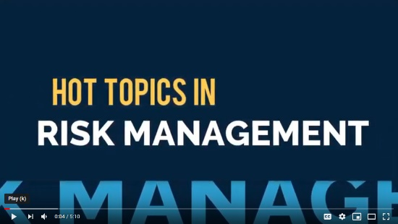
Wire fraud, copyright infringement, employees vs. independent contractors, text messages without recipient’s consent, and RESPA. These are all hot topics in risk management.

NAR helps us make sense of these modern risks in a new five-minute video you can share at your next meeting, with a transcript you can use as a handout.

See the video and print out a transcript online here:

https://www.nar.realtor/videos/hot-topics-in-risk-management

REAL ESTATE MARKET FORUM

Register online now for the 32nd annual Real Estate Market Forum, covering trends in real estate, construction, and the local economy in the Spokane-Kootenai-Bonner County area.

This much-anticipated and well-attended event will be held, this year, on Thursday, February 21st, at the Spokane Convention Center.

https://www.skrerc.com/market-forum/register/

More information about this event is online here.

Advance registration ends at noon on Friday, February 15.

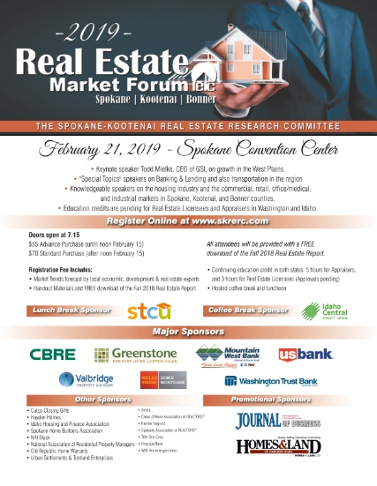
Share the word with your colleagues and associates!

The event flyer (pictured), suitable for posting in your office and sharing with colleagues, is offered among the supporting documents to this newsletter.

REDCON
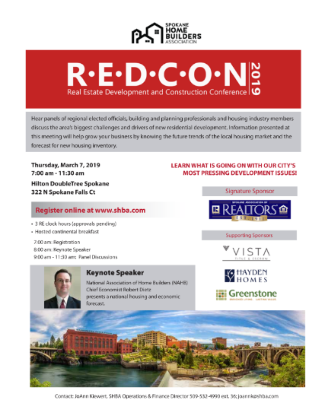
The Spokane Association of REALTORS® is Signature Sponsor to the Spokane Home Builders Association Real Estate Development and Construction Conference - REDCON - on March 7th.

Join us for informative panel discussions about our area’s biggest challenges to new development. Panels will include elected officials, government planners, and administration along with members of the development community in the Spokane area. Attendees will also hear from NAHB Chief Economist Robert Dietz who will speak on national housing trends and give an economic update.

https://info.shba.com/membereventscalendar/details/redcon-real-estate-development-and-construction-conference-88036

JAMES S. BLACK MEMORIAL SCHOLARSHIP
Applications are now being accepted for the 2019 James S. Black Memorial Scholarship.
This scholarship helps members pay for tuition and expenses leading to professional designations such as GRI, CRS, CPM, SIR, or MAI.
The deadline to submit applications to the SAR is Friday, February 22nd.
The scholarship will be awarded March 21st at the SAR's quarterly membership meeting at Centerplace Regional Events Center.
Download the scholarship information/application packet among the supporting documents to this newsletter.

NEW SAR WEBSITE

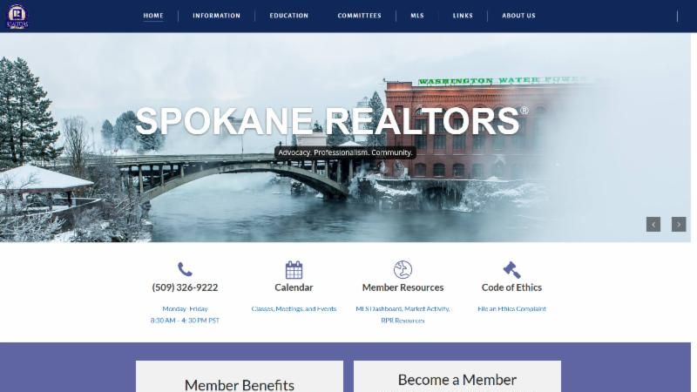
The SAR website - spokanerealtor.com - has an all-new look and feel!

The new website, launched at the beginning of the month, is easier to navigate and find what you're looking for, configures automatically to both desktop and mobile users, and generally is a better resource to support your business as a REALTOR®.

A direct link to Paragon is still there – right on the main page – as well as links to the SAR calendar and the REALTOR® Code of Ethics.

The redesign work and programming was handled in-house with the time and talents of members of the SAR Technology Committee, SAR IT Director Edward Chovgan, and SAR staff.
We encourage you to take it for a test drive and report here your feedback on what you like and think could be improved.

VETERANS CHRONICLE

Here is an excellent place to market your listings that accept VA-Financing!

The Spokesman-Review special monthly insert, Veterans Chronicle, delivers your listing to every print and online reader of The Spokesman-Review, with a unique veteran-centric audience on Friday, March 15th.

This insert is the result of an SAR Work Group that has worked the past two years to move the association closer to a friendlier relationship with our local veterans.

DEADLINE IS MARCH 8TH to participate in next month’s edition.

The sales flyer (pictured) is offered among the supporting documents to this newsletter.

CODE OF ETHICS

If you took a Code of Ethics class in the past two years - congratulations - you are an active REALTOR® today with full access to the Spokane MLS!

If you are one of the 87 SAR members who did not, your REALTOR® status is suspended for two months while you either take the class and return to active membership or become a former REALTOR®. Take no action and your status as a REALTOR® will be terminated at the end of this month.

NAR requires all active members to take a Code of Ethics class every other year. NAR grants and NAR revokes REALTOR® status.

Check your Code of Ethics status and learn more about your training options online here.

NAR: COMMITMENT TO EXCELLENCE

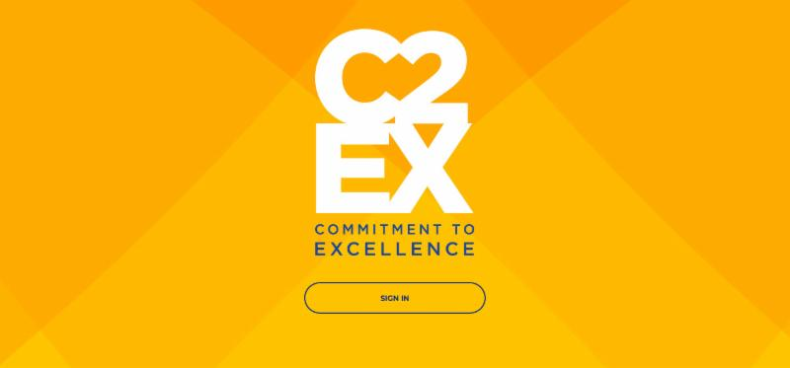
The National Association of REALTORS® just launched C2EX: Commitment to Excellence - a cutting-edge program that empowers REALTORS® to evaluate, enhance, and showcase the highest levels of professionalism.

Members start by taking the self-assessment that measures their proficiency in each of the elements of professionalism, known as the C2EX Competencies.

Based on their results, the platform will generate customized learning paths, recommend experiences, and provide tools and resources to increase their knowledge and enhance their skill sets.
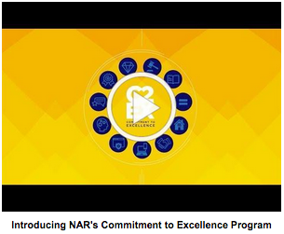
Find out more in this two-minute video:
https://youtu.be/hYYv_8IXm6Y

Then, make the commitment to excellence and take the self-assessment, online here: https://www.c2ex.realtor/

JANUARY MARKET STATISTICS

365 closed sales of single-family homes on less than one acre, including condominiums were reported for January 2019. This number is down 21.7% from January 2018. Remember, in January 2018 a record number of closed sales were reported for a January. The average sales price for this January was $255,850 up 14% from last January when the average price was $224,463. The median closed sales price was $235,000, up 12.7% from the median price in January last year, which was $208,500.

These numbers reflect year to date totals.

Inventory remains very low and is having a significant impact on the number of sales and the average and median prices. As of this report 841 properties are on the market. This is down 11.1% from last year when 946 properties were on the market. New construction closed sales totaled 50 for January, down four sales from January 2018.

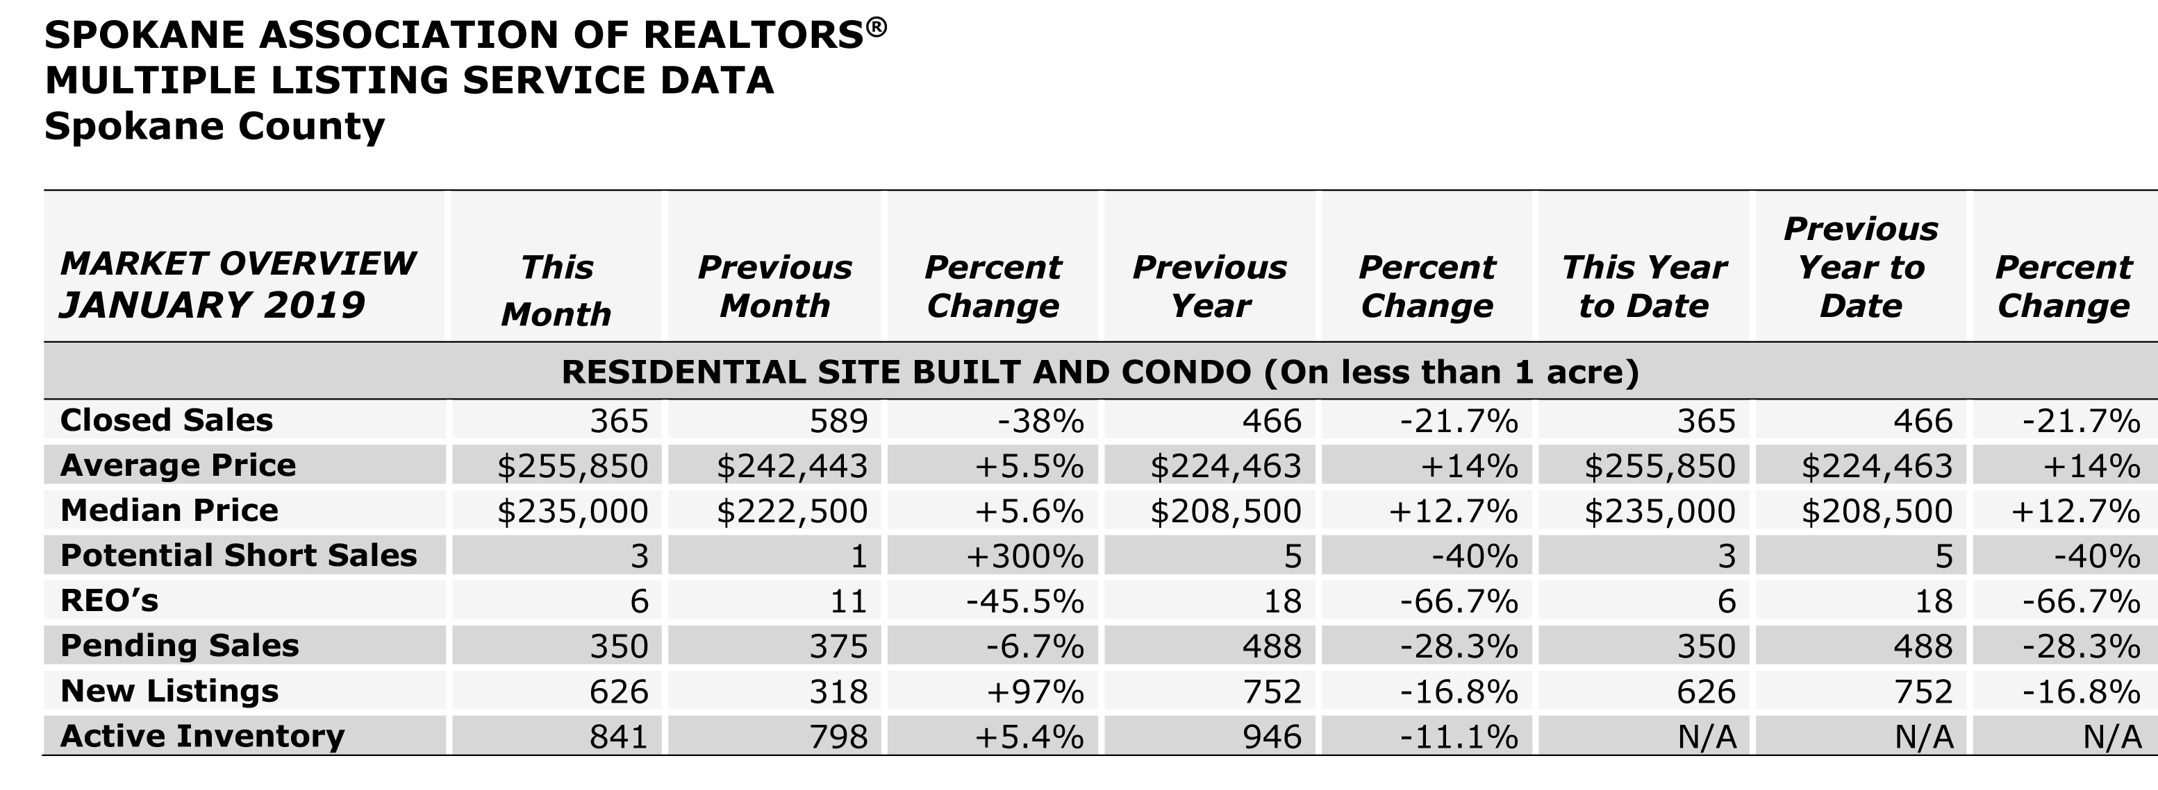

The above is an excerpt of the Spokane Association of REALTORS’® January 2019 Residential Market Activity Report. Access to the full report each month is a benefit of your association membership. See the full report online here (after you log in to the member portal): https://www.spokanerealtor.com/mls/market-activity-mls-statistics

JANUARY LOCKBOX STATISTICS

