APRIL 2019

2019 SAR LEADERSHIP LISTENING TOUR
Dear managing broker:

Sign up here for the 2019 SAR Leadership Listening Tour!

These office visits take 15-20 minutes for a team of SAR officers, directors, and committee chairs to visit with your brokers and staff to offer an update on association activities and listen to their needs, wants, and questions.

Click here to invite the 2019 SAR Leadership Listening Tour.

THIS WEEKEND!
April 27-28

Brokers - watch this short (one-minute) personal invitation to participate in the 2019 Spokane REALTORS® Open House Weekend from 2019 SAR President-elect Tom Clark and SAR Communications Committee Vice-chair Laura Branning:

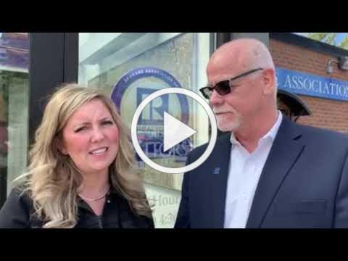
Invitation to Brokers to Participate
Spokane Association of REALTORS®
2019 Open House Weekend

See a complete Broker’s Check-list in the Weekly Notices!

POSSIBLE LISTING VIOLATION? HERE’S HOW TO REPORT IT!

The Spokane Association of REALTORS® MLS encourages our members to self-police listings to ensure information is properly displayed. If you see that the information is the wrong data field or is incorrect, follow the instructions below.

How do we report possible violations?

- When you bring a property report up you will see a “Correction” link above in the blue banner.
- Click on the link and a new window will pop up with a pre-addressed “Correction E-Mail” box.
- Explain the possible violation (e.g. wrong status, wrong grid#, etc.) and click “Send”.
- This will send an email to the SAR/MLS.
- If this is a possible violation, a Notification of Violation email will be sent to the broker and Participant letting them know they have until the next business day to get this corrected or they will be subject to a $500 fine.
- All “Corrections” are anonymous.

Is this effective? Here are the statistics from the last two months from the “Correction” link:
Corrections March 14, 2019 through April 16, 2019 | April 19 Meeting
2 identical listings - Both Residential or TOM and NEW | 3
Active No Show Date not in remarks | 3
Address Wrong | 2
Corrections March 14, 2019 through April 16, 2019 | April 19 Meeting
Auction | 1
Combo Lockbox
Contact Info | 8
Grid | 17
Legal Name wrong
Map | 1
No Compensation
No Exhibit A | 9
No Photo | 1
No showings - Status Active | 13
No Violation | 32
Non-Disclosure of ownership | 2
Not in MLS | 0
Open house in remarks | 5
Photo wrong | 3
Release/Relist | 8
Room Count
School District Wrong | 1
Square Footage wrong
Status | 8
Style of Construction
Subdivision Wrong | 1
Subtype | 4
Taxes wrong
TOM being advertised
Virtual Tour wrong
Zip code | 1

All corrected the next business day of notification.

SPOKANE IN TOP 20 PERFORMING MARKETS
REALTOR.COM® is just out with its newest list of the Top 20 Hottest Housing Markets - Spokane is #14!

A year ago, realtor.com®'s list was dominated by California markets. But a slowdown in Western markets and big cities has been benefiting the Midwest, which is often known for greater affordability in its housing.

"Historically, there wasn't much demand in those areas," says Danielle Hale, REALTOR.COM®'s chief economist. "Now that home prices are higher across the board, people are looking to those [more wallet-friendly] areas to buy."

Spokane is super affordable with a median home price of $245,800 - up 12.2% over last year - compared to the national listing price of $300,000. It attracts a lot of younger buyers.

Read the full article in REALTOR® magazine, online here.

WASHINGTON REALTORS® LEGISLATIVE UPDATE

Washington REALTORS® Governmental Affairs Director Nathan Gorton and Washington State Senator Guy Palumbo (D-Maltby) update on us on the Unlock the Door for Affordable Homeownership campaign and the progress we've made to push housing policy issues to the forefront this session.

Watch the new seven-minute video online here:

APRIL IS FAIR HOUSING MONTH

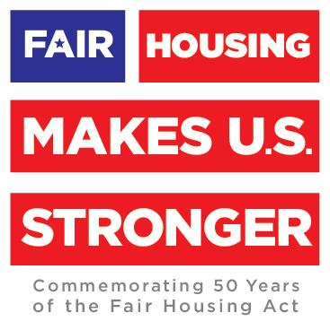
The National Association of REALTORS® (NAR), last year, commemorated the 50th anniversary of the Fair Housing Act, historic legislation that established this nation's commitment to equal housing opportunities.

While significant progress has been made since 1968, there's more work to be done.

As a nation, we are continually improving our commitment to fair housing.

April may be Fair Housing Month, but we need to raise awareness and take action every day of the year.

As a broker, you play a vital role in keeping fair housing front and center, starting with new-agent training.

Make fair housing a topic of discussion in your brokerage and a focus for specific activities throughout the year.

Watch NAR's new one-minute video, The Future of Fair Housing: It's Our Story to Write, online here:

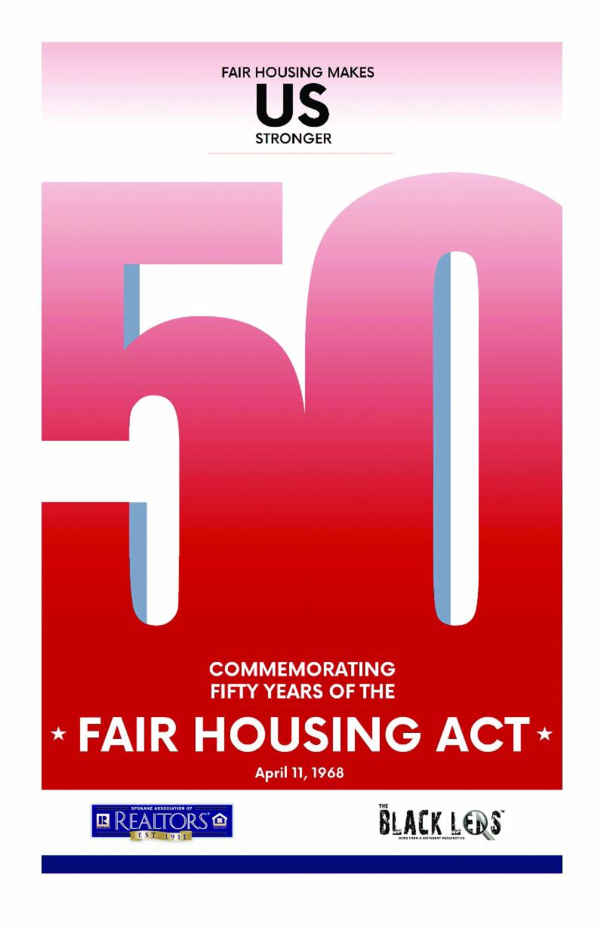
Download the special Fair Housing insert to the Black Lens newspaper (pictured) - a project of your Governmental Affairs Committee's Fair Housing Sub-committee - online here.

Hard copies of this Fair Housing insert - in quantities to share with your clients – are available at the SAR.

2019 SAR AWARDS LUNCHEON

Wednesday, May 8th
Noon - 1:30 p.m.

You are invited to the 2019 Spokane Association of REALTORS® Awards Luncheon - Wednesday, May 8th, at the Ruby River Hotel!

Come honor the 2019 award recipients: REALTOR® of the Year, Steve Flinn REALTOR® Achievement, REALTOR® Community Service, Affiliate of the Year, Partner of the Year, and Citizen of the Year.

The winners of this year's 3rd Grade Poster/Essay Contest on the theme "what my home means to me" will also be announced.

Download the event flyer (pictured), with more information, from among the supporting documents to this newsletter.

REALTORS PROPERTY RESOURCE (RPR)®

REALTORS® Property Resource is the nation's largest property database.

As a new agent, this user-friendly, data-driven platform and business tool should never leave your side. Regular use of RPR will help you help your clients, which can lead to more listings, and hopefully, more deals!

RPR makes it easy for REALTORS® to stand out from their competition. Using RPR as a real estate business tool will make you a more informed, more savvy, and more efficient REALTOR®.

Ready to better serve your clients, market yourself like a pro, and grow your brand and business?

Click here to dive in.

MARCH MARKET STATISTICS

459 sales of single family homes on less than one acre including condominiums were reported for March 2019. This number is down 24.4% from the 607 sales reported in March 2018. The average sales price for March was $270,190 up 14.1% from the average sales price for March last year which was $236,851. The median sales price for this March was $245,800, up 12.2% from March last year when the median price was $219,000.
Year to date sales through March total 1,226 closed sales compared to 1,476 closed sales through March last year. Sales are down 16.9% for the first three months of 2019. The year to date average sales price is $262,673 up 13.5% from the average over the same time last year, which was $231,478. The year to date median sales price is up 11.6%, $240,000 year to date this year compared to $215,000 last year.
Inventory as of this report totals 894 properties compared to 1,018 properties at the same time last year. Inventory is down 12.2%. New construction closed sales in March reported to the SAR/MLS totaled 43 compared to 81 last year. Year to date new construction closed sales are down 11.5%, 154 this year compared to 174 last year through March.

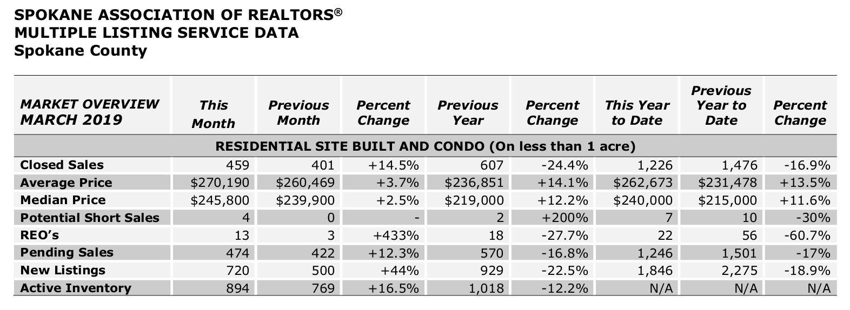

The above is an excerpt of the Spokane Association of REALTORS’® March 2019 Residential Market Activity Report. Access to the full report each month is a benefit of your association membership. See the full report online here (after you log in to the member portal): https://www.spokanerealtor.com/mls/market-activity-mls-statistics

MARCH LOCKBOX STATISTICS

